You are President Abraham Lincoln.  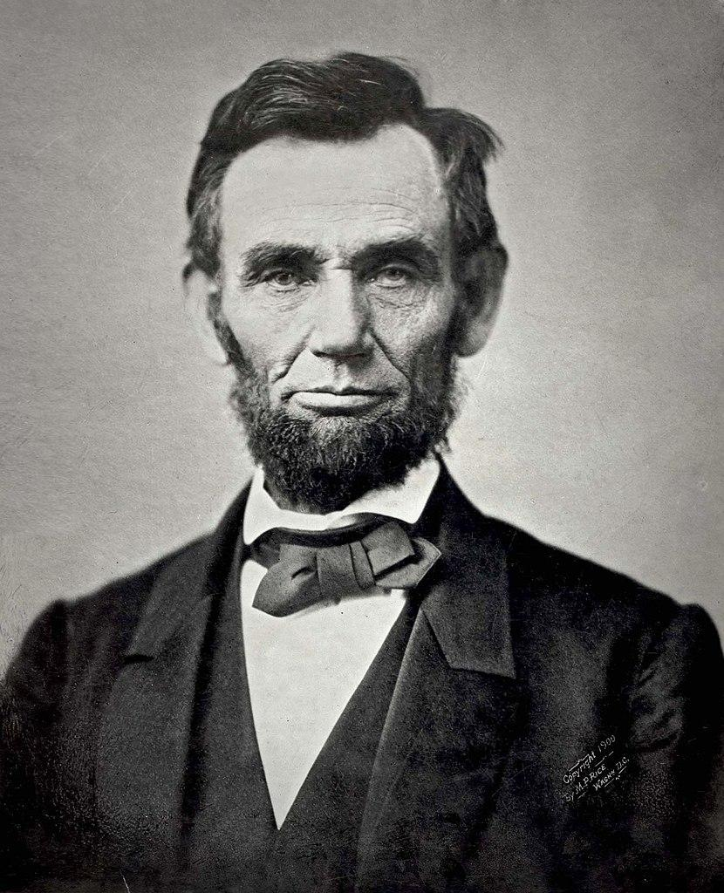  “I am the 16th President of the United States of America. I am modernizing the U.S. economy, and I want to preserve the Union. I am currently working with Congress to ratify the Thirteenth Amendment to the Constitution of the United States, which would outlaw slavery across the country. I denounced the Dred Scott v. Sandford decision, because I think that it is a conspiracy to continue slavery.”  Gardner, A. (1863, Nov. 8). Abraham Lincoln, the sixteenth president of the United States. Retrieved from https://commons.wikimedia.org/wiki/File:Abraham_Lincoln_November_1863.jpg | You are General Robert E. Lee.  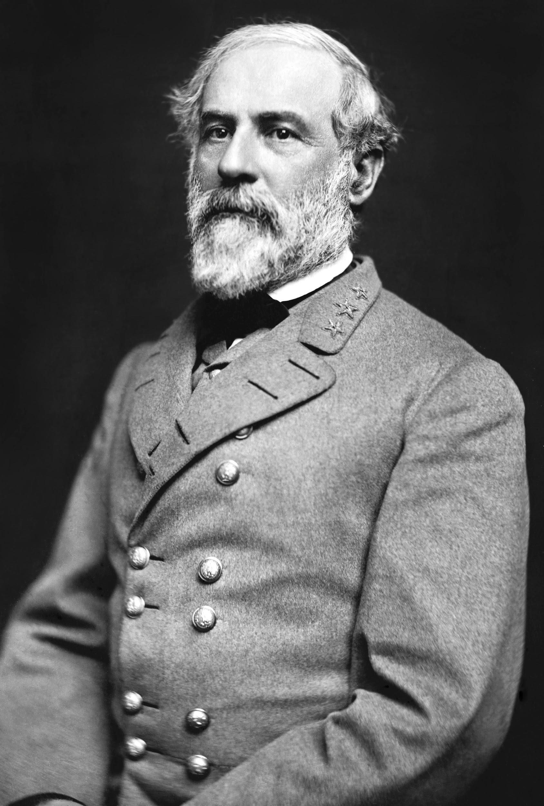  “I am a general of the Confederate Army. I was previously offered the command of the Federal forces, but I resigned from the army after Virginia seceded, because I will not fight against my own people. I own Custis-Lee Mansion at Arlington, and as executor of the estate, my family owns 196 slaves.”  Vannerson, J. (1864, March). Portrait of Gen. Robert E. Lee, officer of the Confederate Army. The Library of Congress Prints & Photographs Online Catalog. Retrieved from https://commons.wikimedia.org/wiki/File:Robert_Edward_Lee.jpg | You are John Lincoln Clem.  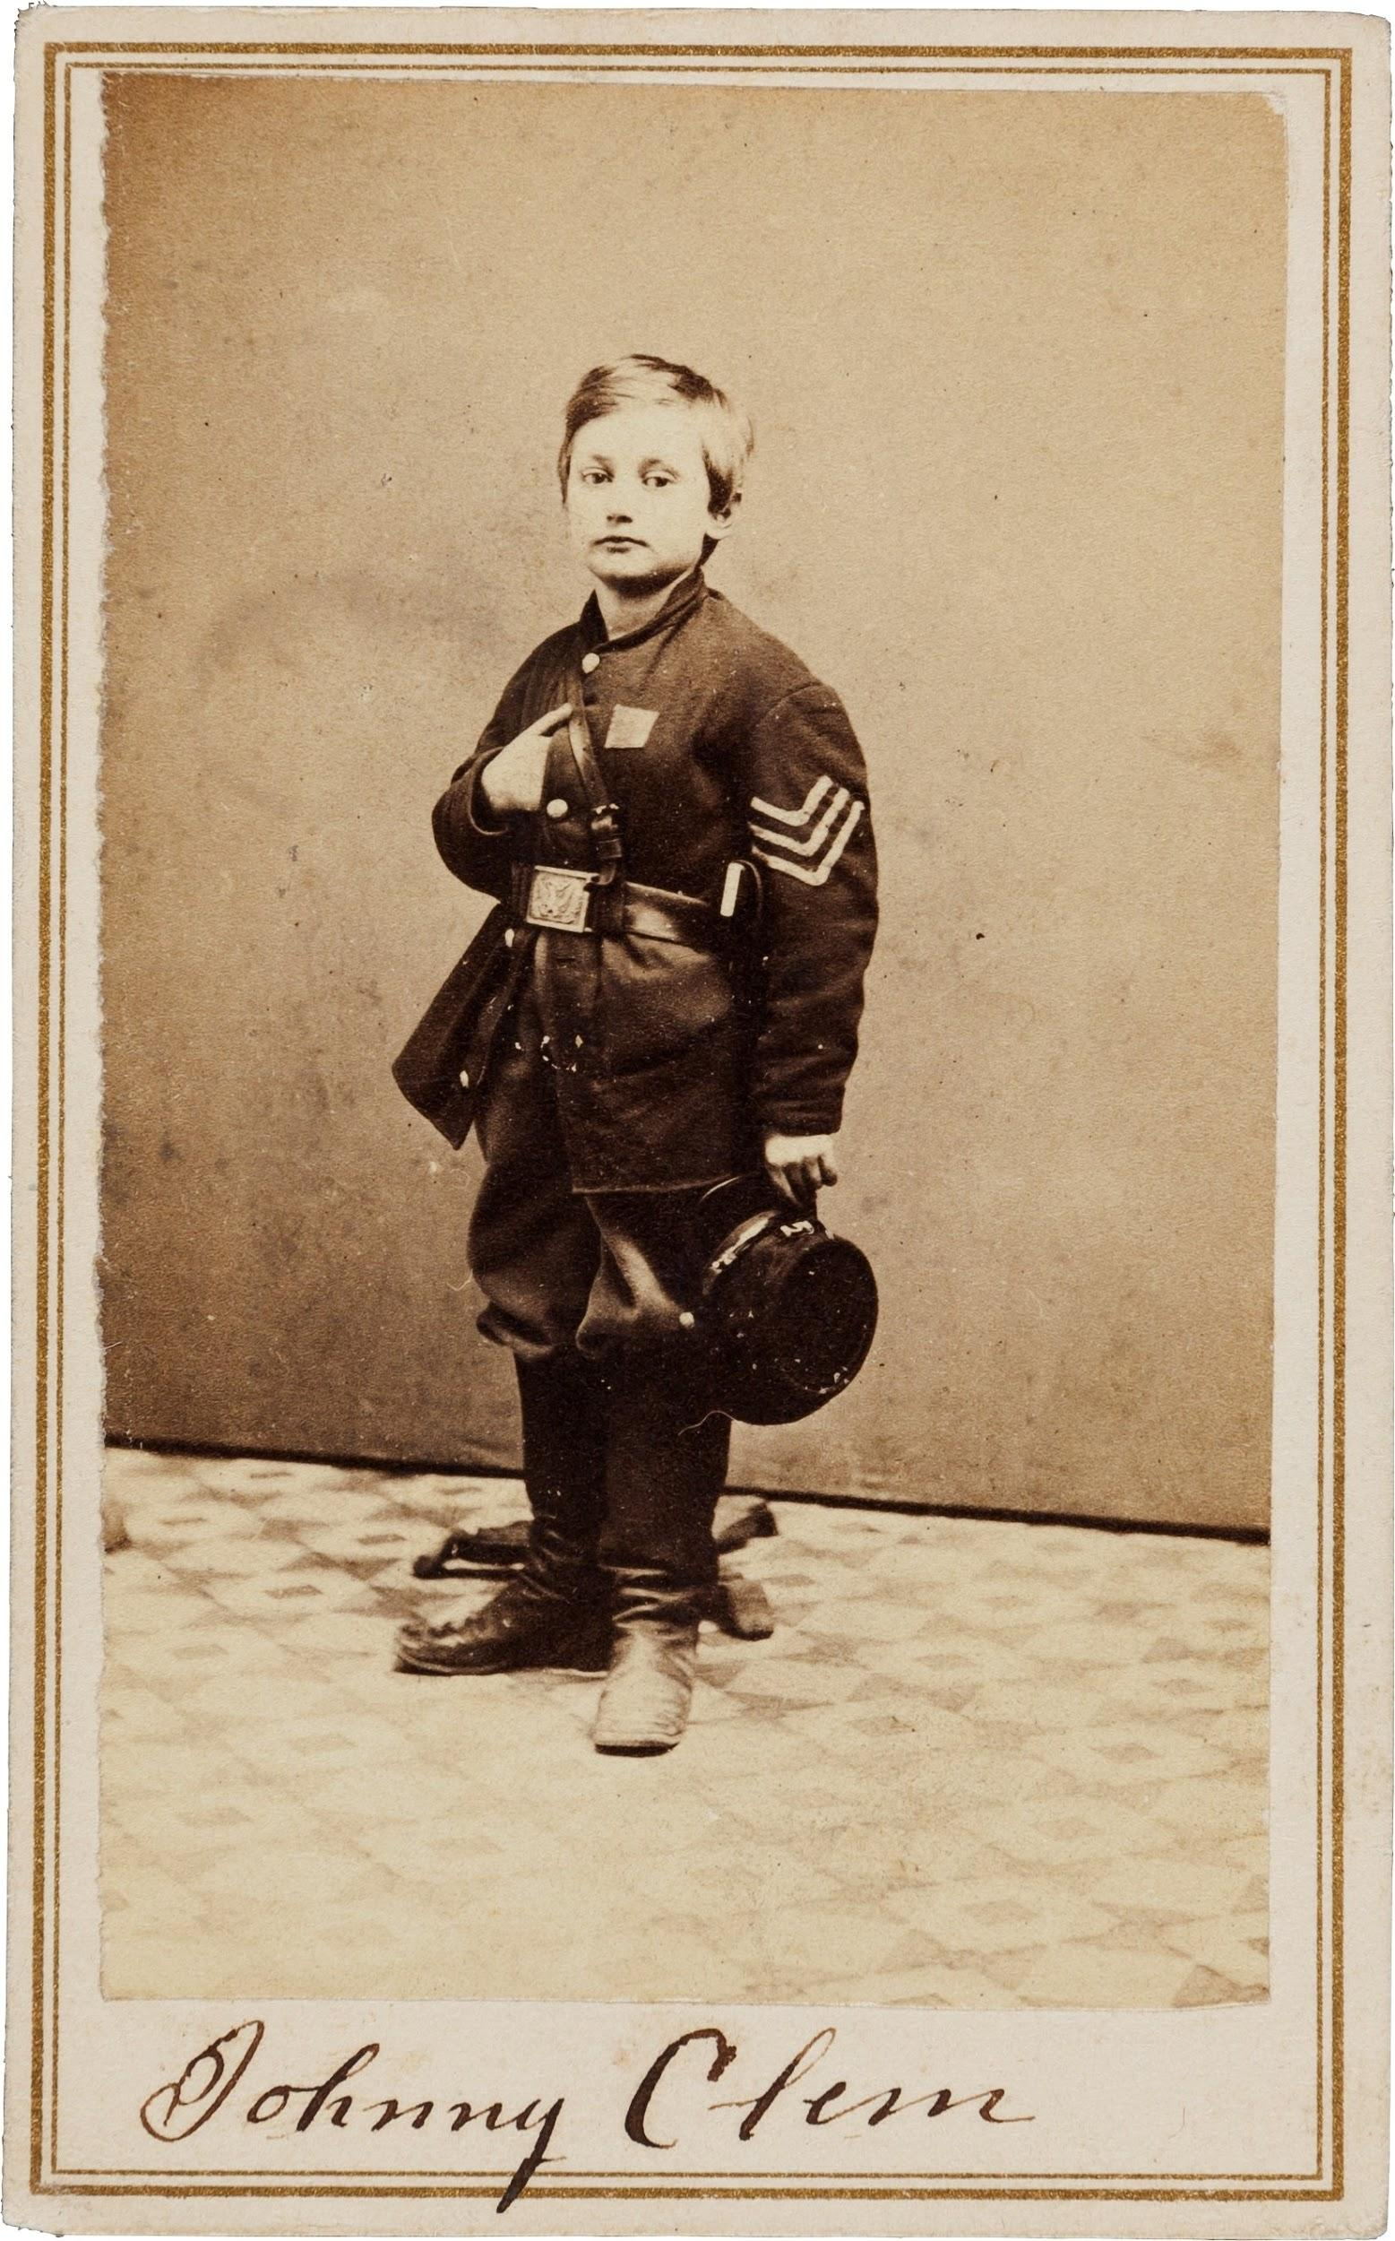  “I am a Union Army drummer boy. I ran away from home when I was 9 to join the Union Army, but I was denied twice. Instead, I tagged along anyway, and the 22nd Michigan Infantry adopted me. They let me officially enlist on my 11th birthday. After the Battle of Chickamauga, I was promoted to sergeant.”  Heritage Auctions. (1865). Civil War Union signed carte de viste of drummer boy Johnny Clem. Wikimedia Commons. Retrieved from https://commons.wikimedia.org/wiki/File:John_Clem_signed_CDV.jpg
You are Harriet Tubman.  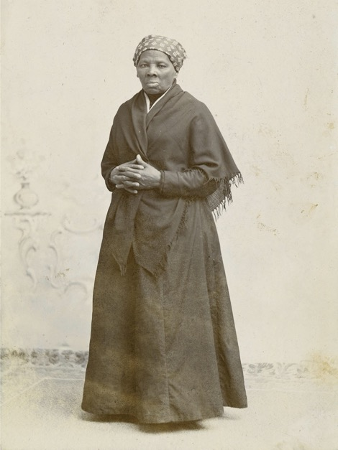  “I was born a slave, and as a child as young as 5, I was rented out by my owners to neighbors as a domestic servant. When I was 12, I suffered head injuries as I tried to keep my master from beating another slave. Two of my brothers and I used a network of escape routes and safe houses in 1849 to escape to the North. This network is known as the Underground Railroad, and I have helped nearly 70 other enslaved men and women use it to escape to free states and Canada. I still participate in antislavery efforts, including supporting John Brown’s raid on Harpers Ferry.”  Squyer, H.S. (1885). Portrait of Harriet Tubman. National Portrait Gallery. Retrieved from https://commons.wikimedia.org/wiki/File:Harriet_Tubman_by_Squyer,_NPG,_c1885.jpg | You are Stand Watie.  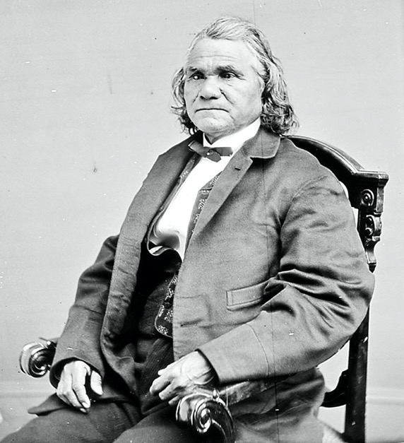  “I am the Principal Chief of the Cherokee Nation, and I serve as a general in the Confederate Army commanding the Confederate Indian cavalry. When I was younger, I served as a clerk for the Cherokee Supreme Court, and I was among the minority of tribe members who supported removal to the western Cherokee Nation.”  N.a. (n.d.). Portrait of Stand Watie as leader of the Treaty Party of the Cherokee Nation. Wikimedia Commons. Retrieved from https://en.wikipedia.org/wiki/Stand_Watie#/media/File:Stand_Watie.jpg | You are George Kye.  No Known Photo  “I am a slave on Abraham Stover’s Arkansas plantation. I served in the Confederate Army as a substitute for my master. ‘When the war come along, I was a grown man, and I went off to serve because old Master was too old to go, but he had to send somebody anyways. I served as George Stover, but every time the sergeant would call ‘Abe Stover,’ I would answer ‘Here.’”  N.a. (2006 August). Man silhouette. Wikimedia Commons. Retrieved from https://commons.wikimedia.org/wiki/File:Man_silhouette.svg
You are Michael Corcoran.  “I am a general in the Union Army. I was born in Ballymote, Ireland, and I emigrated to the United States when I was 22 years old. I enlisted in the 69th New York Militia, and as colonel, I refused to march my regiment on parade for the Prince of Wales to protest the British imposition of the Irish Famine. I was removed from command, but once the Civil War broke out, I was restored to command, because I was instrumental in bringing other Irish immigrants to the Union cause. I led my regiment into action at the First Battle of Bull Run.”  Brady, M. (1865). Gen. Michael Corcoran. U.S. National Archives and Records Administration. Retrieved from https://commons.wikimedia.org/wiki/File:Gen._Michael_Corcoran_-_NARA_-_528494.jpg | You are William Harvey Carney.  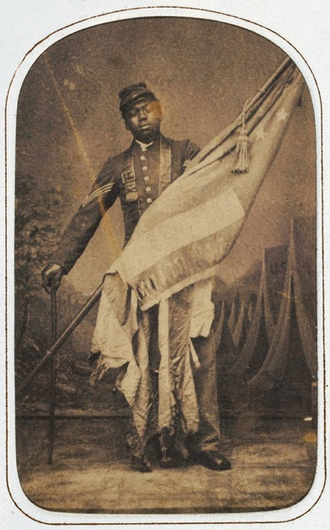  “I was born in slavery in Virginia, and with my family, I escaped servitude on the Underground Railroad, a network of escape routes and safe houses that allowed slaves to flee to free states and Canada. I signed up to join the war in 1863 after President Lincoln signed a decree allowing African Americans to serve in the Union Army. I planted the flag atop Fort Wagner in South Carolina. As a result, I am the first African American soldier to receive the Medal of Honor.”  Ritchie, J. (c. 1864). William Harvey Carney. National Museum of African American History & Culture. Retrieved from https://commons.wikimedia.org/wiki/File:William_Harvey_Carney_c1864.jpg | You are Mathew Brady.  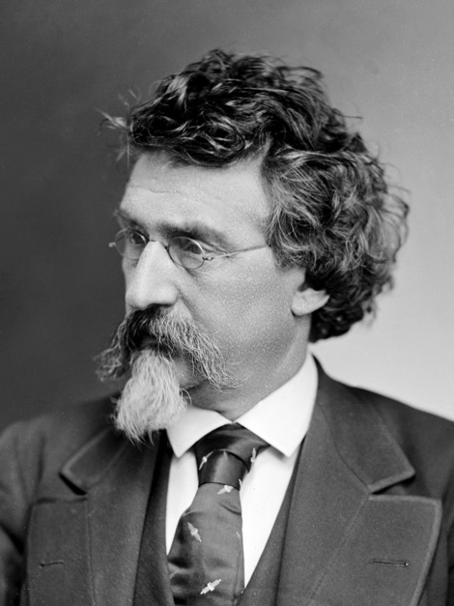  “I was born in New York to Irish immigrants. I was tutored by Samuel Morse, the inventor of the telegraph, in the newly developed technology of daguerreotype, an early type of photography. At the outbreak of the Civil War, I worked to document and photograph the war. I organized a group of photographers to follow the troops as the first field photographers. I shocked the nation when my exhibit, “The Dead of Antietam,” revealed the first photographs of the carnage of the war to the public.”  N.A. (1875). Mathew Brady. Brady-Handy Photograph Collection, Library of Congress. Retrieved from https://commons.wikimedia.org/wiki/File:Mathew_Brady_circa_1875.png
You are Mary Jane Richards.  No Known Photo  “I have many names, including Mary Elizabeth Bowser. I was born a slave in Virginia, but I was baptized in a predominantly white church and attended school. I even joined a white missionary and a group of black emigrants on a trip to Liberia, where I lived for five years. When I returned from Liberia, I was employed by Elizabeth Van Lew as a Union spy. So far, I have helped secure food and medicine for Union soldiers, and I have even helped some escape.”  N.a. (2006 August). Man silhouette. Wikimedia Commons. Retrieved from https://commons.wikimedia.org/wiki/File:Man_silhouette.svg | You are Loreta Janeta Velazquez.  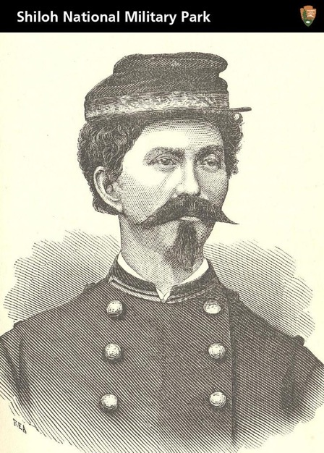  “I was born in Cuba, but I went to school in New Orleans. I moved to Texas after I eloped. Once Texas seceded from the Union, my husband joined the Confederate Army. He would not take me with him, so I had a uniform made, and I disguised myself as a man named Harry Buford. I raised a regiment of volunteers in Arkansas and brought them to my husband in Florida, where I presented myself as their commanding officer. I fought in the First Battle of Bull Run, and then I donned a dress and gathered intelligence in Washington, D.C., for the Confederacy.”  TradingCardsNPS. (2012, May 18). Civil War Soldier, Spy, and Author. Wikimedia Commons. Retrieved from https://commons.wikimedia.org/wiki/File:Civil_War_Soldier,_Spy,_and_Author_(7223011484).jpg

