You are President Abraham Lincoln.  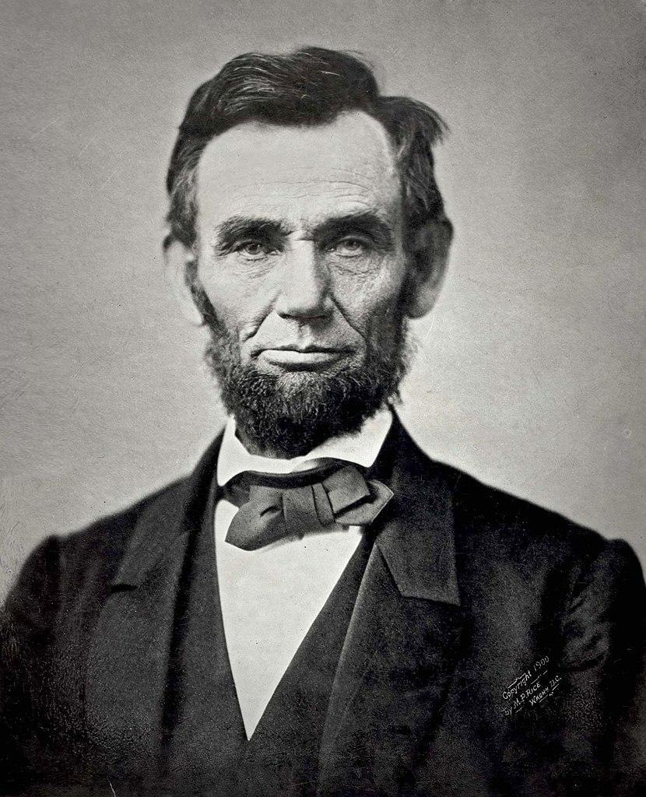  “I am the 16th President of the United States of America. I am modernizing the U.S. economy, and I want to preserve the Union. I am currently working with Congress to ratify the Thirteenth Amendment to the Constitution of the United States, which would outlaw slavery across the country. I denounced the Dred Scott v. Sandford decision because I think that it is a conspiracy to continue slavery.”  Gardner, A. (1863). Abraham Lincoln November 1863 [Image]. Wikimedia Commons. https://commons.wikimedia.org/wiki/File:Abraham_Lincoln_November_1863.jpg | You are General Robert E. Lee.  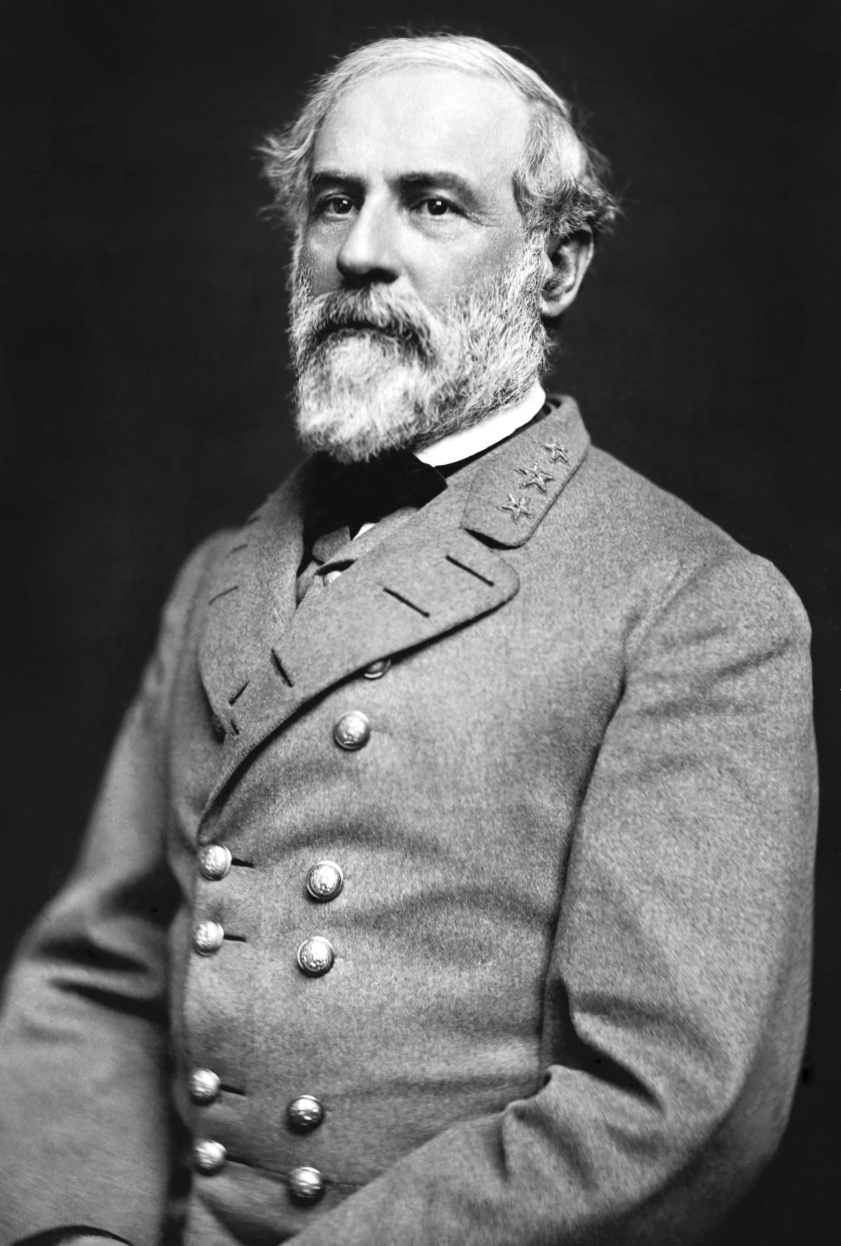  “I am a general of the Confederate Army. I was previously offered the command of the federal forces, but I resigned from the army after Virginia seceded, because I will not fight against my own people. I own Custis-Lee Mansion at Arlington and am executor of the estate. My family owns 196 slaves.”  Vannerson, J. (1864, March). Portrait of Gen. Robert E. Lee, officer of the Confederate Army [Image]. Wikimedia Commons. https://commons.wikimedia.org/wiki/File:Robert_Edward_Lee.jpg | You are John Lincoln Clem.  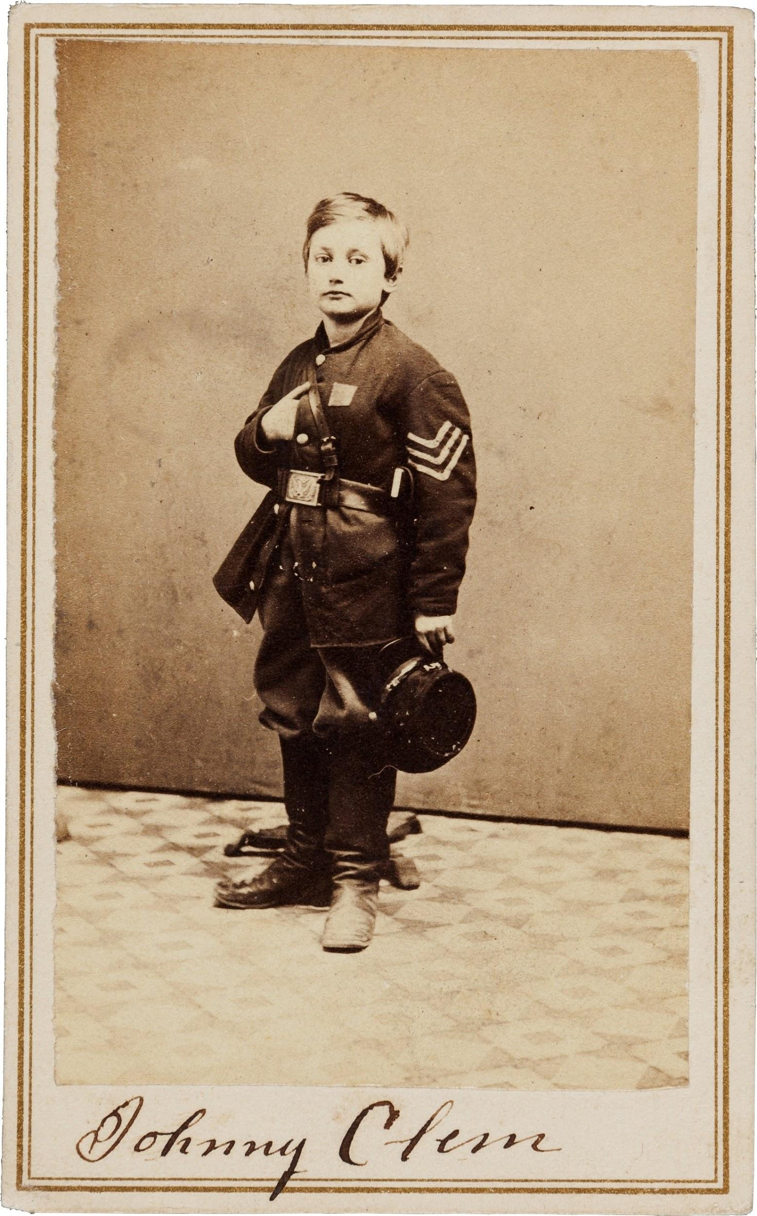  “I am a Union Army drummer boy. I ran away from home when I was 9 to join the Union Army, but I was denied twice. Instead, I tagged along anyway, and the 22nd Michigan Infantry adopted me. They let me officially enlist on my 11th birthday. After the Battle of Chickamauga, I was promoted to sergeant.”  Heritage Auctions. (1865). Civil War Union signed carte de viste of drummer boy Johnny Clem [Image]. Wikimedia Commons. https://commons.wikimedia.org/wiki/File:John_Clem_signed_CDV.jpg
You are Harriet Tubman.  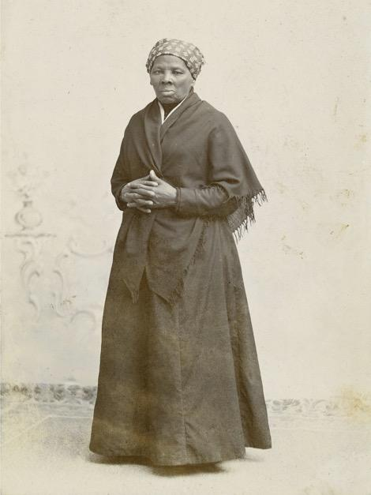  “I was born a slave, and as a child as young as 5, I was rented out by my owners to neighbors as a domestic servant. When I was 12, I suffered head injuries when I tried to keep my master from beating another slave. Two of my brothers and I used a network of escape routes and safe houses in 1849 to escape to the North. This network is known as the Underground Railroad, and I have helped nearly 70 other enslaved men and women use it to escape to free states and Canada. I still participate in antislavery efforts, including supporting John Brown’s raid on Harpers Ferry.”  Squyer, H.S. (1885). [Portrait photograph of Harriet Tubman]. Wikimedia Commons. https://commons.wikimedia.org/wiki/File:Harriet_Tubman_by_Squyer,_NPG,_c1885.jpg | You are Stand Watie.  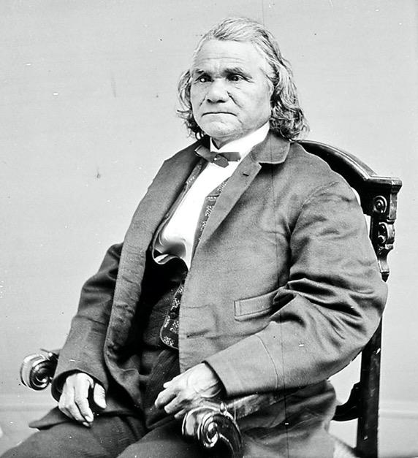  “I am the Principal Chief of the Cherokee Nation, and I serve as a general in the Confederate Army commanding the Confederate Indian cavalry. When I was younger, I served as a clerk for the Cherokee Supreme Court, and I was among the minority of tribe members who supported removal to the western Cherokee Nation.”  Isaac Stand Watie Degataga [Image]. (1871). Wikimedia Commons. https://commons.wikimedia.org/wiki/File:Stand_Watie.jpg | You are George Kye.    No Known Photo  “I am a slave on Abraham Stover’s Arkansas plantation. I served in the Confederate Army as a substitute for my master. When the war come along, I was a grown man, and I went off to serve because old Master was too old to go, but he had to send somebody anyways. I served as George Stover, but every time the sergeant would call ‘Abe Stover,’ I would answer ‘Here.’”  liftarn. (2006, August 30). Man silhouette [Image]. Wikimedia Commons. https://commons.wikimedia.org/wiki/File:Man_silhouette.svg
You are Michael Corcoran.  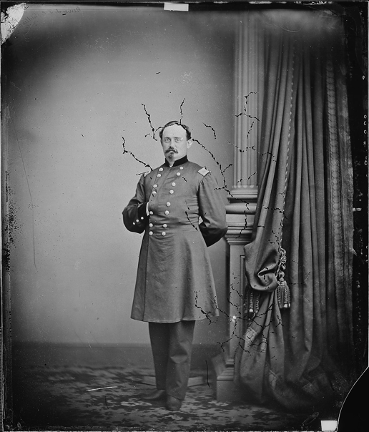  “I am a general in the Union Army. I was born in Ballymote, Ireland, and I emigrated to the United States when I was 22 years old. I enlisted in the 69th New York Militia, and as a colonel, I refused to march my regiment on parade for the Prince of Wales to protest the British imposition of the Irish Famine. I was removed from command, but once the Civil War broke out, I was restored to command, because I was instrumental in bringing other Irish immigrants to the Union cause. I led my regiment into action at the First Battle of Bull Run.”  Brady, M. B. (1860). Gen. Michael Cocoran [Photograph]. Wikimedia Commons. https://commons.wikimedia.org/wiki/File:Gen._Michael_Corcoran_-_NARA_-_528494.jpg | You are William Harvey Carney.  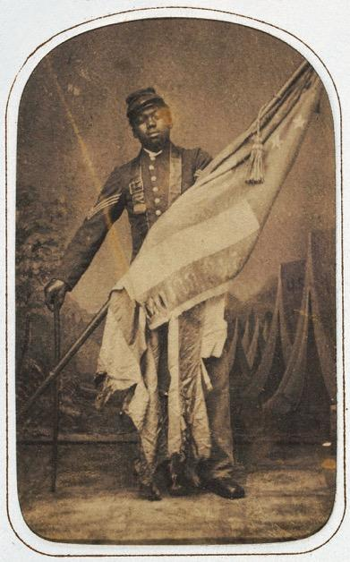  “I was born in slavery in Virginia. With my family, I escaped servitude on the Underground Railroad, a network of escape routes and safe houses that allowed slaves to flee to free states and Canada. I signed up to join the war in 1863 after President Lincoln signed a decree allowing African Americans to serve in the Union Army. I planted the flag atop Fort Wagner in South Carolina. As a result, I am the first African American soldier to receive the Medal of Honor.”  Ritchie, J. (ca. 1864). William Harvey Carney [Image]. Wikimedia Commons. https://commons.wikimedia.org/wiki/File:William_Harvey_Carney_c1864.jpg | You are Mathew Brady.  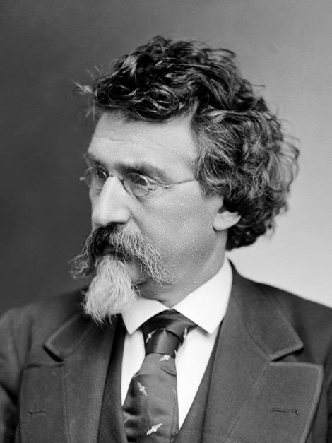  “I was born in New York to Irish immigrants. I was tutored by Samuel Morse, the inventor of the telegraph, in the newly developed technology of daguerreotype, an early type of photography. At the outbreak of the Civil War, I worked to document and photograph the war. I organized a group of photographers to follow the troops as the first field photographers. I shocked the nation when my exhibit, “The Dead of Antietam,” revealed the first photographs of the carnage of the war to the public.”  Mathew Brady circa 1875 [Photograph]. (ca. 1875). Wikimedia Commons. https://commons.wikimedia.org/wiki/File:Mathew_Brady_circa_1875.png
You are Mary Jane Richards.  No Known Photo  “I have many names, including Mary Elizabeth Bowser. I was born a slave in Virginia, but I was baptized in a predominantly white church and attended school. I even joined a white missionary and a group of black emigrants on a trip to Liberia, where I lived for five years. When I returned from Liberia, I was employed by Elizabeth Van Lew as a Union spy. So far, I have helped secure food and medicine for Union soldiers, and I have even helped some escape.”  liftarn. (2006, August 30). Man silhouette [Image]. Wikimedia Commons. https://commons.wikimedia.org/wiki/File:Man_silhouette.svg | You are Loreta Janeta Velazquez.  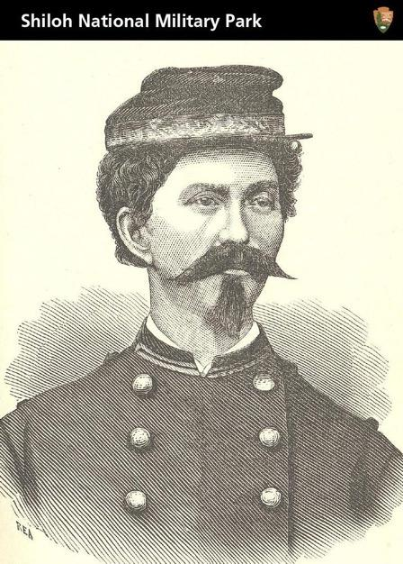  “I was born in Cuba, but I went to school in New Orleans. I moved to Texas after I eloped. Once Texas seceded from the Union, my husband joined the Confederate Army. He would not take me with him, so I had a uniform made, and I disguised myself as a man named Harry Buford. I raised a regiment of volunteers in Arkansas and brought them to my husband in Florida, where I presented myself as their commanding officer. I fought in the First Battle of Bull Run, and then I donned a dress and gathered intelligence in Washington, D.C., for the Confederacy.”  TradingCardsNPS. (2012, May 18). Civil War soldier, spy, and author [Image]. Wikimedia Commons. https://commons.wikimedia.org/wiki/File:Civil_War_Soldier,_Spy,_and_Author_(7223011484).jpg

