TWO-VOICE POEM

Use your knowledge of the Civil War to create a Two-Voice Poem. Feature the voices of people who are not traditionally represented in historical discussions, such as women, immigrants, African Americans (free or enslaved), or American Indians.
I AM…
WE ARE…
I AM…

I FEEL…
WE FEEL…
I FEEL…

I BELIEVE…
WE BELIEVE…
I BELIEVE…

I FEAR…
WE FEAR…

I FEAR…

I HOPE…
WE HOPE...

I HOPE…

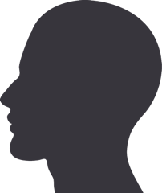
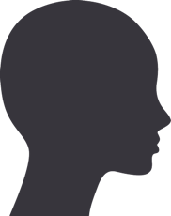
WE ARE…

I AM…
I AM…

