PAINT A PICTURE—PHOTO SET

Photograph #1

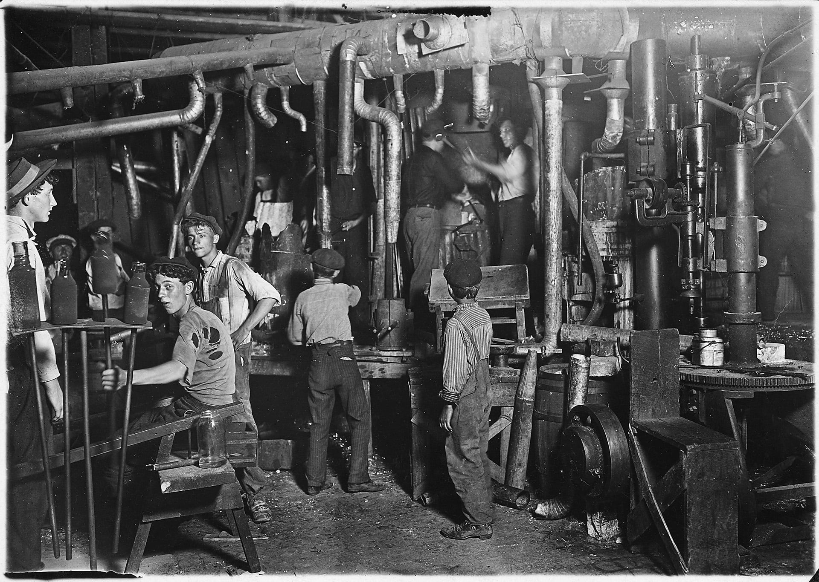
9 P.M. in an Indiana Glass Works. Indiana, 1908.

Library of Congress. (1908). 9 P.M. in an Indiana Glass Works, Aug. 1908. Location: Indiana. Library of Congress Prints and Photographs Division Washington, D.C. 20540 USA. Retrieved from https://hdl.loc.gov/loc.pnp/nclc.01166

Photograph #2

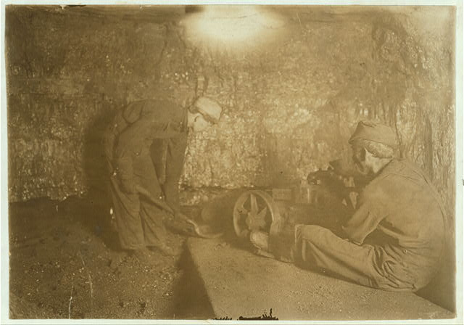
Man with punching machine [preparing] to drill into coal. Boy shovels out 10 [hours] daily. Red Star, West Virginia.

Library of Congress. (n.d.). National Child Labor Committee, No. 69. Man with punching machine to drill into coal. Boy shovels out 10 hrs. daily, Laura Mine, Red Star, W. Va. Location: Red Star, West Virginia.. Library of Congress Prints and Photographs Division Washington, D.C. 20540 USA. Retrieved from https://hdl.loc.gov/loc.pnp/nclc.01048

Photograph #3

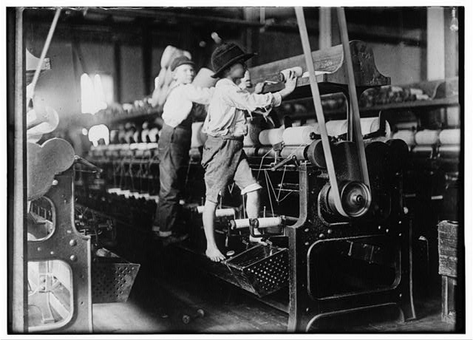
Many youngsters here. Some boys were so small they had to climb up on the spinning frame to mend the broken threads and put back the empty bobbins. Macon, Georgia.

Library of Congress (1909, January 19). 488 Macon, Ga. Lewis W. Hine 1-19-1909. Bibb Mill No. 1 Many youngsters here. Some boys were so small they had to climb up on the spinning frame to mend the broken threads and put back the empty bobbins. Location: Macon, Georgia.. Library of Congress Prints and Photographs Division Washington, D.C. 20540 USA. Retrieved from https://hdl.loc.gov/loc.pnp/nclc.05394

Photograph #4

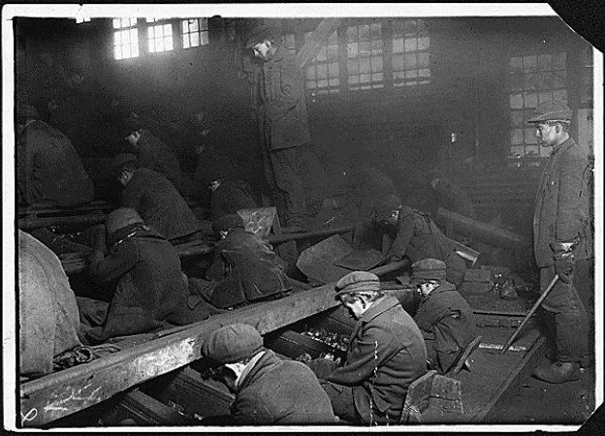
View of the Ewen Breaker of the Pa. Coal Co. The dust was so dense at times as to obscure the view. This dust penetrated the utmost recesses of the boys’ lungs. A kind of slave-driver sometimes stands over the boys, prodding or kicking them into obedience. Pittston, Pennsylvania, 1911.

Hine, L. (1912.). View of the Ewen Breaker of the Pa. Coal Co. The dust was so dense at times as to obscure the view. This dust penetrated the utmost recesses of the boy's lungs. A kind of slave-driver sometimes stands over the boys, prodding or kicking them into obedience. S. Pittston, Pa.. National Archives Catalog. Retrieved from https://catalog.archives.gov/id/523378

Photograph #5

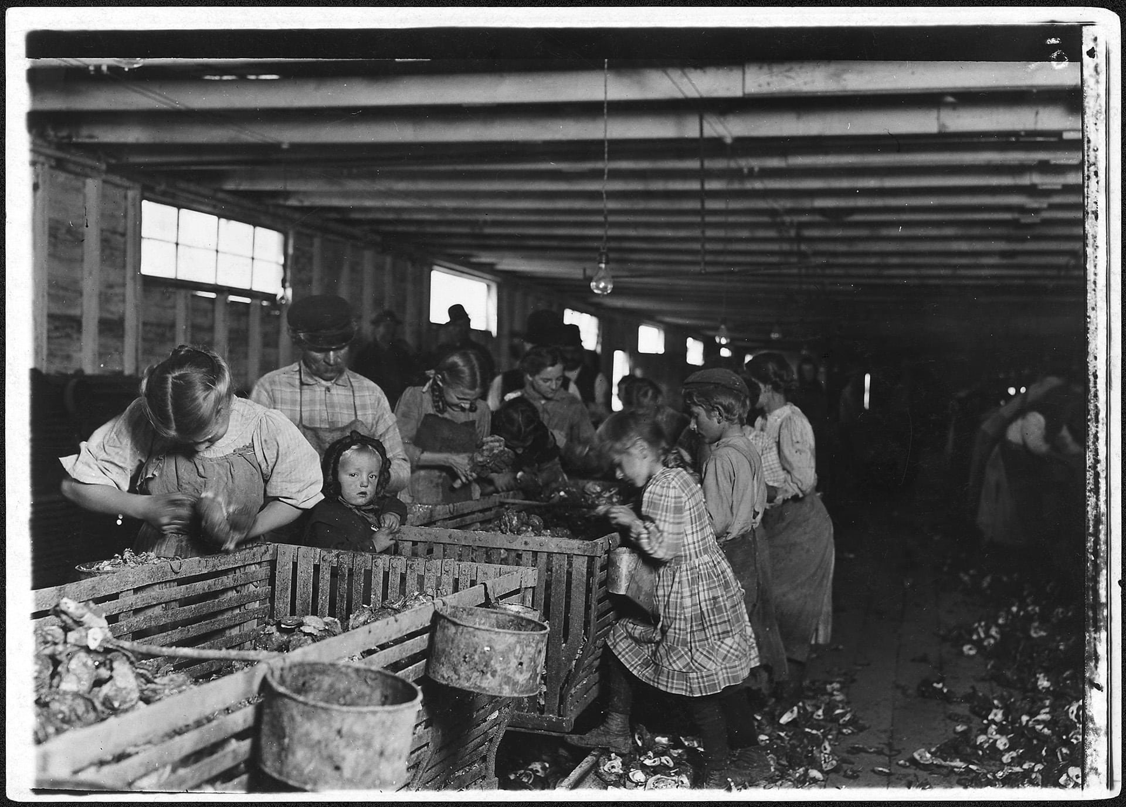
Rosy, an 8-year old oyster shucker, works steady all day from about 3 A.M. to 5 P.M. The baby will shuck as soon as she can handle the knife. Dunbar, Louisiana, 1911.

Hine, L. (1912.). Rosy, an 8 year old oyster shucker works steady all day from about 3 A.M. to 5 P.M. The baby will shuck as soon as she can handle the knife. Dunbar, La.. National Archives Catalog. Retrieved from https://catalog.archives.gov/id/523414

