AMERICAN Progress Photo deconstruction
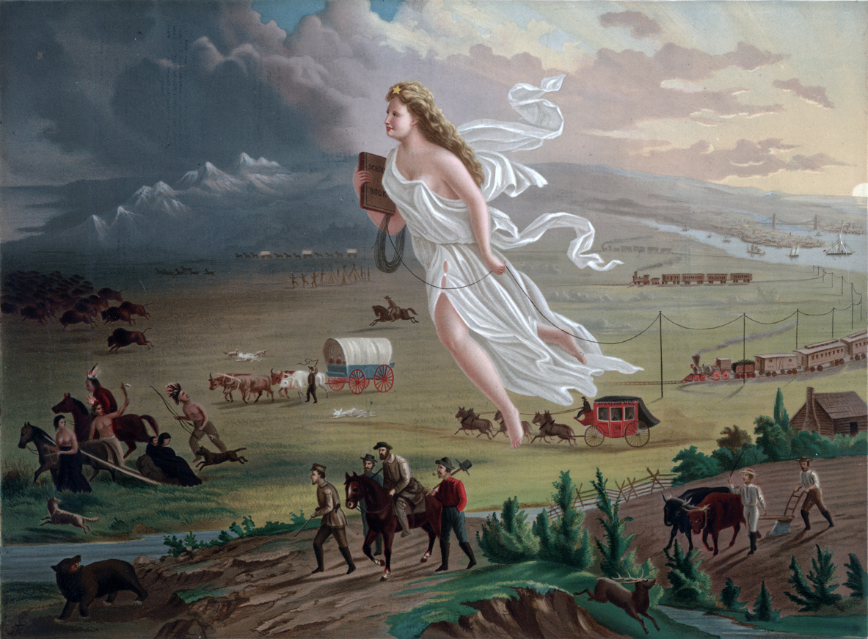

American Progress by John Gast, 1872

Observations (What do you see?) | Inferences (What conclusions can you make or interpret, based on what you see?)
Gast, J. (1872). American progress. Chromolithograph published by George A, Crofutt. Prints and Photographs Division, Library of Congress. https://upload.wikimedia.org/wikipedia/commons/f/fd/American_Progress_%28John_Gast_painting%29.jpg

