manifest destiny disputed
Document 1: Map of Native American nations and cultural regions during the 1800s
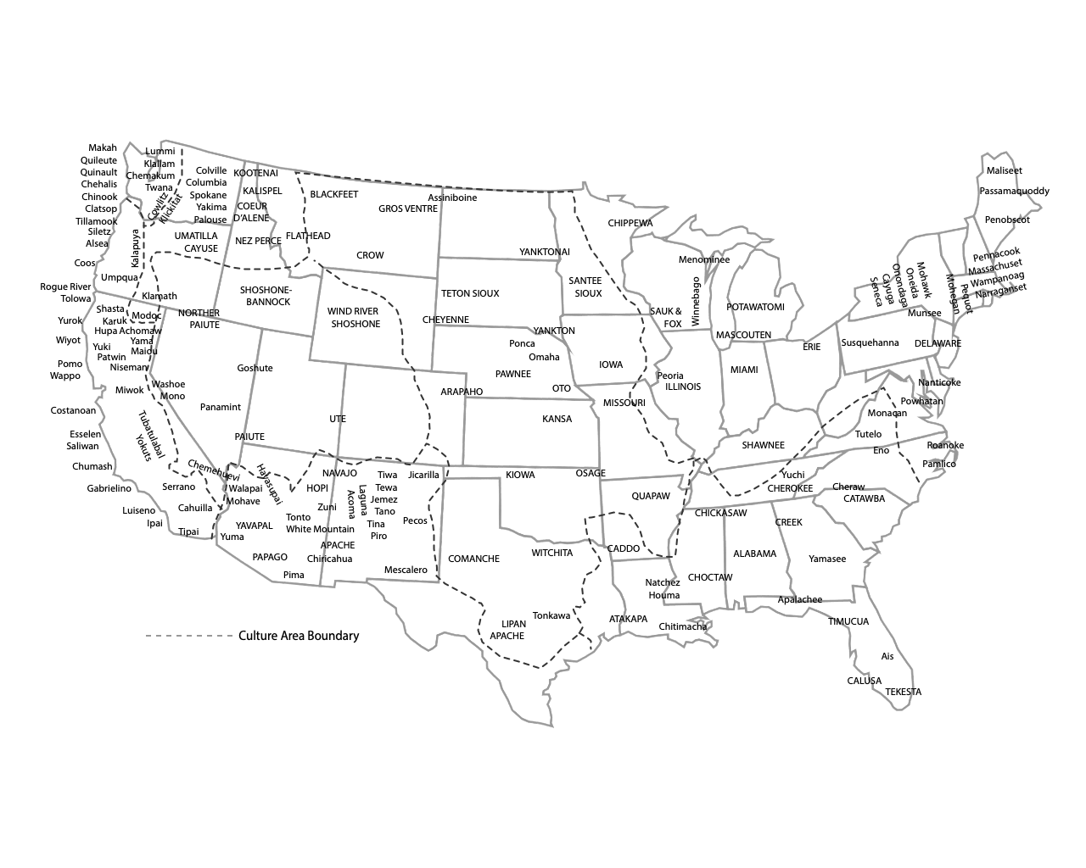

Document 2: Map of U.S. territorial claims in 1840.

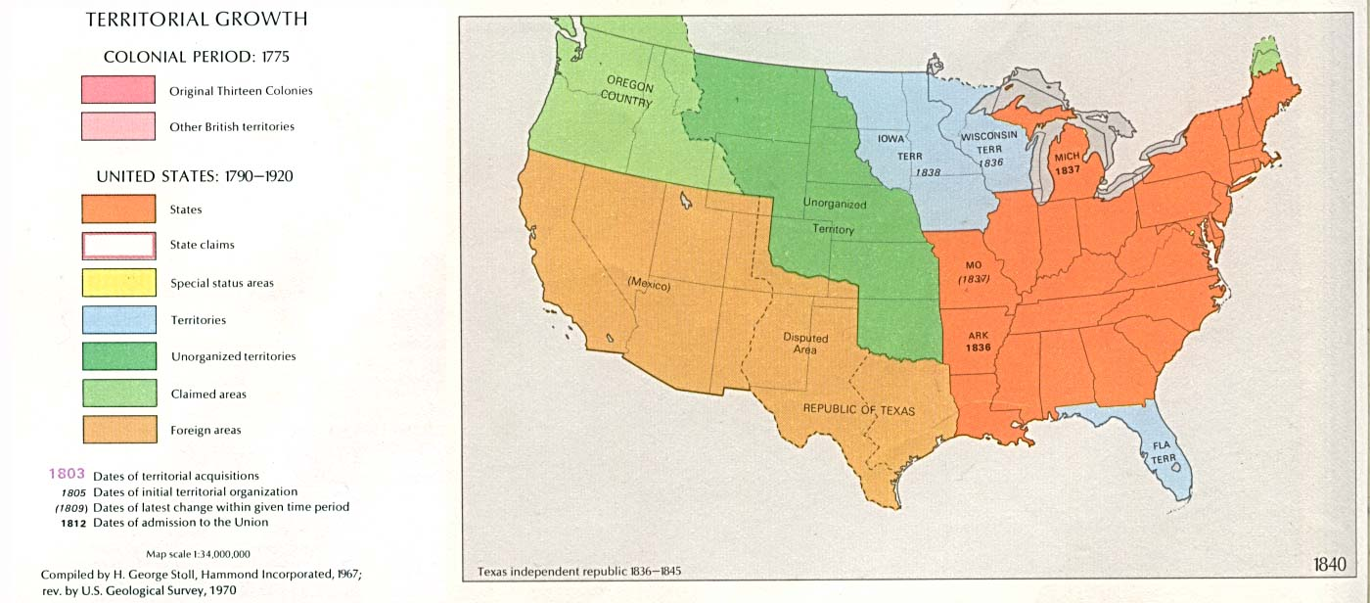
Document 3: In 1837, William E. Channing, Unitarian minister, wrote to Henry Clay, a US senator and former Republican nominee for president who was opposed to expansionism. Channing wrote:

It is [past] time that we [, the United States] should…[show] restraint. Possessed of [land], [big] enough for the growth of ages, it is time for us to stop [taking land] and [conquering].

It is sometimes said, that ... the Indians have melted before the white man, and the mixed, degraded race of Mexico must melt before the [white man]. Away with [these false arguments]!

There is no necessity for crime. There is no fate to justify [greedy] nations, any more than to justify gamblers and robbers, in plunder. We boast of the progress of society, [but] this progress [substitutes] reason and moral principle for the sway of brute force.

Reasons for Opposing Manifest Destiny
Document 1 | Document 2 | Document 3

National Museum of American History. (n.d.). Map of the Plains Indians [Map]. Smithsonian Institution. https://americanhistory.si.edu/buffalo/map.html
U.S. Geological Survey. (1970). U.S. territorial growth, 1840 [Map]. Wikimedia Commons. https://commons.wikimedia.org/wiki/File:USA_Territorial_Growth_1840.jpg
Lubragge, M. T. (n.d.). Manifest destiny: The philosophy that created a nation. American History: From Revolution to Reconstruction and Beyond. http://www.let.rug.nl/usa/essays/1801-1900/manifest-destiny/manifest-destiny---the-philosophy-that-created-a-nation.php#dis

