MANIFEST DESTINY DISPUTED

Document 1: Map of the territories occupied by various Native American tribes during the 1800s.

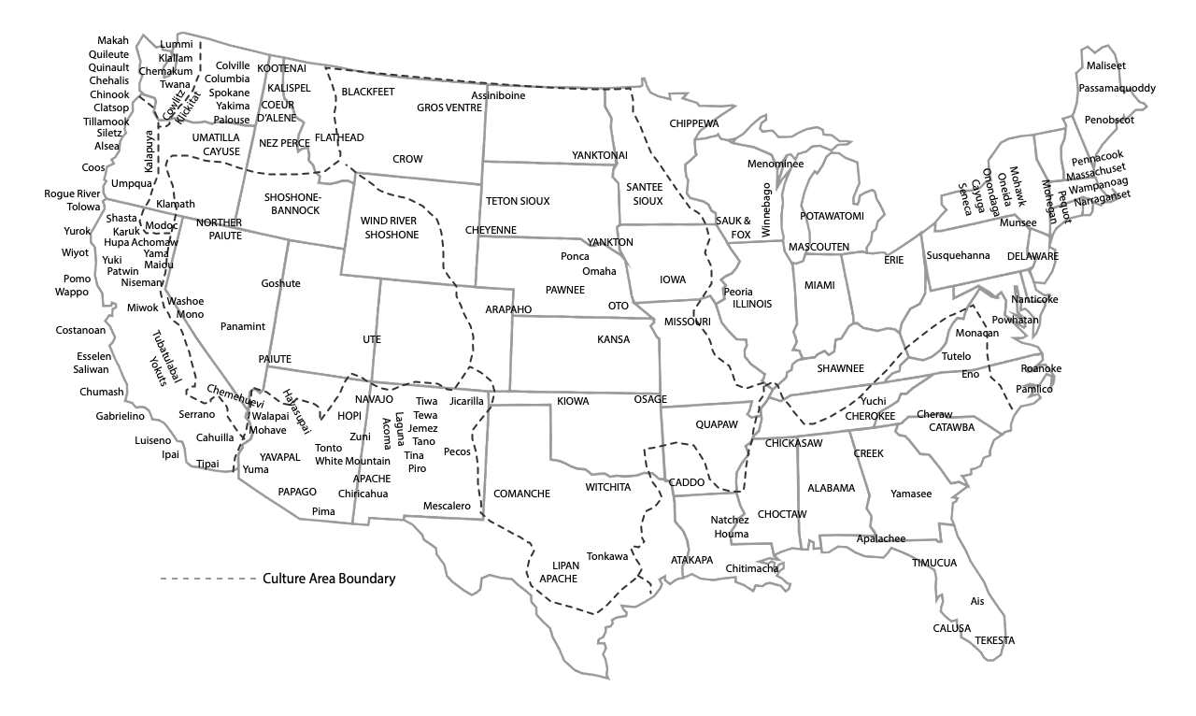

Document 2: Map of the United States in 1840.
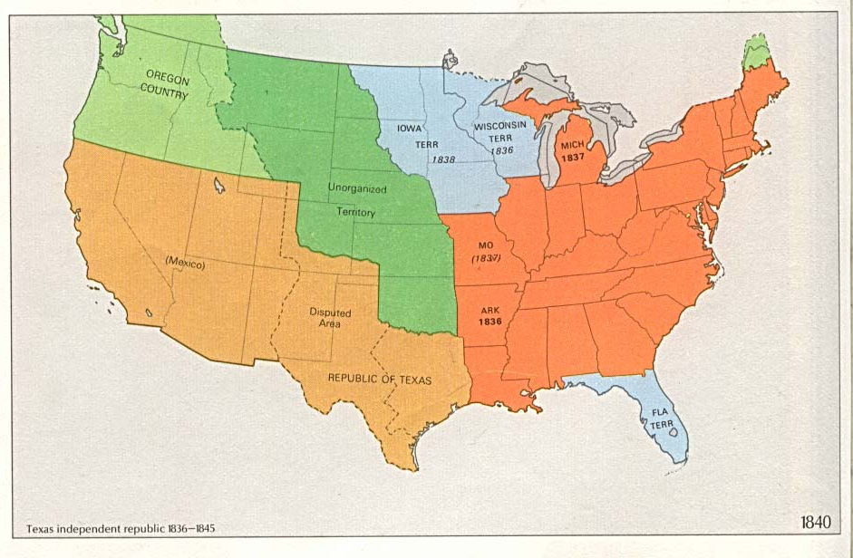

Document 3: In 1837, William E. Channing, Unitarian minister, wrote to Henry Clay, a US Senator and former Republican nominee for president who was opposed to expansionism. Channing wrote:

It is [past] time that we [, the United States] should…[show] restraint. Possessed of [land], [big] enough for the growth of ages, it is time for us to stop [taking land] and [conquering].

It is sometimes said, that ... the Indians have melted before the white man, and the mixed, degraded race of Mexico must melt before the [white man]. Away with [these false arguments]!

There is no necessity for crime. There is no fate to justify [greedy] nations, any more than to justify gamblers and robbers, in plunder. We boast of the progress of society, [but] this progress [substitutes] reason and moral principle for the sway of brute force.

Opposition to Manifest Destiny
Document 1 | Document 2 | Document 3

Sources:

Map of the Plains Indians. Retrieved from: https://americanhistory.si.edu/buffalo/map.html

U.S. Territorial Growth 1840. Retrieved from: https://commons.wikimedia.org/wiki/File:USA_
Territorial_Growth_1840.jpg

Lubbrage, M. (2012). Manifest destiny. Essays. American history: from revolution to reconstruction and beyond. Retrieved from: http://www.let.rug.nl/usa/essays/1801-1900/manifest-destiny/manifest-destiny---the-philosophy-that-created-a-nation.php#dis

