MOON PHASES WHEEL

Directions
- Cut out both the large Wheel A and Wheel B.
- Cut out the viewing window section in Wheel A.
- Place Wheel A on top of Wheel B and attach them with a brad in the center of the wheels.
- Draw the moon phase on each section of Wheel B.
- Rotate Wheel A on top of Wheel B to see each moon phase.
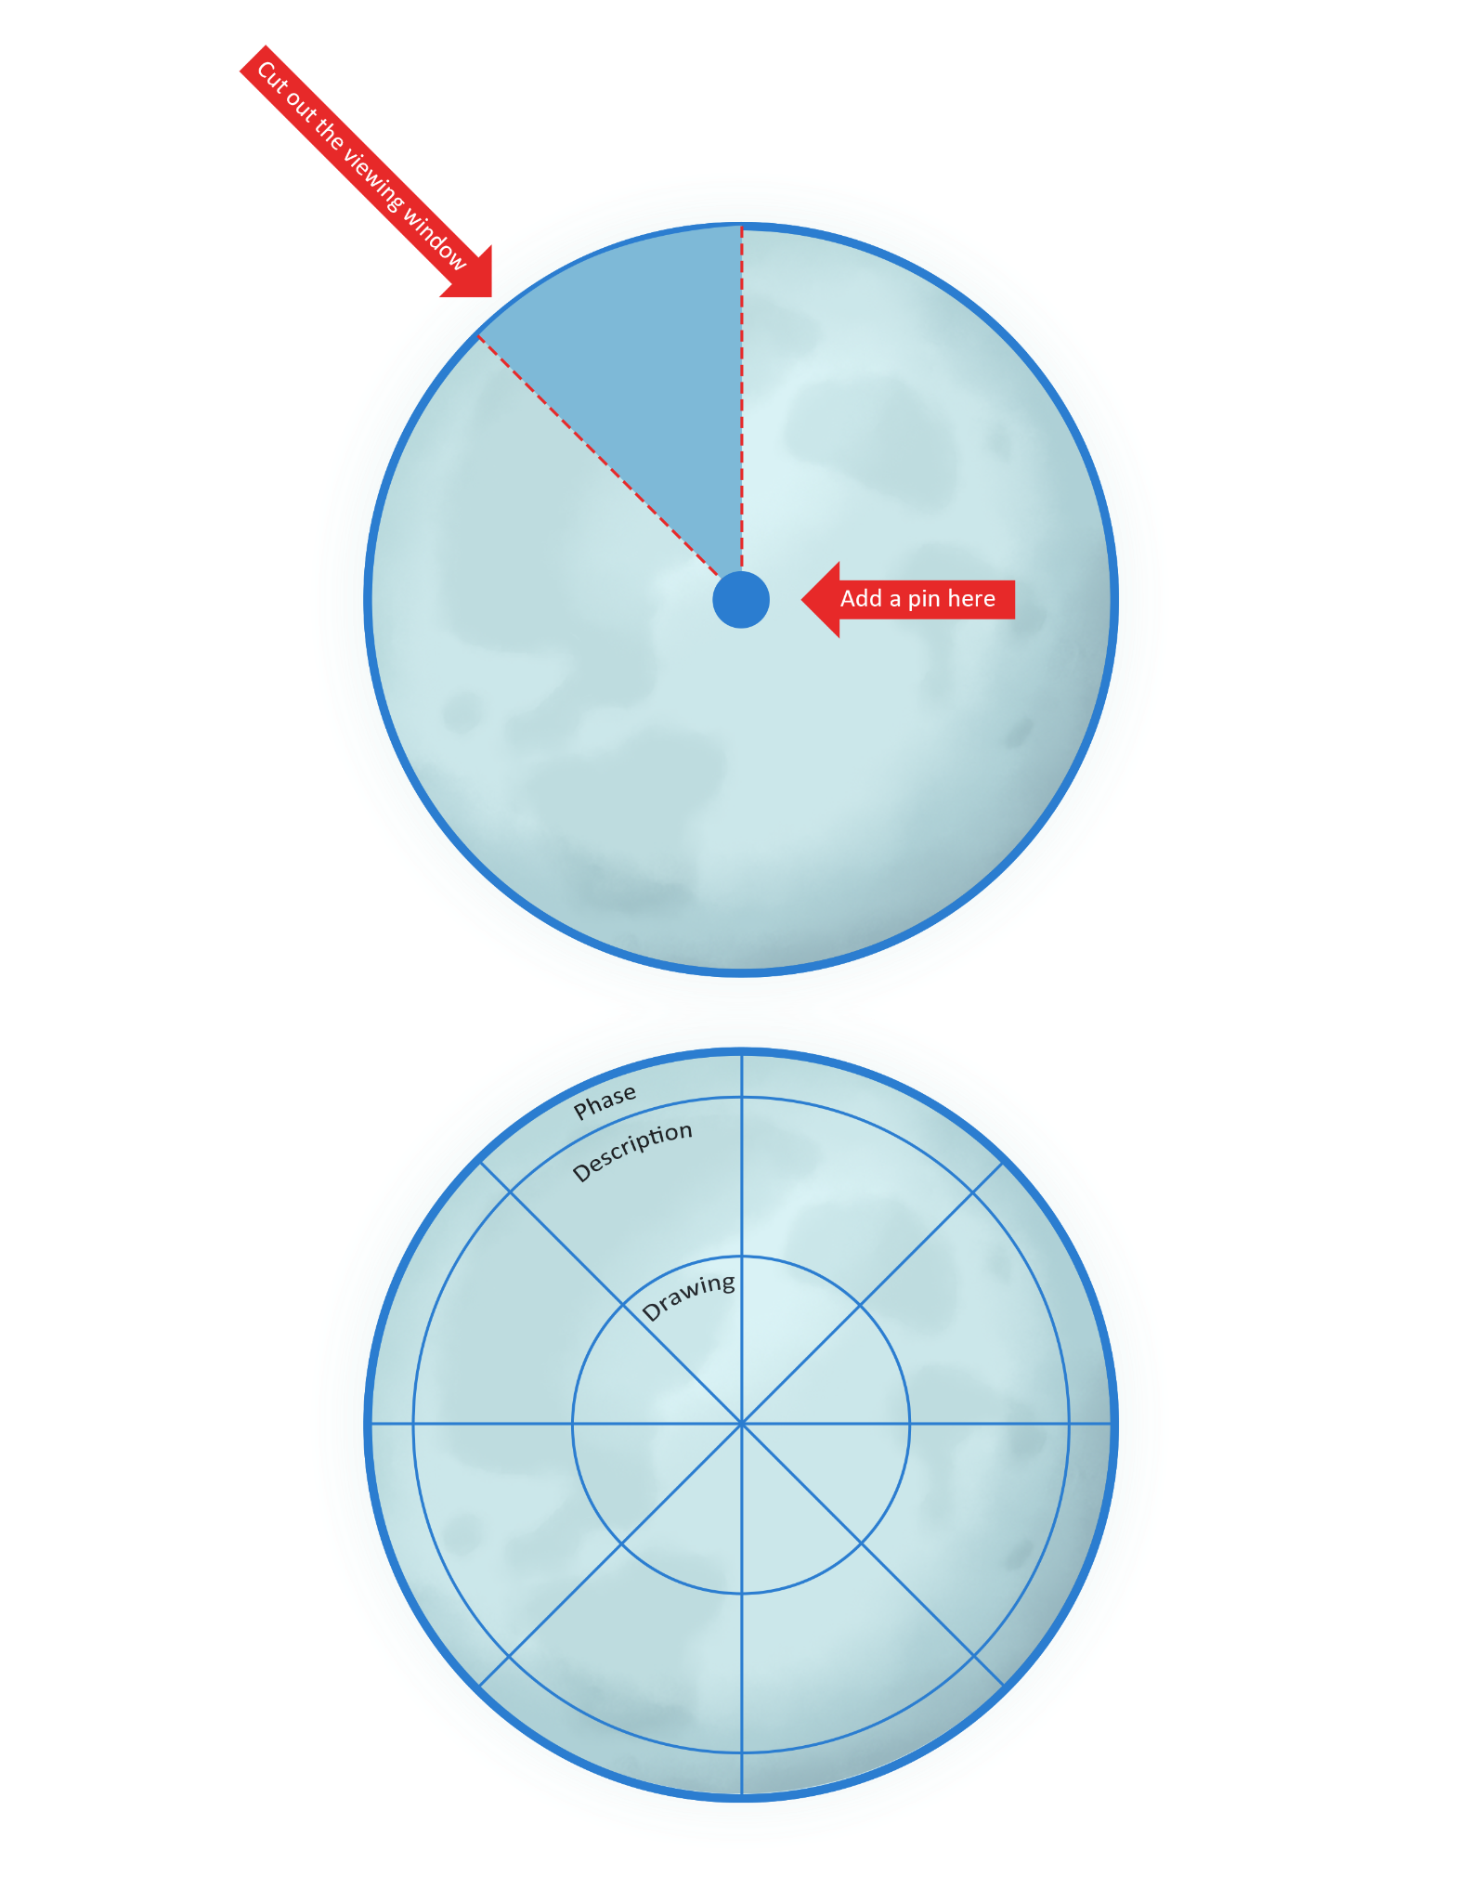
Wheel A

Viewing
Window

Wheel B

