HAND IT TO THE ANIMALS
Study the x-ray images of animal hands below and record notes about each image.
- Description: Describe the main features of each hand. Include details about the fingers, fingernails, claws, thickness of bones compared to length, number of joints on each finger, shape of the flesh, etc.
- Animal: Identify which animal the hand in the x-ray belongs to. Each hand belongs to one of the following animals: baboon, human, hyena, lion, macaque, monkey, owl, panda, sea lion, sun bear, zebra.
- Function: Determine a function of the hand (e.g., flying, swimming, grasping/manipulating, walking/running).

X-Ray 1 | X-Ray 2 | X-Ray 3 | X-Ray 4 | X-Ray 5
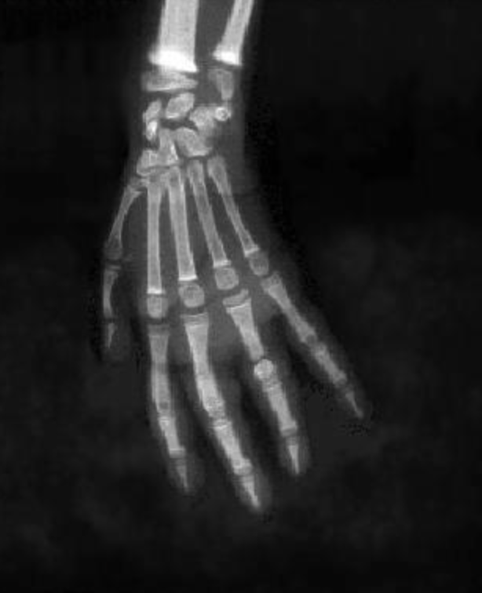 | 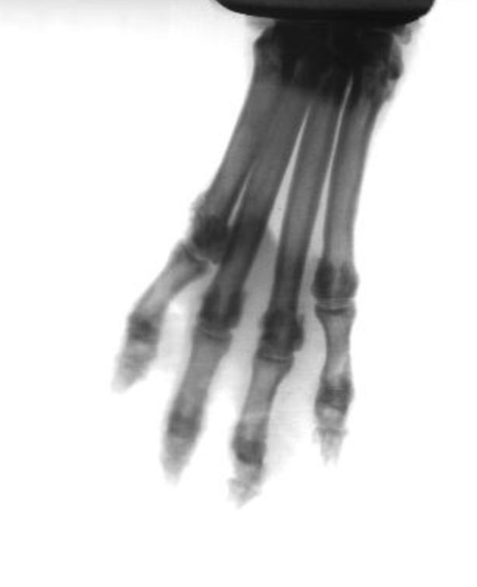 | 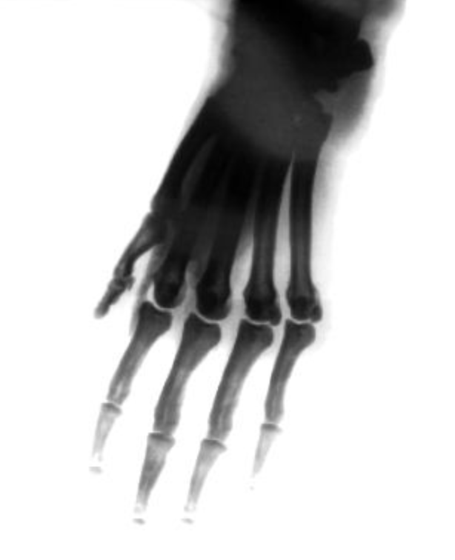 | 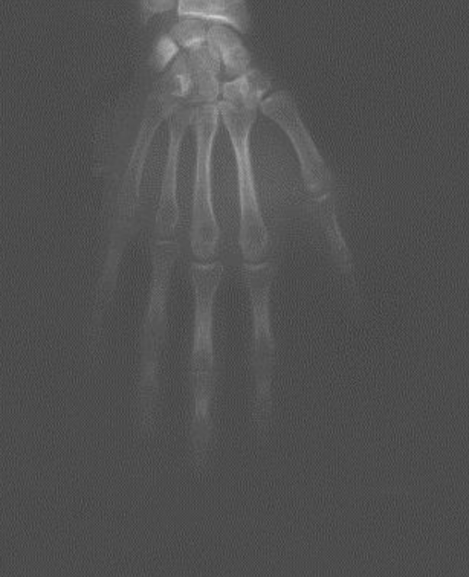 | 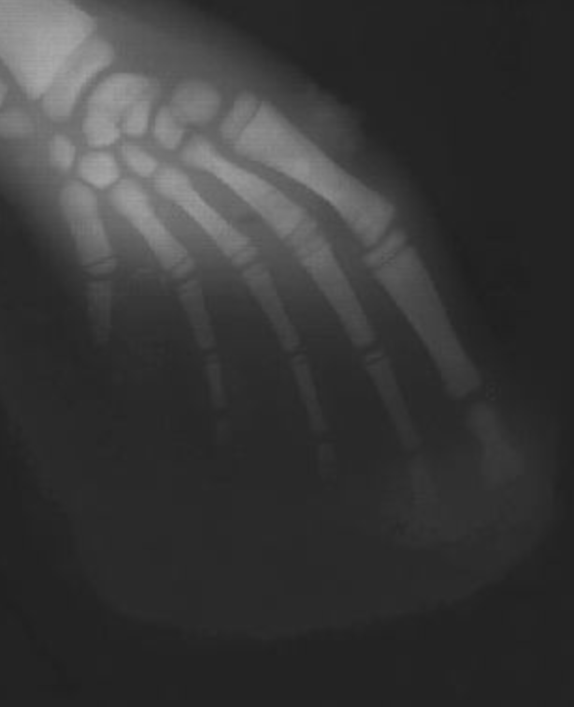
Description: | Description: | Description: | Description: | Description:
Animal:  Function: | Animal:  Function: | Animal:  Function: | Animal:  Function: | Animal:  Function:

X-Ray 6 | X-Ray 7 | X-Ray 8 | X-Ray 9 | X-Ray 10
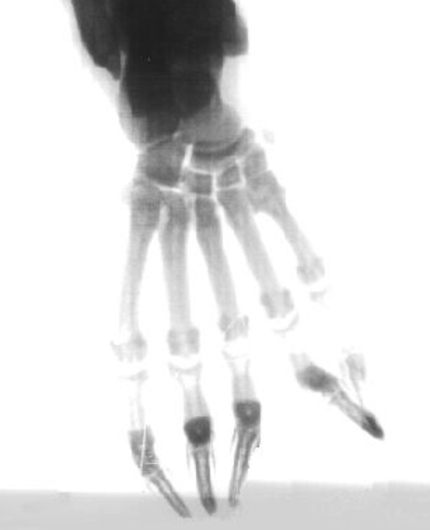 | 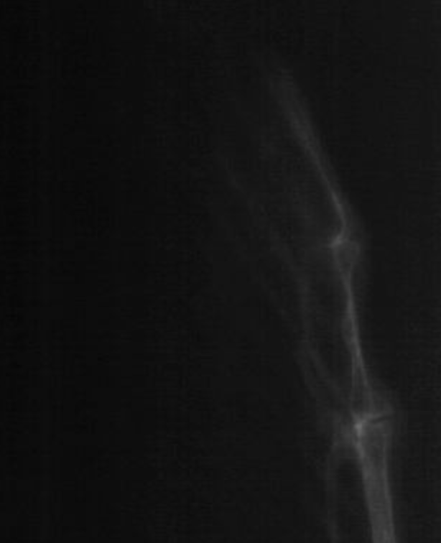 | 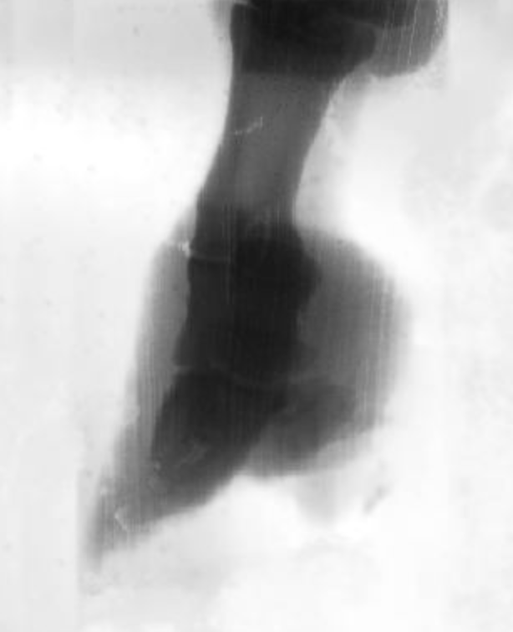 | 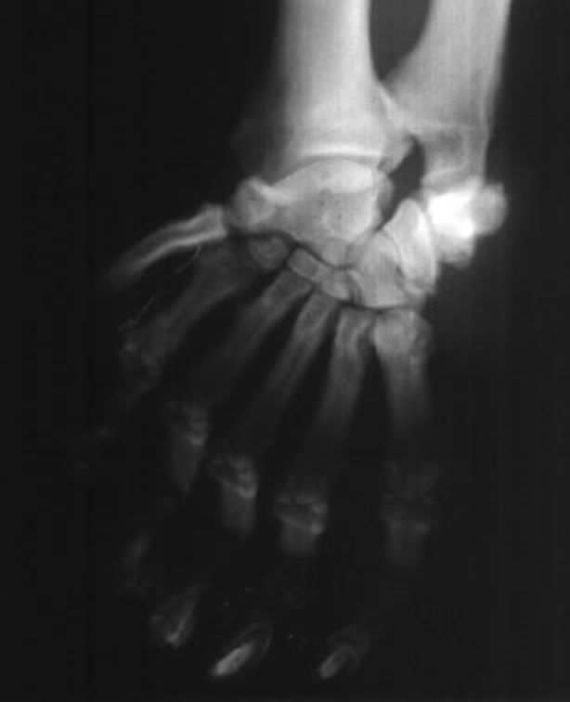 | 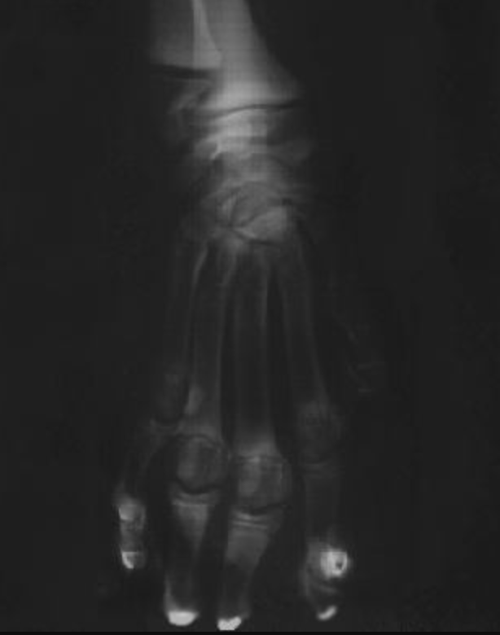
Description: | Description: | Description: | Description: | Description:
Animal:  Function: | Animal:  Function: | Animal:  Function: | Animal:  Function: | Animal:  Function:

Source: Animal hand x-ray images. (2021, February 21). 40two. https://40two.info/barge/ap/ip_images/Animal%20Hands%20X-ray%20Images/

