text impressions

Terms

- “President of the United States”
- “proclamation”
- “war measure”
- “declare”
- “slaves
- “states in rebellion”
- “forever free”
Prediction Statement

- “such persons”
- “received into the Armed Services”
- “act of justice”
- “military necessity”

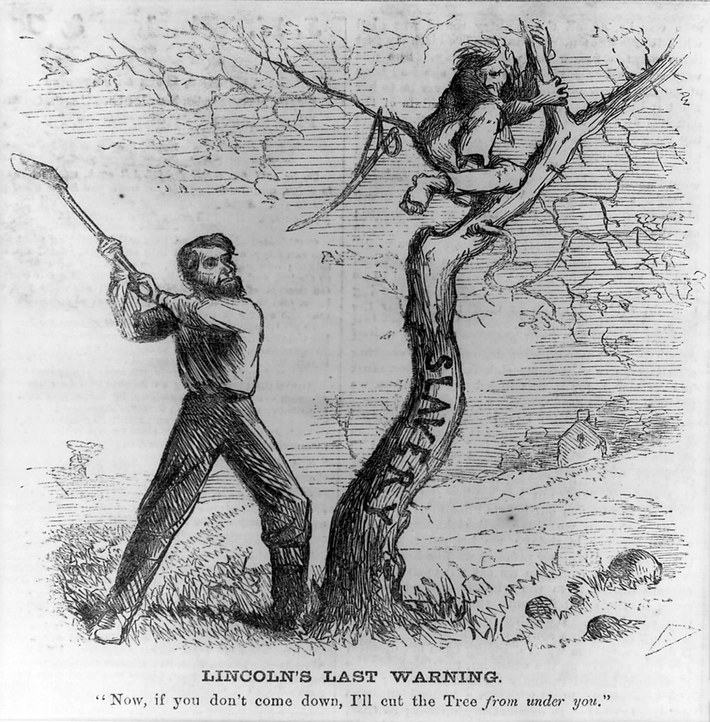

Revised Prediction Statement

Source: Bellew, Frank. (1862). Lincoln’s last warning. Library of Congress; reproduction number LC-USZ62-48218. Retrieved from https://commons.wikimedia.org/wiki/File:Lincoln%27s_Last_Warning,_October_1862.jpg

