Constructing Origami Boxes
1) Set a square piece of paper in front of you on a hard, flat surface. | 2) Fold your paper in half to create a rectangle and then unfold. |  | 3) Rotate your paper 90°, fold it in half again, and then unfold.
4) You should have a square with four distinct quadrants. Now, fold each corner to the center, which will result in a smaller square.
 | 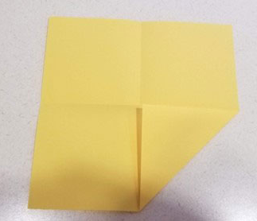 | 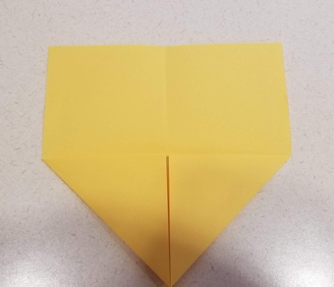 | 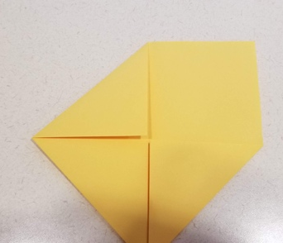 | 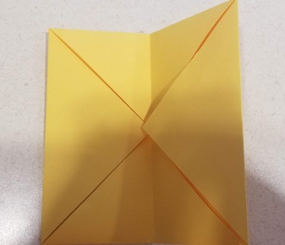
5) Fold the square in half to create a vertical line of symmetry. Fold each side to this line. You have now divided your square into fourths, vertically. |  |  | 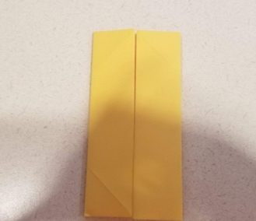
6) Unfold two opposite sides as in the picture below. | 7) Rotate the paper 90°. With the paper partially unfolded, fold the longest sides to the center, and then unfold.
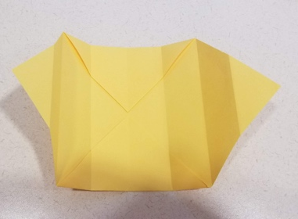 | 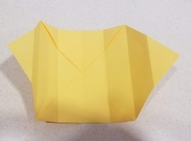 | 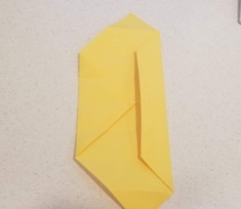 | 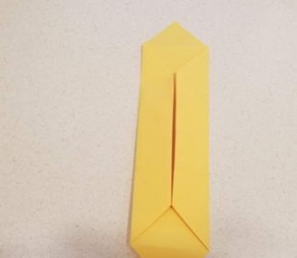 | 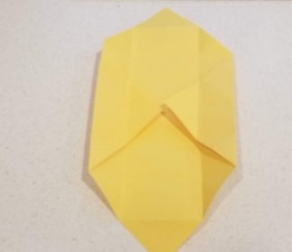
8) Pinch the paper together as in the pictures below to begin forming the corners of your box. |  |  | 9) Fold upward to create the sides of your box. | 10) Fold the remaining flaps over to put the finishing touches on your box.
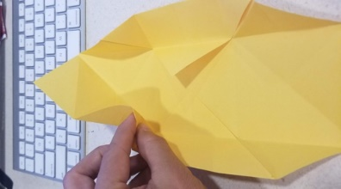 | 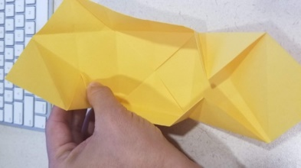 | 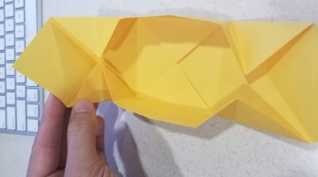 | 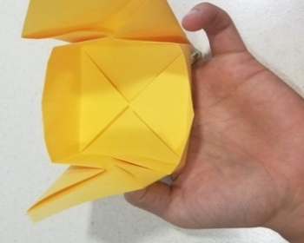 | 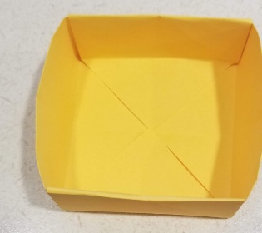
Congratulations, you’ve made a 3-D box out of a 2-D piece of paper! Now let’s explore some of its properties.

