OSCEOLA RESPONSE

Osceola, Seminole Tribal Leader Response to Demand to Emigrate According to the 1832 Treaty of Payne’s Landing [excerpt]
October 23, 1834: Agent Wiley Thompson has demanded that the Seminoles begin to gather for emigration, as called for in the 1832 Treaty of Payne’s Landing. The principal leaders meet among themselves to discuss how they will respond. (Potter, 53)

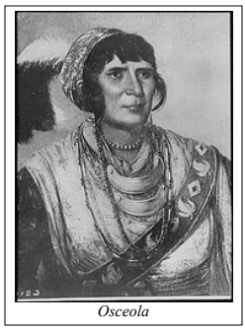
My Brothers! The white people got some of our chiefs to sign a paper to give our lands to them, but our chiefs did not do as we told them to do; they done wrong; we must do right. The agent tells us we must go away from the lands which we live on—our homes, and the graves of our Fathers, and go over the big river among the bad Indians. When the agent tells me to go from my home, I hate him, because I love my home, and will not go from it.

My Brothers! When the great spirit tells me to go with the white man, I go: but he tells me not to go— The white man says I shall go, and he will send people to make me go; but I have a rifle, and I have some powder and some lead. I say, we must not leave our homes and lands. If any of our people want to go west we won't let them; and I tell them they are our enemies, and we will treat them so, for the great spirit will protect us.

Source: Osceola. (2009). [Response to Agent Wiley Thompson] [Speech transcript]. In J. Missall & M. L. Missall (Eds.), In Their Own Words: Selected Seminole “Talks” 1817-1842 (Vol. 1, p. 14). The Seminole Wars Foundation. https://seminolewars.org/wp-content/uploads/2018/05/In-Their-Own-Words.pdf (Original work transcribed October 23, 1834).

