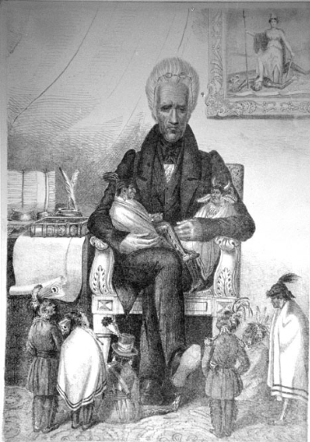
REFLECTIONS ON PATERNALISM

I Notice… | I Wonder…

Source: University of Michigan, Clements Library. (n.d.). Indians of the Midwest: Andrew Jackson, the great father, ca. 1830. Newberry Dis. https://digcoll.newberry.org/indians-midwest/media/andrew-jackson-the-great-father-ca-1830
Frayer Model
Definition | Synonyms/Characteristics
Examples | Visuals

