FloodGates
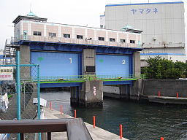  Jones, J. (2005, June 12). Oshimakawa Floodgate in Eitai 1-chome, Koto, Tokyo [Image file]. Retrieved from https://commons.wikimedia.org/wiki/File:Floodgate_Tokyo.jpg | 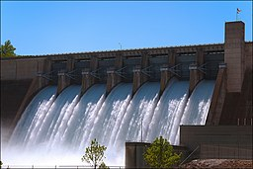  Wertman, D. (2011, May 21). The floodgates are open at the Beaver Lake Dam in northwest Arkansas [Image file]. Retrieved from https://commons.wikimedia.org/wiki/File:Beaver_Lake_Dam_-_Floodgates_Open.jpg | 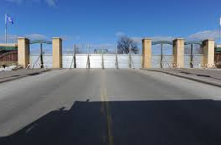  FEMA/Rieger, M. (2010, March 19). North Dakota flooding [Image file]. Retrieved from https://www.fema.gov/media-library/assets/images/56625

Sandbags
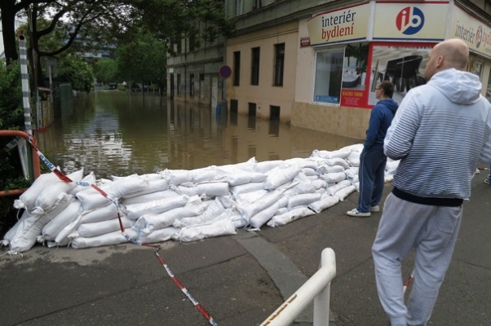  Sedláček, J. (2014, June 3). Flood in Prague 2013 [Image file]. Retrieved from https://commons.wikimedia.org/wiki/File:Flood_in_  Prague_2013,_Ko%C5%BEelu%C5%BEsk%C3%A1_street_with_sand_bags.JPG | 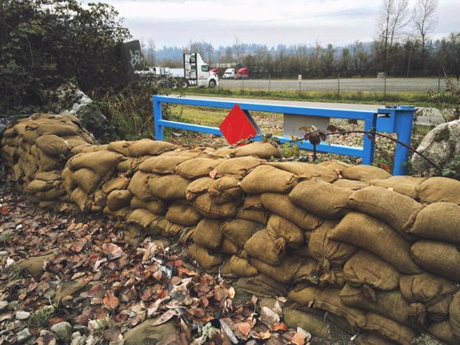  Pavlov, S. (2015, Nov. 30). Hessian sandbags [Image file]. Retrieved from https://commons.wikimedia.org/wiki/File:  Hessian_sandbags_as_flood_protection.jpg | 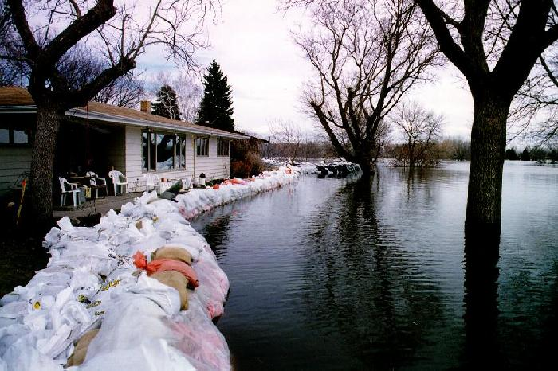  McCourt, M. (1997, April). Sandbags holding back flood waters from a neighborhood [Image file]. Retrieved from https://commons.wikimedia.org/wiki/File:Fargosandbagsflood1997.jpg

