Watershed Teacher’s Guide

Watershed Materials
- Various objects to add shape and height to mimic a watershed—toilet paper rolls, dishes, cups, etc.
- A surface to build the watershed model on. Shown below is a plastic storage lid, but a tray or baking sheet would work, too.
- Plastic grocery bag
- Spray bottle with water
- Legos (3rd/4th grade)
- Sand in baggies (3rd/4th grade)
- Objects to “prevent” flooding—dirt, sticks, foil, popsicle sticks, etc. (4th grade)
- Pollutants—glitter, oil, confetti (5th grade)

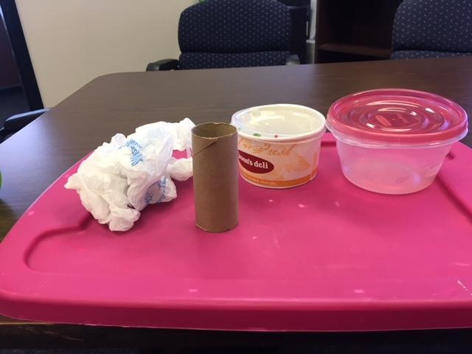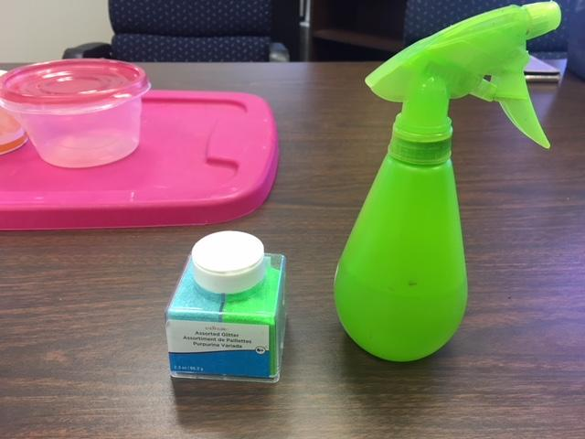

Building a Watershed
- Arrange various items on the surface to create a variety of heights.
- Cover the items with a plastic bag. The various heights and wrinkles in the bag will create areas that water will roll off and down. (Fifth grade: Sprinkle glitter/confetti on top of the plastic bag the second time around.)
- Use a spray bottle filled with water to imitate rain over the plastic bag.

Flood Prevention—Third Grade
- It’s okay to encourage ‘bad’ results to get kids out of thinking that they have to get it right the first time
- Baggies (snack size recommended) filled with sand (but not brimming) as well as interlocking blocks are used to simulate sandbags. What’s fun with the blocks is, once a pool of water is created, taking one block out to see how the water pours out in a more regulated fashion.
- Something students will find out is that the blocks make a great wall, but only when there’s a flat surface, while sandbags can conform to irregular surfaces. This is a great observation, but also refer to the pictures to show that humans cut and level the ground regularly to accommodate floodgates.
- The whole point of this activity is for students to figure out that rain water can either be blocked (sandbags) or blocked with controlled release (floodgates) to protect low areas from too much water.

Flood Prevention—Fourth Grade
Providing the ‘raw’ supplies helps students understand the engineering behind making flood prevention structures. Once again, it is okay for students to get it wrong. In fact, some groups might not get a ‘right’ answer in the time frame allowed. You know your students best, so think of ways to help them understand that this is okay.

Pollution Effects—Fifth Grade
- The glitter, confetti, and oil represent pollution. If your students don’t understand why/how, you can talk to them about what the glitter, confetti, and oil could represent. (For example, glitter is small litter like cigarette butts, confetti is plastic bottles, oil is pesticide runoff from crops or excess nitrogen in the form of manure from animal farms).
- Students are not redirecting water, but rather observing where the pollution goes when it’s sprinkled in various places.

CER Statements—All Grades
- Although the prompts are different for each grade level, construction of the statements is the same.
- If this is one of the first few times students have written CER statements, walk them through the steps to help scaffold. Be sure to start with re-reading observations, then picking which observations best help answer the question.

