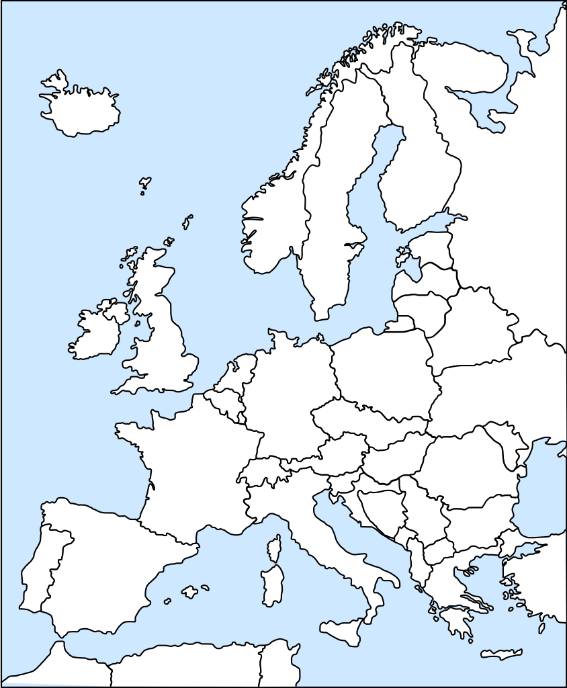
File:Bubba europe outline.svg. (n.d.). Retrieved May 29, 2019 from https://commons.wikimedia.org/wiki/File:Bubba_europe_outline.svg

