Stations Checklist
Stop by each station and complete the tasks listed below.

- Get “Buttoned Up” for GEAR UP
Pick up your 1st GEAR UP button to show your support for the GEAR UP Grant.
- Sign the GEAR UP Banner!
Your signature says that you are “IN” with us on a path to college success!
- Strike a Pose
Stop by the Photobooth with other students and take a photo with the poster showing the benefit of going to college that is most significant to you. Also, there are lots of props there to “ham it up.”
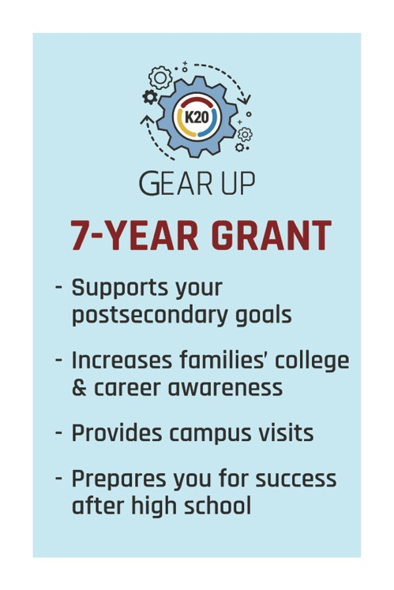
- A Note to Your Future Self
GEAR UP stationary with envelope.
- Evaluation of Activity
Using the pens provided, select an answer for each question by completely filling in the bubble.

Stations Checklist
Stop by each station and complete the tasks listed below.

- Get “Buttoned Up” for GEAR UP
Pick up your 1st GEAR UP button to show your support for the GEAR UP Grant.
- Sign the GEAR UP Banner!
Your signature says that you are “IN” with us on a path to college success!
- Strike a Pose
Stop by the Photobooth with other students and take a photo with the poster showing the benefit of going to college that is most significant to you. Also, there are lots of props there to “ham it up.”
- A Note to Your Future Self
GEAR UP stationary with envelope.
- Evaluation of Activity
Using the pens provided, select an answer for each question by completely filling in the bubble.

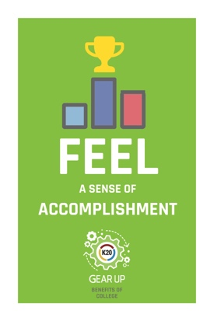
Research suggests if you hold a postsecondary degree you are more likely to…

Research suggests if you hold a postsecondary degree you are more likely to…

