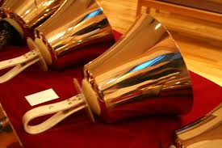 | 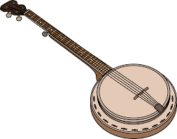
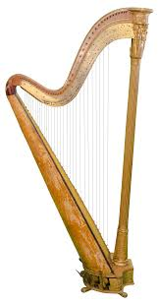 | 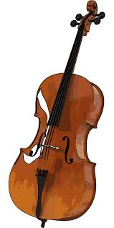
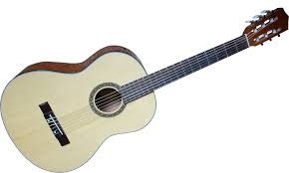 | 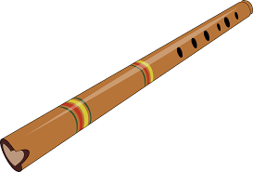

Image sources:
Suguri F. (2005). Hand bell large [Image file]. Retrieved from https://commons.wikimedia.org/wiki/File:Hand_bell_large.jpg
Clker-Free-Vector-Images. (n.d.). Banjo [Image file]. Retrieved from https://pixabay.com/en/banjo-musical-instrument-strings-31562/
Pngimg.com. (n.d.). Harp [Image file]. Retrieved from http://pngimg.com/uploads/harp/harp_PNG21.png
Chrom72. (2016). Cello [Image file]. Retrieved from https://pixabay.com/en/cello-stringed-instrument-music-1871396/
obBilder. (2016). Acoustic guitar [Image file]. Retrieved from https://pixabay.com/en/acoustic-guitar-guitar-1669284/
Clker-Free-Vector-Images. (2012). Flute [Image file]. Retrieved from https://pixabay.com/en/flute-wind-instrument-musical-41967/

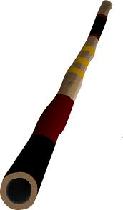 | 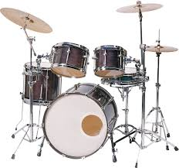
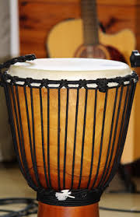 | 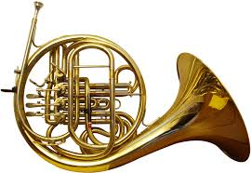
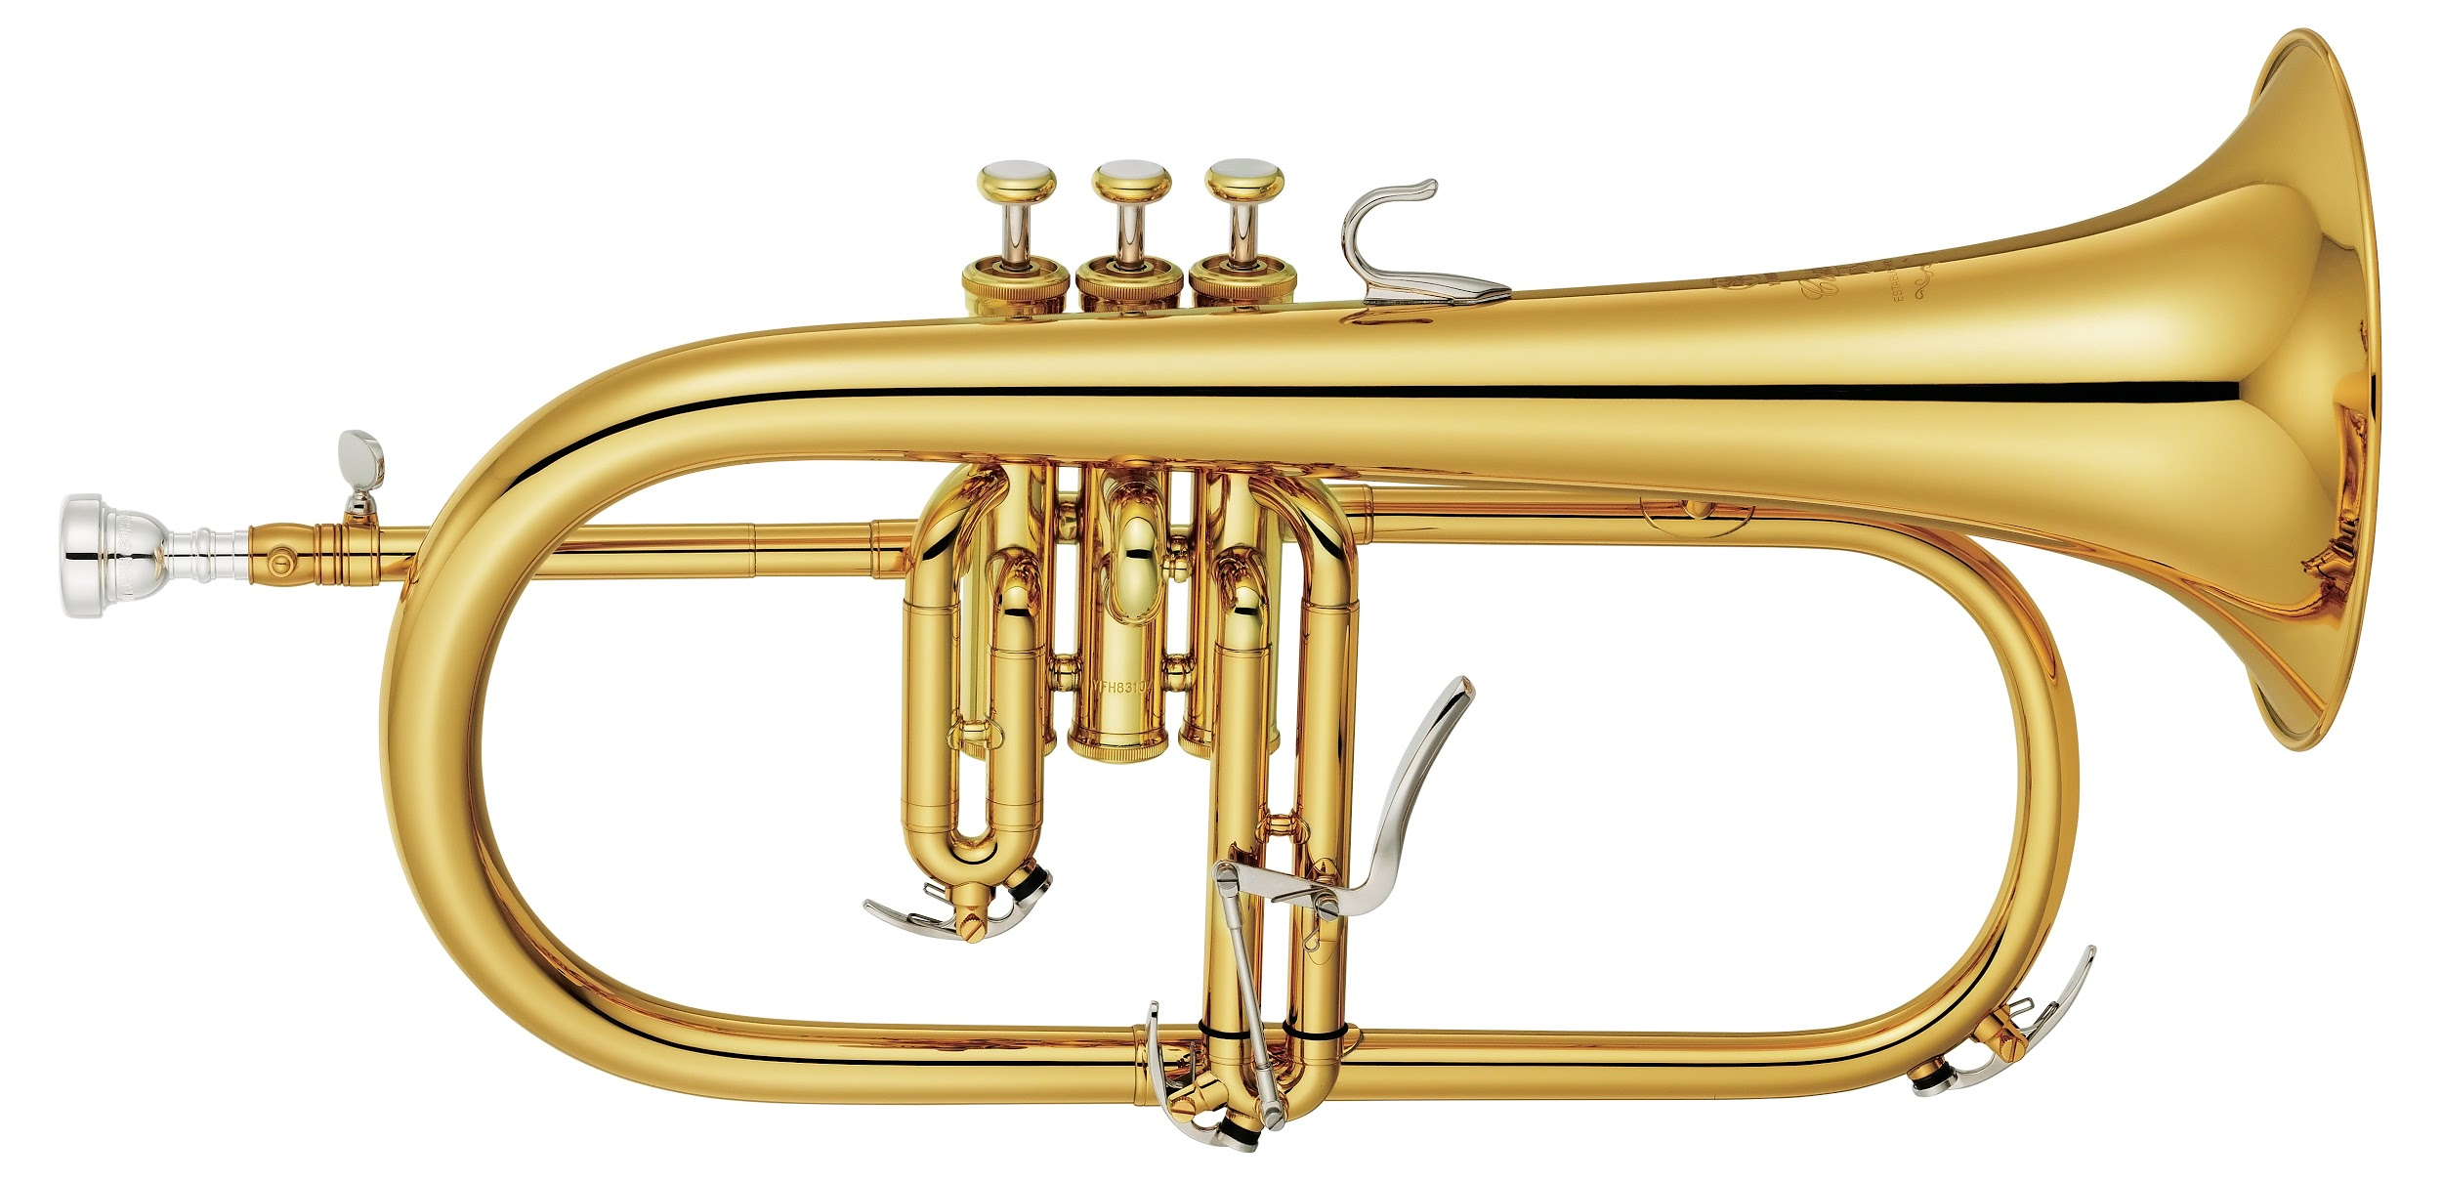 | 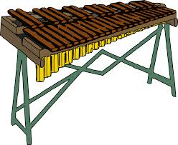

Image sources:
OpenClipart-Vectors. (2013). Didgeridoo [Image file]. Retrieved from https://pixabay.com/en/didgeridoo-music-sound-australian-157072/
Alles. (2016). Drums [Image file]. Retrieved from https://pixabay.com/en/drums-tools-percussion-music-1696802/
Counselling. (2014). Drum [Image file]. Retrieved from https://pixabay.com/en/drum-musical-instrument-instrument-535218/
BenP. (2006). French horn back [Image file]. Retrieved from https://commons.wikimedia.org/wiki/File:French_horn_back.png
Yamaha Corporation. (2017). Yamaha flugelhorn [Image file]. Retrieved from https://commons.wikimedia.org/wiki/File:Yamaha_Flugelhorn_YFH-8310Z.tif
Clker-Free-Vector-Images. (2014). Xylophone [Image file]. Retrieved from https://pixabay.com/en/xylophone-sticcado-instrument-music-308025/

