WAVES AND INVENTORS PARENT GUIDE

Our class is beginning a unit on Waves and Inventors. In this unit will explore how light travels and how sound is made. The students will do several investigations on sound and light and extend their new knowledge to help them understand things like sunglasses and instruments. Students will discover the characteristics of an inventor while learning about famous inventors that changed the way we travel and communicate. Here you will find some activities and resources to keep the learning happening at home.

Books
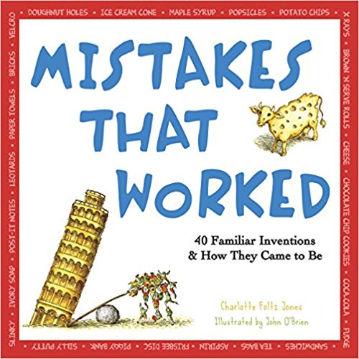
Mistakes that Worked

Videos
Do you have Netflix? The Magic School Bus and the Haunted House (Season 1, Episode 8) has a great episode where the students perform In this episode of the Magic School Bus, Ms. Frizzle and her students explore the Sound Museum. Check it out with your kiddo!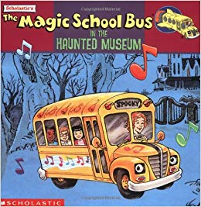

Kid President- Kid President is at it again and this time he learns what it takes to create an invention: an idea, teamwork, and trying and trying again.

Activites
Exploring Sound
- Put a piece of paper in front of a speaker. What happens to the rice?
- Place rice on top of a drum and beat the drum. What happens to the rice?
- Film a slow-motion video of air being slowly being released from the end of a balloon. What happens to the balloon? What kind of sound does it make?
- Some playgrounds have the “hidden” speakers and microphones that let kids send talk to people on the other end. How does that work?

Exploring Light
- Put on a shadow puppet performance. Create puppets by using a variety of materials that may let different amounts of light through.
- Encourage your child to use a flashlight and mirrors to reflect light around a room. Maybe have a few mirrors and aim for a target.

As a family, find a problem and invent something to solve the problem. Maybe it is a chore that you want to make easier. Maybe it is a tool that will help someone that needs a little extra help.

Words to Say
Encourage observation by asking your child, “What do you notice? What do you wonder?” Add to the conversation by adding your own observations and wonderings. This kind of conversation can happen anywhere and doesn’t have to always deal with scientific observations. This could be a good strategy to help your child recognize feelings (their own and others). For example, “I noticed that your voice sounds angry. I wonder what is making you upset. I wonder if there is something that you can do to feel better.”

Encourage the idea that failure is an opportunity to try again. Ask questions like, “How was this different from what you expected?” “What changes can we make?”

