Investigation Notes
Names: __________________________________________________________
Draw a picture of your investigation setup. Show your flashlight 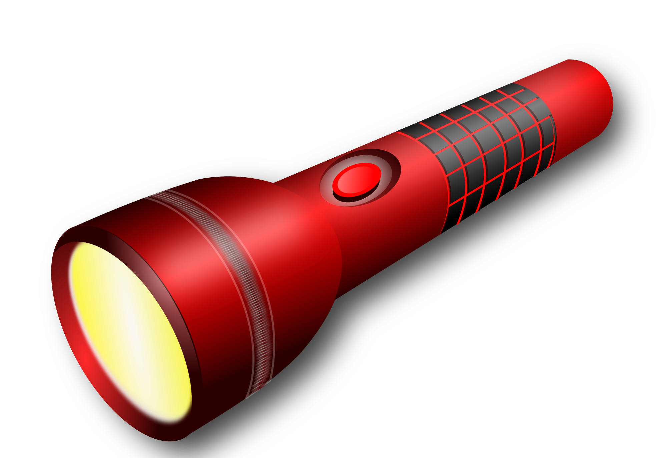, materials, and other items that you use.

Draw a picture or describe using words what happens with each material in your investigation.
Material | Picture | Type of Material
Tissue Paper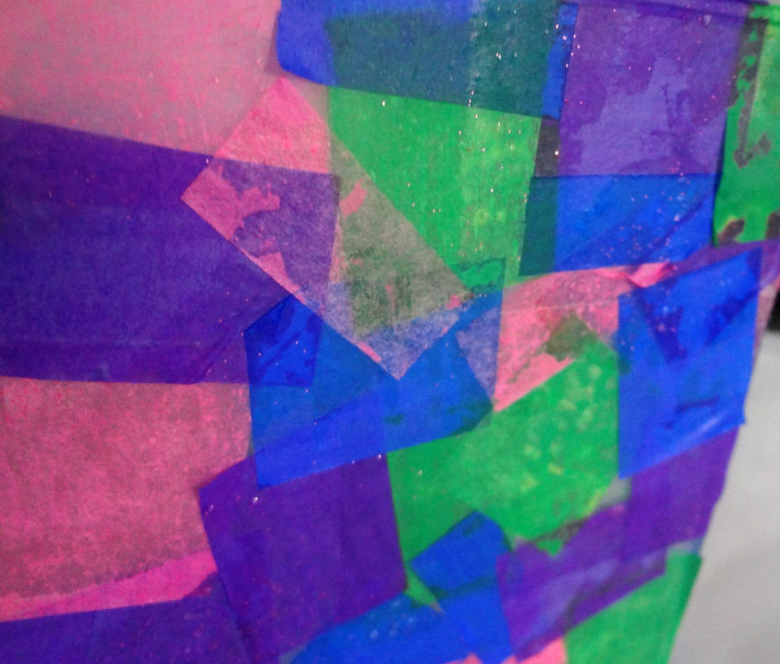 |  | - Opaque  - Transparent  - Reflective  - Other
Foil  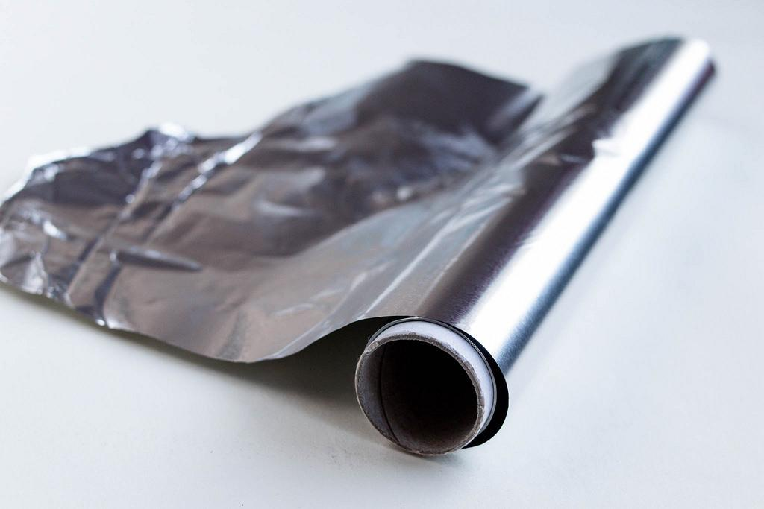 |  | - Opaque  - Transparent  - Reflective  - Other
Construction Paper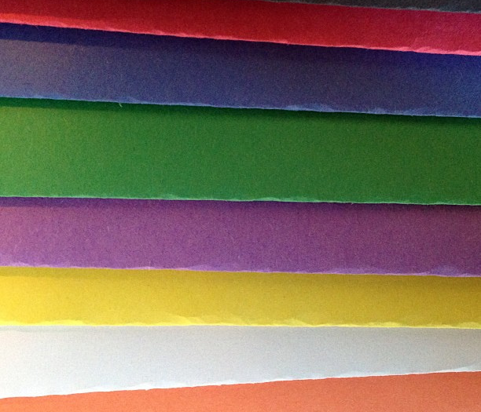 |  | - Opaque  - Transparent  - Reflective  - Other
Plastic Wrap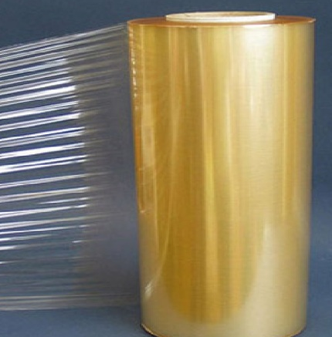 |  | - Opaque  - Transparent  - Reflective  - Other

