Inventor Biographies

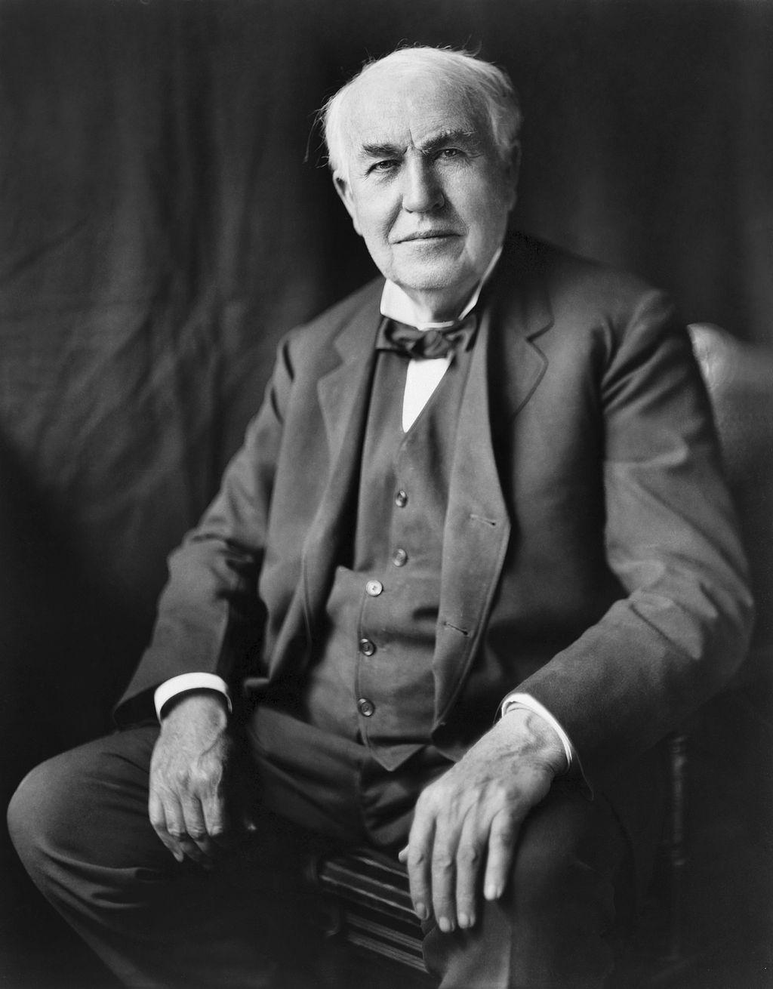  Image source: Bachrach, L. (1922). Thomas Alva Edison [Image file]. Retrieved from https://commons.wikimedia.org/wiki/File:Thomas_Edison2.jpg | Thomas Edison  Thomas Edison developed the motion picture camera, the phonograph, and the lightbulb. He grew up in the Midwest and began his career as a telegraph operator, which inspired some of his earliest inventions. He developed a team of researchers to help with inventing.
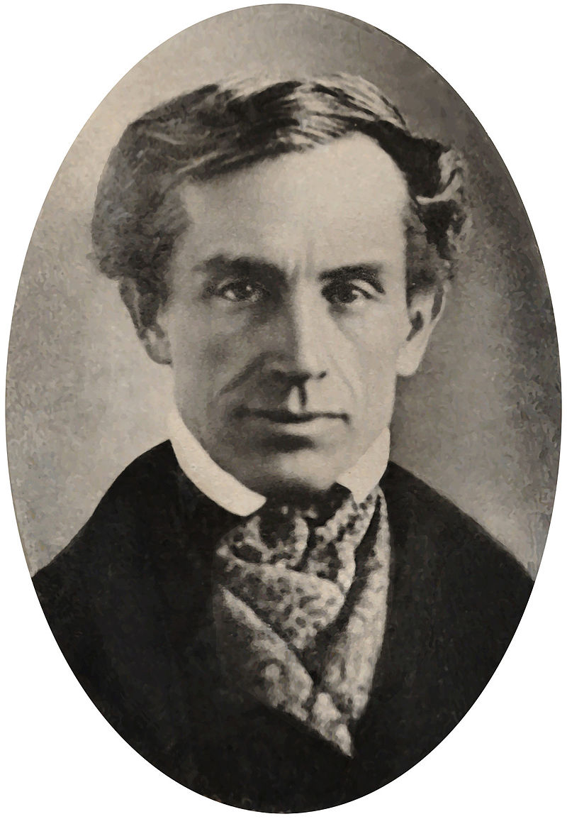  Image Source: Smithsonian Photography Search. (1840). Samuel Finley Breese Morse [Image file]. Retrieved from https://commons.wikimedia.org/wiki/File:Samuel_Morse_1840.jpg | Samuel Morse  Samuel Morse added to the invention of the telegraph by developing a code that allowed people to send messages quickly. Before that, horses and people had to carry messages by hand. Sending messages quickly was important to him because he found out someone he loved died but was too late to say goodbye. He was very sad but developed a tool to solve the problem.
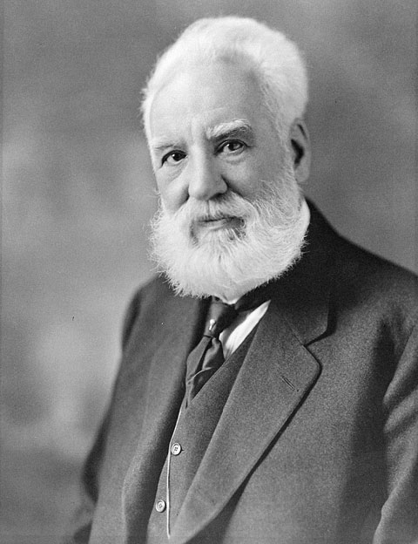  Image Source: Moffett Studio. (c. 1914). Portrait of Alexander Graham Bell [Image file]. Retrieved from https://commons.wikimedia.org/wiki/File:Alexander_Graham_Bell.jpg | Alexander Graham Bell  Alexander Graham Bell was a scientist, inventor, and engineer who invented the telephone. Bell’s mom and wife were deaf, and he researched hearing and speech, which led him to experiment with hearing devices. These experiments led to the creation of the telephone.
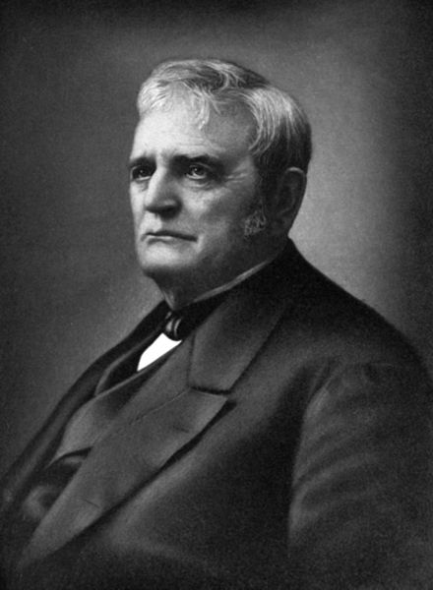  Image Source: Wilson, J. G., Fiske, J., Dick, C., & Homans, J. E. (Unknown). John Deere portrait [Image file]. Retrieved from https://commons.wikimedia.org/wiki/File:John_Deere_portrait.jpg | John Deere  John Deere was a blacksmith and inventor of the steel plow. He used his experience sharpening needles by polishing them to design a plow that would work better in the prairie. He then founded Deere & Company, which we know as John Deere tractors.
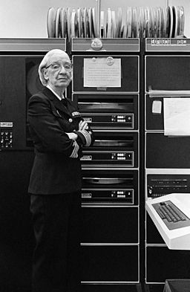  Image Source: Gilbert, L. (1978). Grace Murray Hopper, in her office in Washington DC [Image file]. Retrieved from  https://commons.wikimedia.org/wiki/File:Grace_Murray_Hopper,_in_her  _office_in_Washington_DC,_1978,_%C2%A9Lynn_Gilbert.jpg | Grace Hopper  Grace Hopper was a computer scientist, math professor, and U.S. Navy admiral. She was the first programmer for the first computer. She faced challenges trying to enlist in the navy because they said she was too old and too small. She also wasn’t accepted to college at first because her scores in Latin were not high enough.
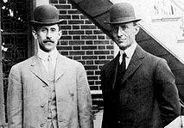  Image Source: Unknown. (1908). Wright brothers [Image file]. Retrieved from https://commons.wikimedia.org/wiki/File:Orville_Wilbur_Wright.jpg | The Wright Brothers  The Wright Brothers, Orville and Wilbur, were pilots, engineers, and inventors who worked together to build and fly the first airplane. Both brothers attended high school but had to drop out for family reasons.
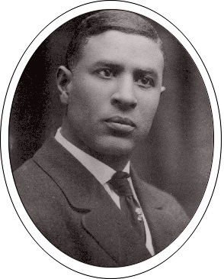  Image Source: Unknown. (2011). Garrett Augustus Morgan [Image file]. Retrieved from https://commons.wikimedia.org/wiki/File:Morgan5.jpg | Garrett Morgan  Garrett Morgan was an entrepreneur and inventor. His inventions included an early version of a gas mask, a chemical to straighten hair, and the first traffic light that included the yellow light. He had to quit school at a young age to work full time.

