Shape Pictures
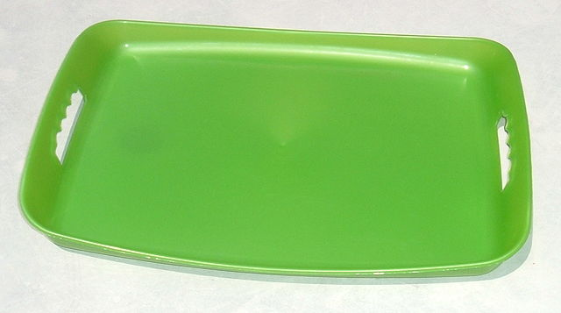  Reinhold, A. (2005). Tray. One of a series of common objects I photographed in the summer of 2005 to illustrate simple Basic English picture wordlist [Image file]. Retrieved from https://commons.wikimedia.org/wiki/File:Tray.agr.jpg | 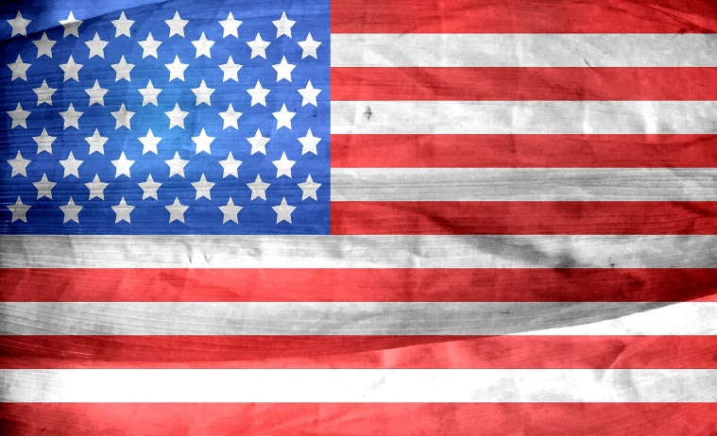  Pixabay. (2015, July 12). American flag USA United States [Image file]. Retrieved from https://pixabay.com/en/american-flag-usa-united-states-839775/
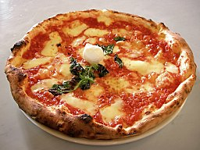  Capello, V [ElfQrin]. (2005, Sept. 6). Picture of an authentic Neapolitan pizza Margherita [Image file]. Retrieved from https://commons.wikimedia.org/wiki/File:Eq_it-na_pizza-margherita_sep2005_sml.jpg | 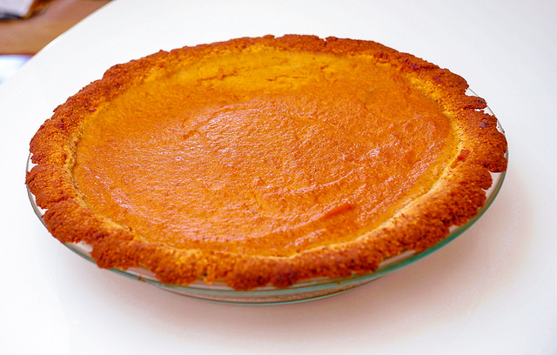  Eytan, T. (2018, Nov. 22). Low carbohydrate pumpkin pie 2.0. Washington, DC USA 08451 [Image file]. Retrieved from https://www.flickr.com/photos/taedc/45092734565
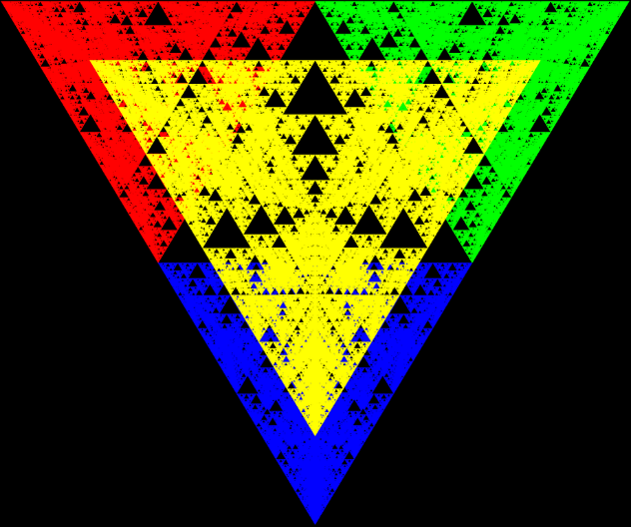  Supuhstar. (2008, July 9). Sierpinski pyramid from above [Image file]. Retrieved from http://www.wikizero.biz/index.php?q=aHR0cHM6Ly9lbi53aWtpcGVkaWEub3Jn  L3dpa2kvRmlsZTpTaWVycGklQzUlODRza2lfUHlyYW1pZF9mcm9tX0Fib3ZlLlBORw | Chen, M. (2018, April 11). A yield sign in Washing D. C. [Image file]. Retrieved from https://commons.wikimedia.org/wiki/File:Yield_Sign_DC.jpg
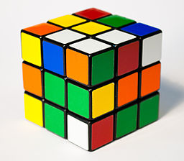  Acdx. (2009, July 25). Rubik’s cube [Image file]. Retrieved from https://commons.wikimedia.org/wiki/File:Rubik%27s_Cube_cropped.jpg | Silver, S. (2015, Nov. 3). One red dice [Image file]. Retrieved from https://commons.wikimedia.org/wiki/File:One-red-dice-01.jpg
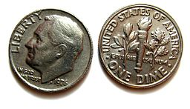  Lordnikon (2008, Jan. 15). Both sides of a 1976 dime [Image file]. Retrieved from https://commons.wikimedia.org/wiki/File:One_dime_1976_revised.JPG | 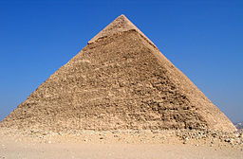  Digr. (2014, Oct. 17). Pyramid of Khafre [Image file]. Retrieved from https://commons.wikimedia.org/wiki/File:Pyramid_of_Khufu.jpg
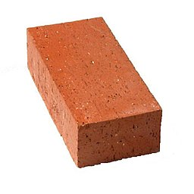  Lowes. (2017, April 16). Bennett is brick [Image file]. Retrieved from https://commons.wikimedia.org/wiki/File:Brick_Bennett.jpg | 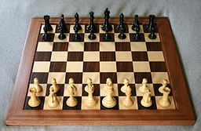  Staxringold. (2006, July 11). Photo of a Staunton chess set [Image file]. Retrieved from https://commons.wikimedia.org/wiki/File:Chess_board_opening_staunton.jpg

