Point of View
Author Name: ________________________________
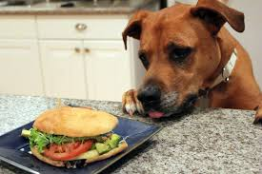
Image Source: Adopt a Pet. (2013, June 10). Adopt-a-Pet.com Staff Pets [Blog post]. Retrieved from https://www.adoptapet.com/blog/staff-pets/

Using the image above, write a story about what happens next.

Reviewer Name: ___________________________

Is the story written in first person or third person?

How do you know? Provide evidence from the story text.

