Bear Writing
Name: _________________________

Look at the picture below.
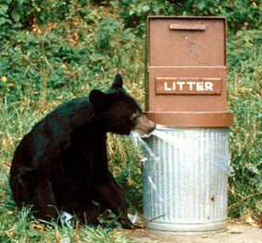
Image Source: NPS. (n.d.). A bear cub bites the plastic trash can liner on a bear-proof garbage can [Image file]. Retrieved from https://www.nps.gov/grsm/learn/
nature/black-bears.htm

Write about the picture.
Choose if you want to entertain or inform.

Circle your choice:
Entertain Inform

