quadrilaterals card sort
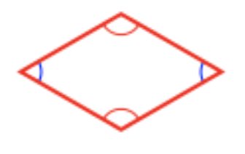 | 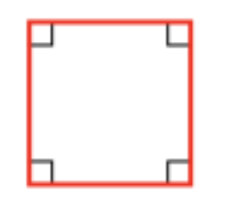 | 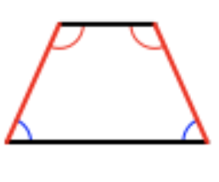
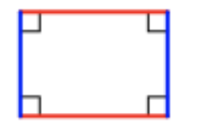 | 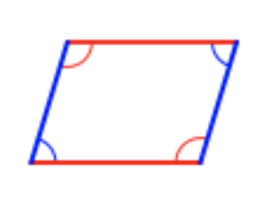 | 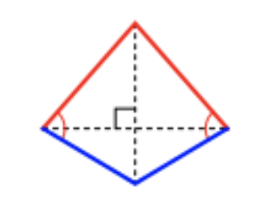

Rhombus  - 4 equivalent sides  - 2 acute angles  - 2 obtuse angles | Kite  - 2 equivalent touching shorter sides  - 2 equivalent touching longer sides | Rectangle  - Equivalent opposite sides  - 4 right angles
Square  - 4 equivalent sides  - 4 right angles | Parallelogram  - Opposite sides are parallel  - Opposite angles are equivalent | Isosceles Trapezoid  - Side-by-side angles are equivalent  - 2 sides are equivalent

