fire department Station
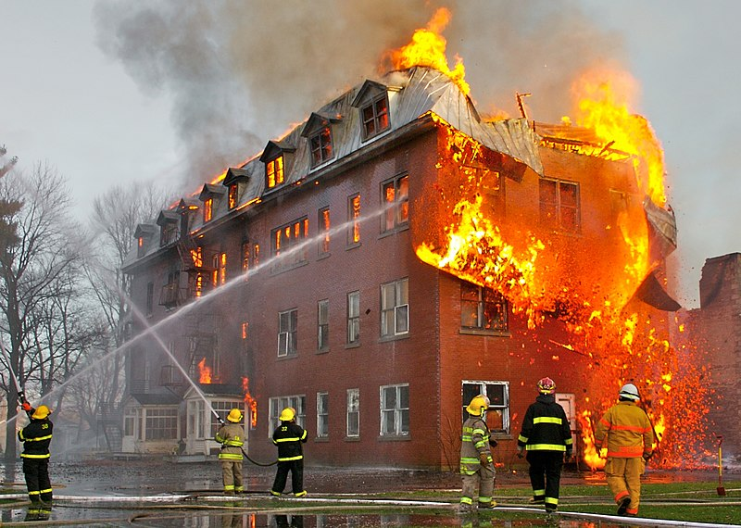
File:Fire inside an abandoned convent in Massueville, Quebec, Canada.jpg. (n.d.). [Digital image]. Retrieved from https://commons.wikimedia.org/wiki/File:Fire_inside_
an_abandoned_convent_in_Massueville,_Quebec,_Canada.jpg
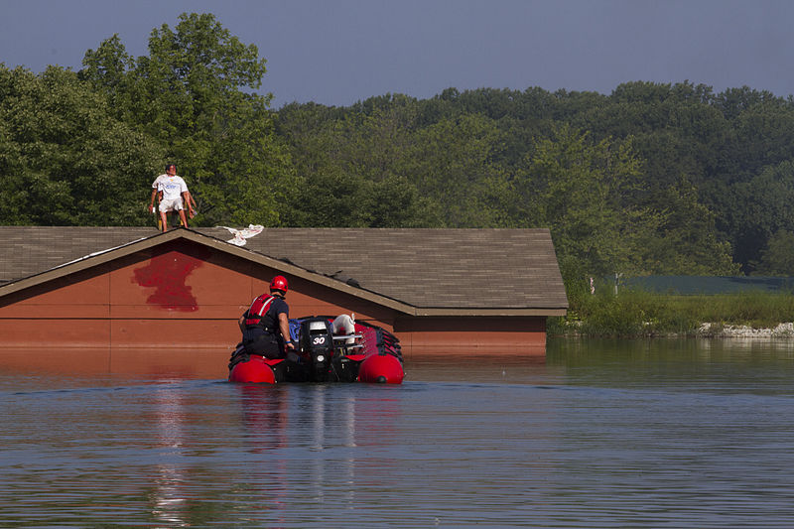
File:Firefighters train to save lives 140804-A-DU810-0010.jpg. (n.d.). [Digital image]. Retrieved from https://commons.wikimedia.org/wiki/File:Firefighters_train_to_save_lives_140804-A-DU810-0010.jpg
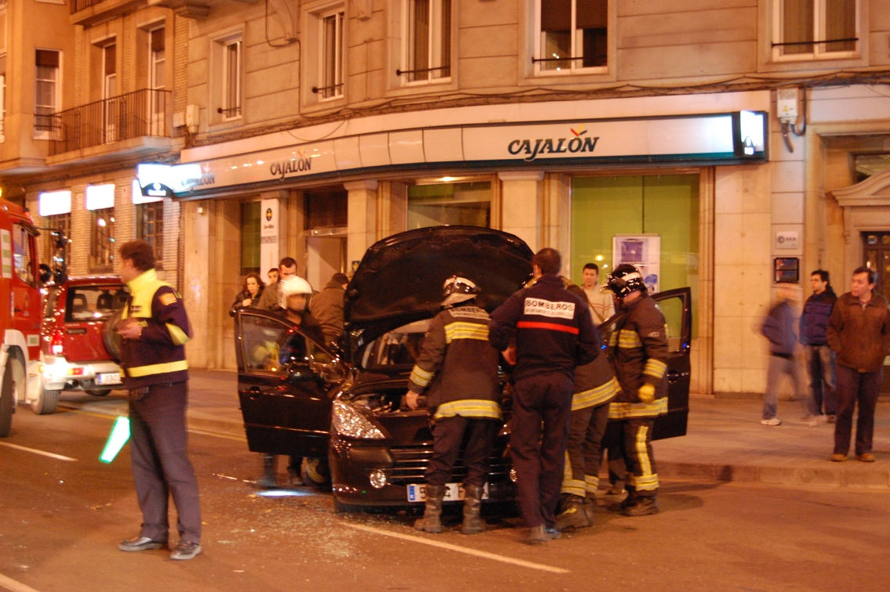
File:Car crash in Downtown Saragossa.jpg. (n.d.). [Digital image]. Retrieved from https://commons.wikimedia.org/wiki/File:Car_crash_in_Downtown_Saragossa.jpg
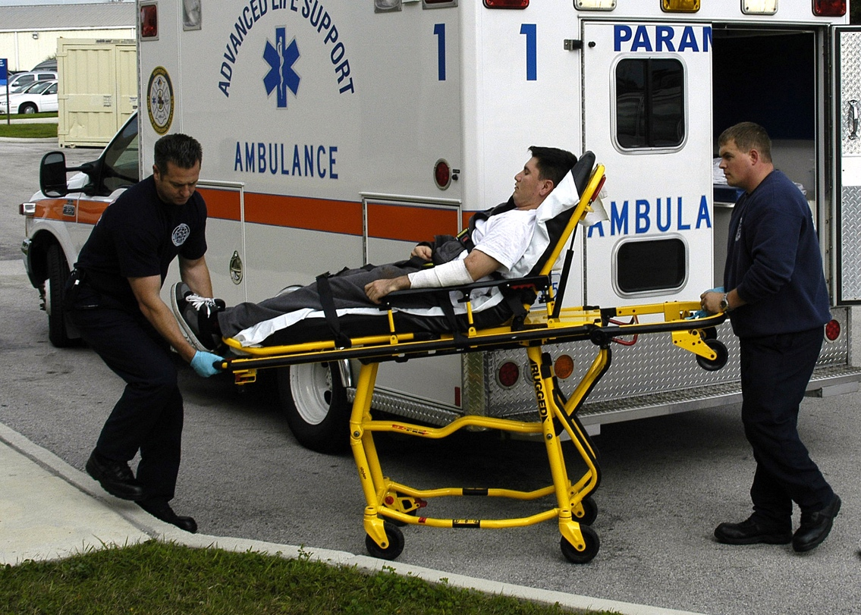
File:US Navy 070119-N-4049C-024 Firefighter Paramedics William Strickland and Steven Ames assist a simulated burn victim during a mass casualty drill at Naval Branch Health Clinic Mayport.jpg. (n.d.). [Digital image]. Retrieved from https://commons.wikimedia.org/wiki/File:US_Navy_070119-N-4049C-024_Firefighter_Paramedics_William_Strickland_and_Steven_Ames_assist_a_simulated_burn_victim_during_a_mass_casualty_drill_at_Naval_Branch_Health_Clinic_Mayport.jpg
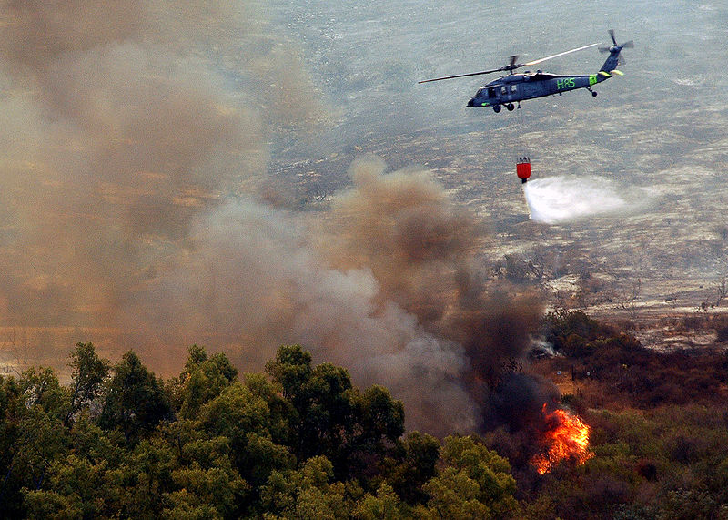
File:US Navy drops water from a helicopter-borne firefighting bucket.jpg. (n.d.). [Digital image]. Retrieved from https://commons.wikimedia.org/wiki/File:US_Navy_drops_water_from_
a_helicopter-borne_firefighting_bucket.jpg

