Libraries Station
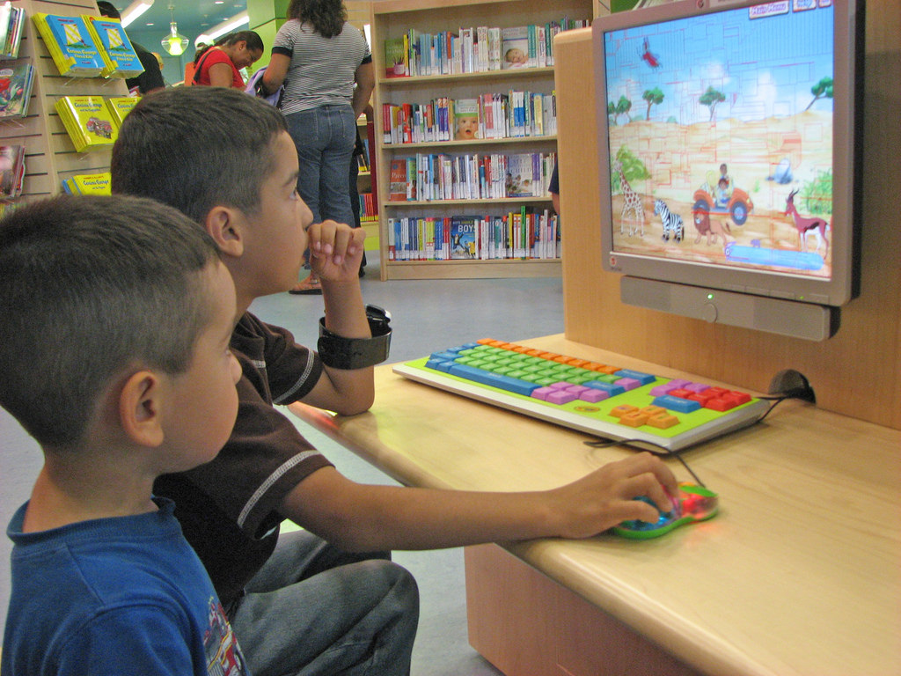
File:Children using the computer.jpg. (n.d.). [Digital image]. Retrieved from https://commons.wikimedia.org/wiki/File:Children_using_the_computer.jpg
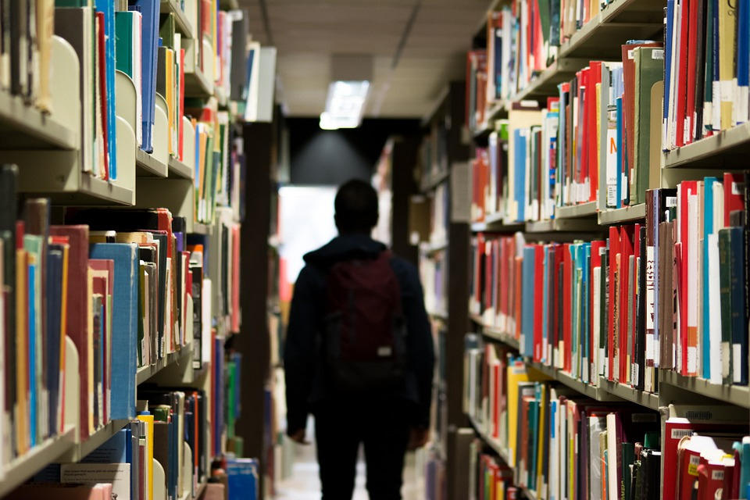
Library, books, shelves, student. (n.d.). [Digital image]. Retrieved from https://pixabay.com/photos/library-books-shelves-student-922998/
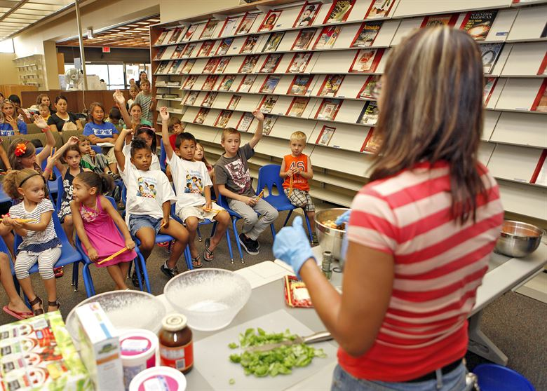
Edwards Air Force Base. Edwards library serves up one 'delicious' summer reading program finale. (n.d.). [Digital image]. Retrieved from https://www.edwards.af.mil/News/Article/394338/
edwards-library-serves-up-one-delicious-summer-reading-program-finale/
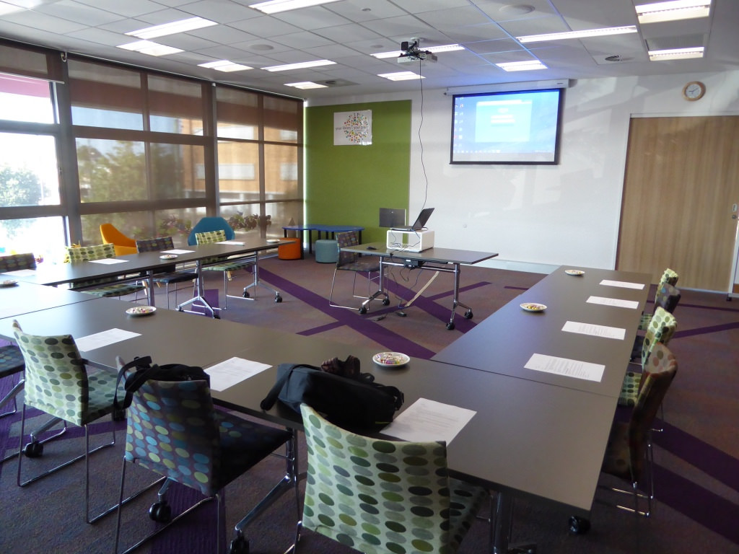
State Library of NSW Public Library Services. Meeting Room at Grafton Library. (2015, August 25). [Digital image]. Retrieved from https://www.flickr.com/photos/publiclibrariesnsw/20882150555

