Police department
Shebley, C. (2018, June 25). Everett, Washington, USA - June 25, 2018. Police officers inspect a logging truck accident. [Digital image]. Retrieved from https://www.flickr.com/photos/cindyshebley/42961240562
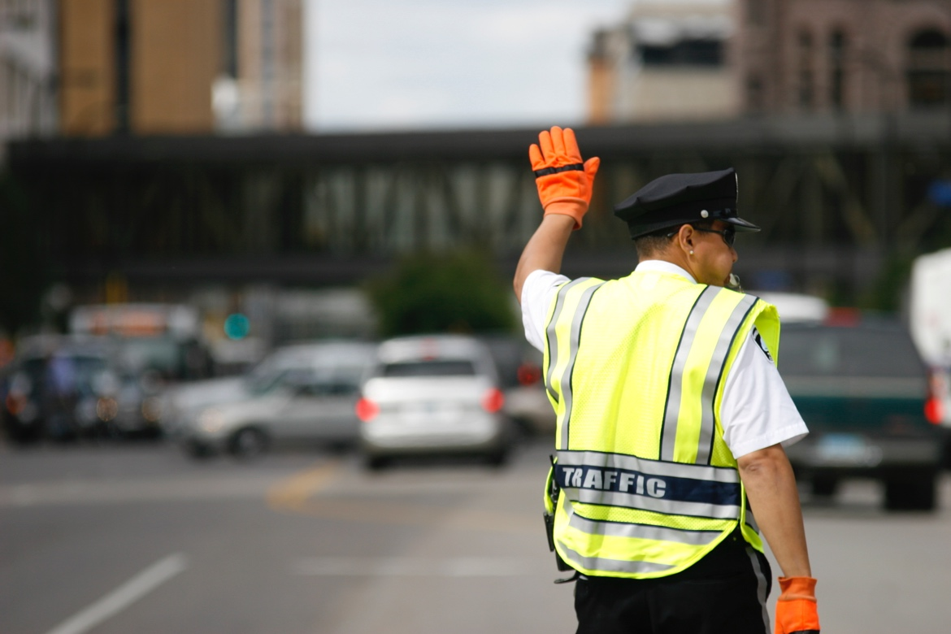
090610-Minneapolis-Traffic-Officer-2.jpg (n.d.). [Digital image]. Retrieved from https://commons.wikimedia.org/wiki/File:090610-Minneapolis-Traffic-Officer-2.jpg
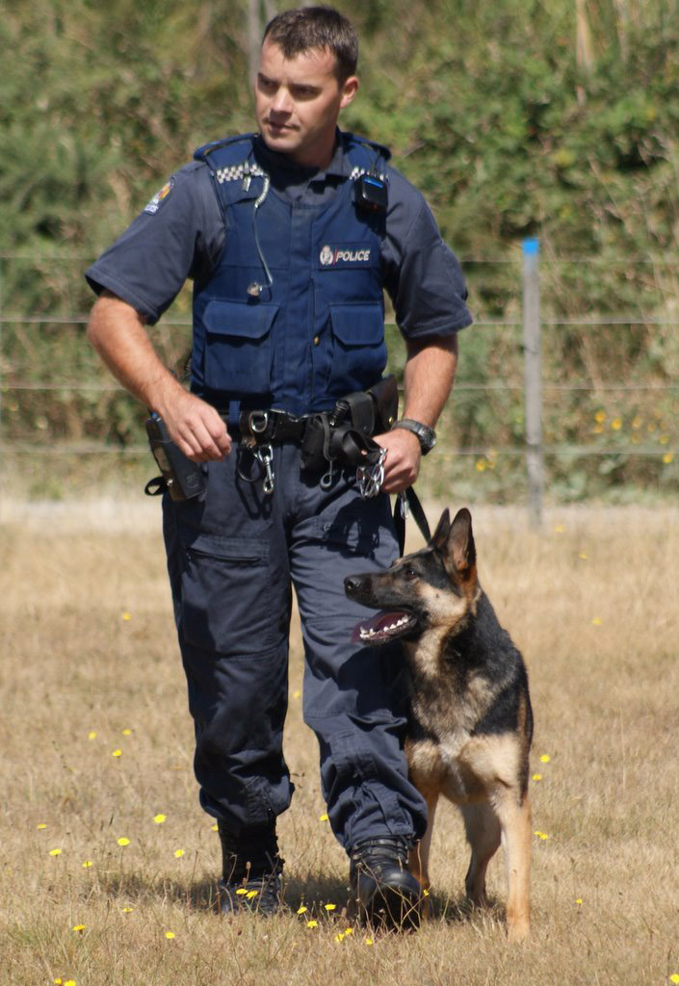
NZ Police Dog.jpg. (n.d.). [Digital image]. Retrieved from https://commons.wikimedia.org/wiki/File:NZ_Police_Dog.jpg
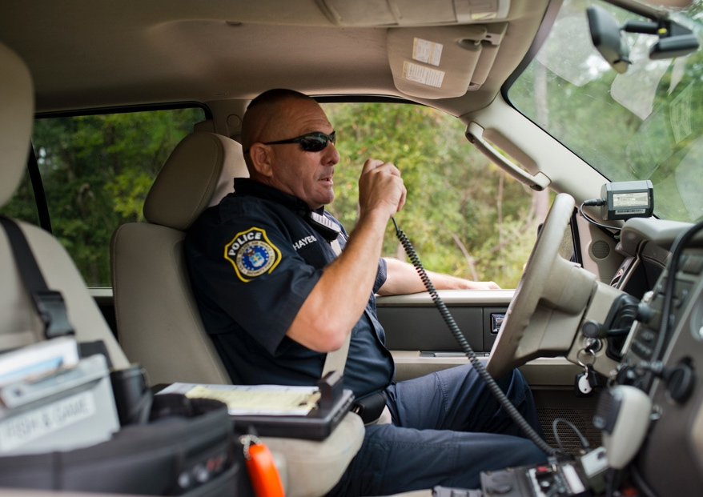
Range Police (n.d.). [Digital image]. Retrieved from https://www.eglin.af.mil/News/Photos/igphoto/2001307278/

