Schools Station
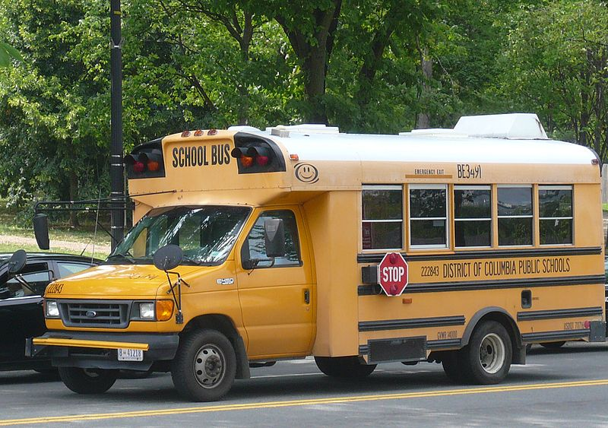
School bus DC.jpg. (n.d.). [Digital image]. Retrieved from https://commons.wikimedia.org/wiki/File:School_bus_DC.jpg
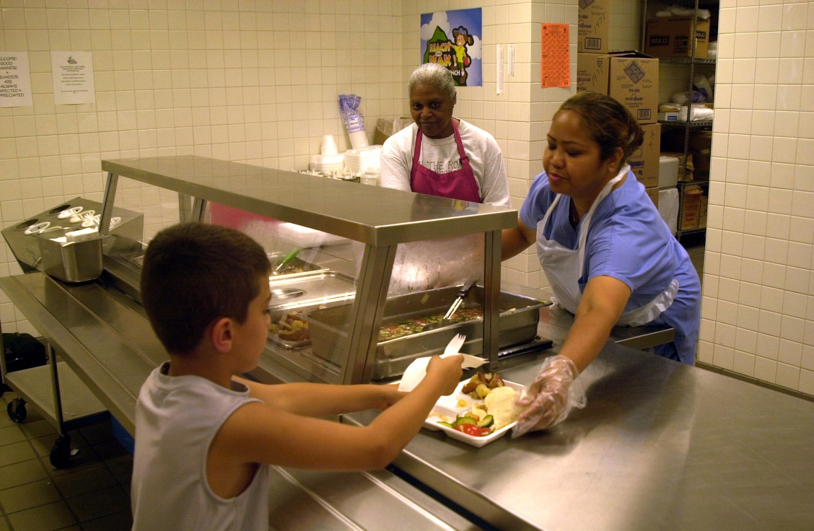
File:USMC-05471.jpg. (n.d.). [Digital image]. Retrieved from https://commons.wikimedia.org/wiki/File:USMC-05471.jpg
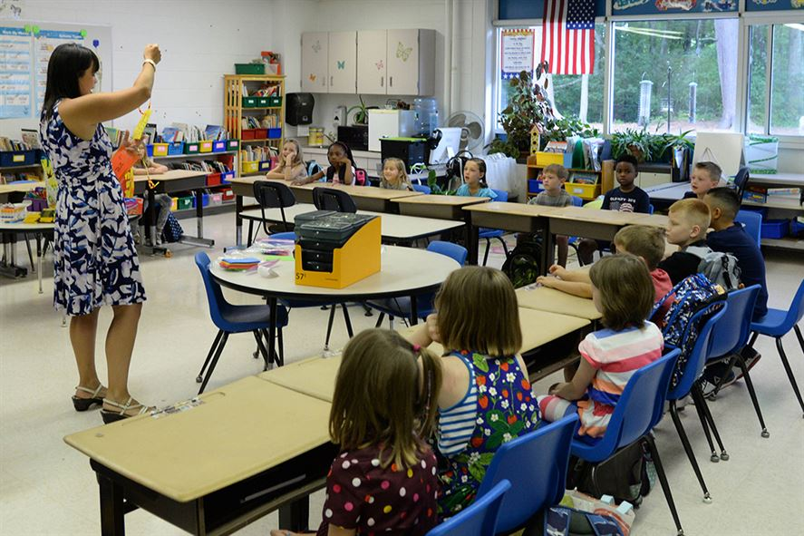
Hanscom Air Force Base. Hanscom children return to school. (n.d.). [Digital image]. Retrieved from https://www.hanscom.af.mil/News/Photos/igphoto/2001618929/
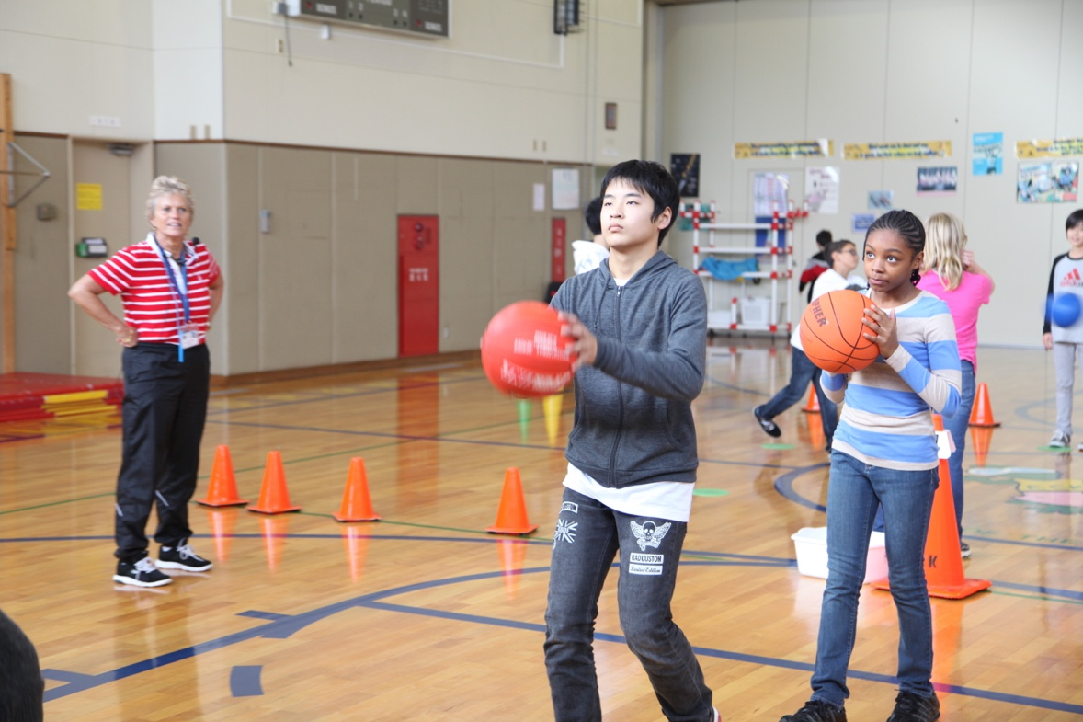
Oshima children join classes at E. C. Killin Elementary 130113-M-AX780-005.jpg. (n.d.). [Digital image]. Retrieved from https://commons.wikimedia.org/wiki/File:Oshima_children_join_classes_at_E._
C._Killin_Elementary_130113-M-AX780-005.jpg

