department of Transportation/roads
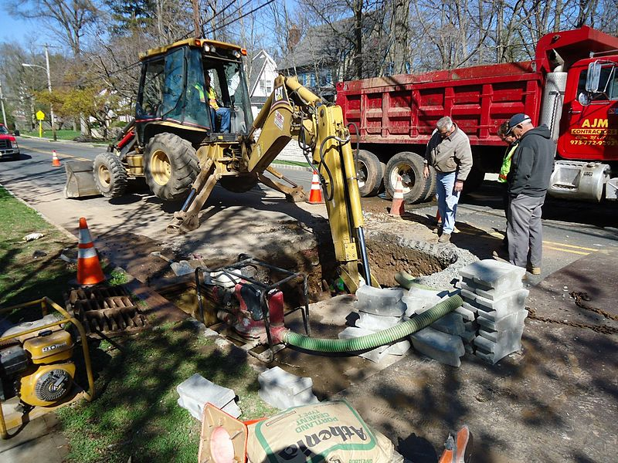
File: Road repair digging beneath street.jpg. (n.d.). [Digital image]. Retrieved from https://commons.wikimedia.org/wiki/File:Road_repair_digging_beneath_street.jpg
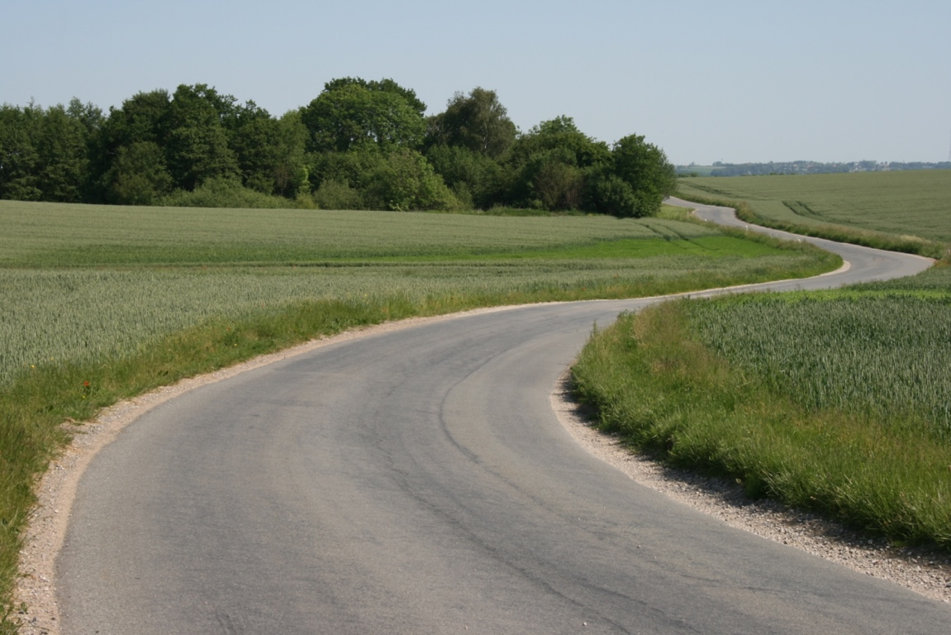
File: Middle Age-road.jpg. (n.d.). [Digital image]. Retrieved from https://commons.wikimedia.org/wiki/File:Middle_Age-road.JPG
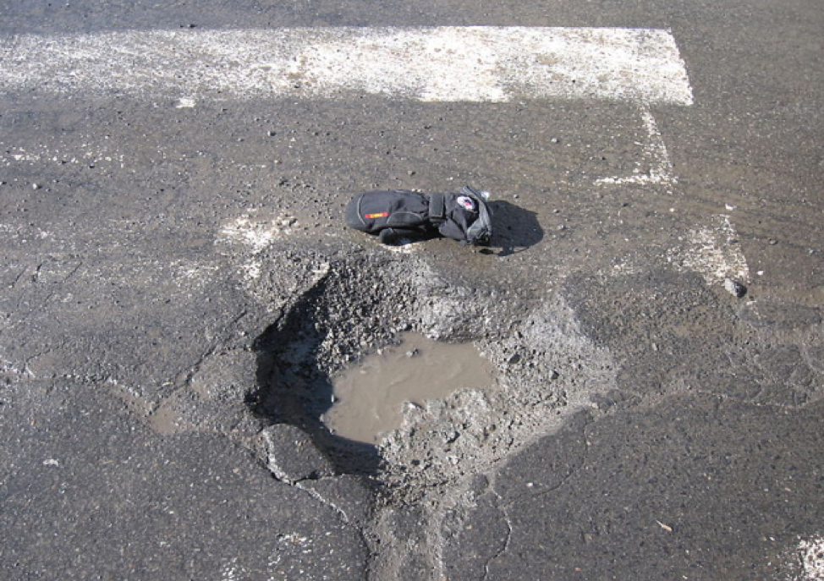
File: Pothole.jpg. (n.d.). [Digital image]. Retrieved from https://commons.wikimedia.org/wiki/File:Pothole.jpg
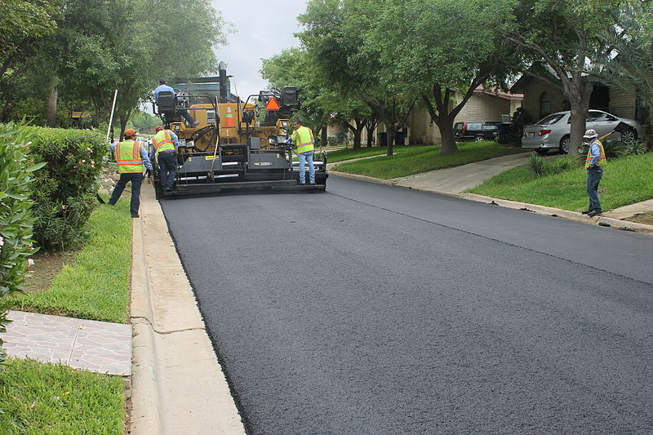
File:Street paving in Laredo, TX, 2015 IMG 5515.JPG. (n.d.). [Digital image]. Retrieved from https://commons.wikimedia.org/wiki/File:Street_paving_in_Laredo,_TX,_2015_IMG_5515.JPG
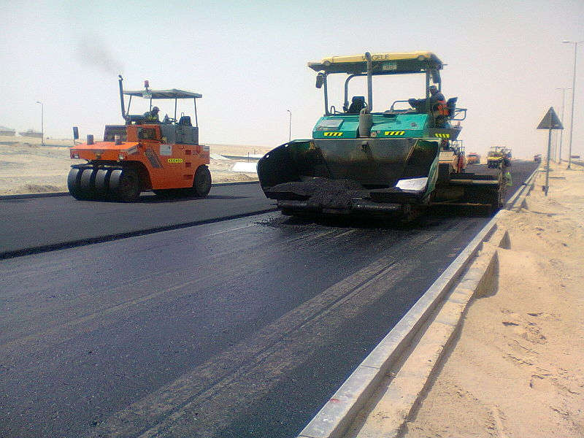
File:Road construction in progress.jpg. (n.d.). [Digital image]. Retrieved from https://commons.wikimedia.org/wiki/File:Road_construction_in_progress.jpg
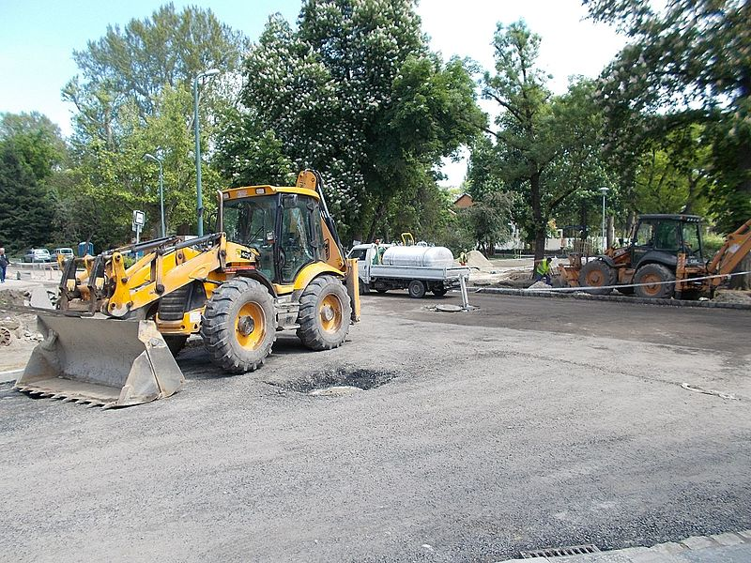
File:Backhoe loaders, road construction, 2017 Margaret Island.jpg. [Digital image]. Retrieved from https://commons.wikimedia.org/wiki/File:Backhoe_loaders,
_road_construction,_2017_Margaret_Island.jpg

