Water and sanitation Station
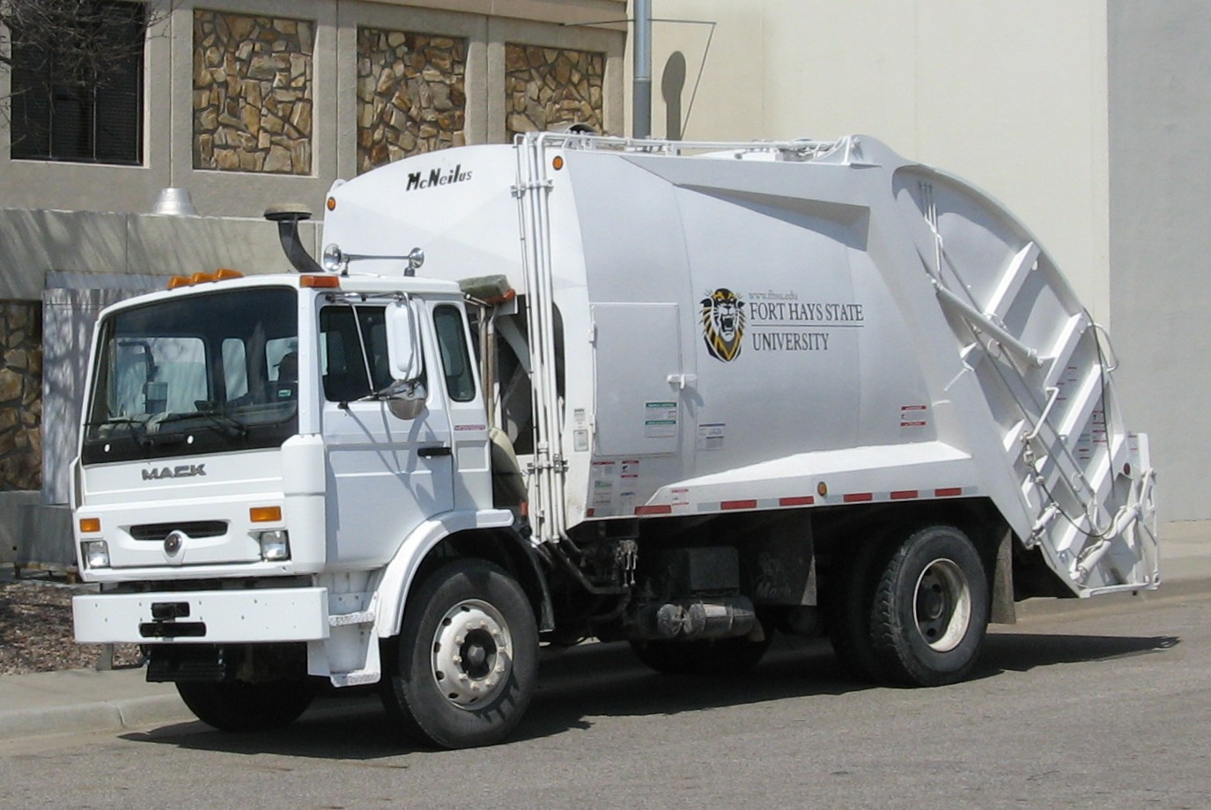
Mack MidLiner trash truck of Fort Hays State University.jpg. (n.d.). [Digital image]. Retrieved from https://commons.wikimedia.org/wiki/File:Mack_MidLiner_trash_truck_of_Fort
_Hays_State_University.jpg
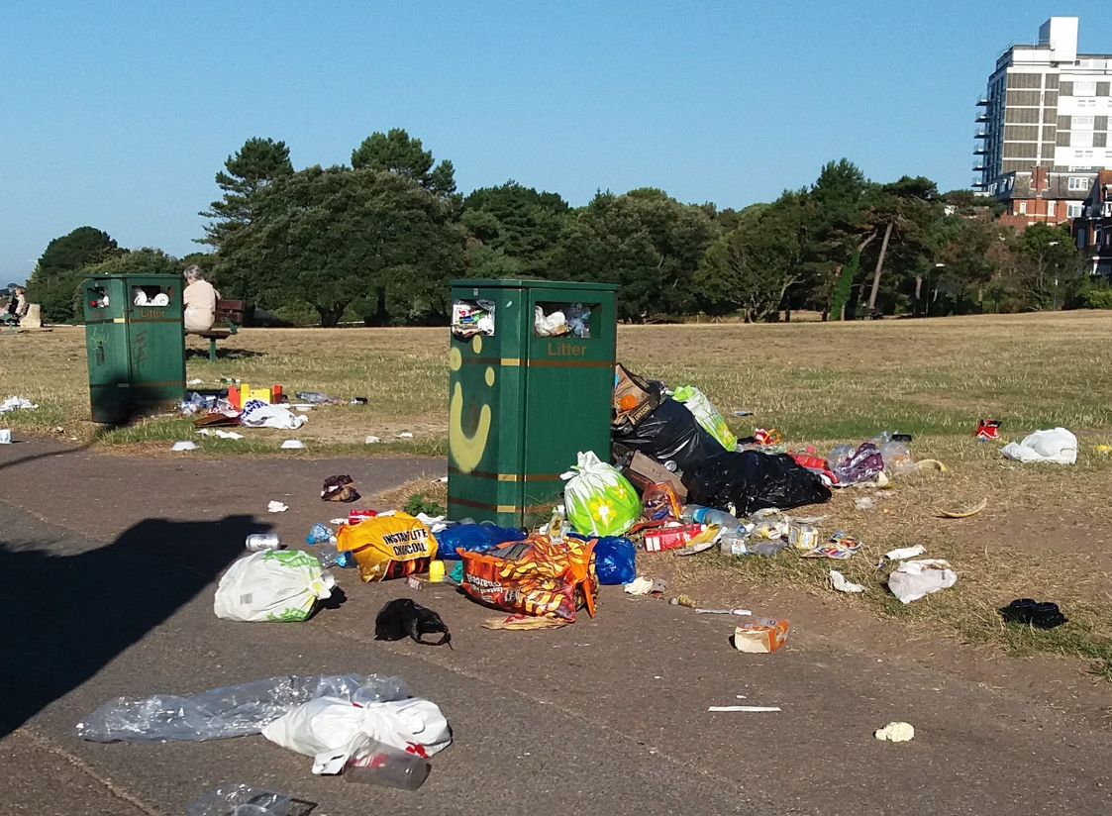
Trash in park.jpg. (n.d.). [Digital image]. Retrieved from https://commons.wikimedia.org/wiki/File:Trash_in_park.jpg
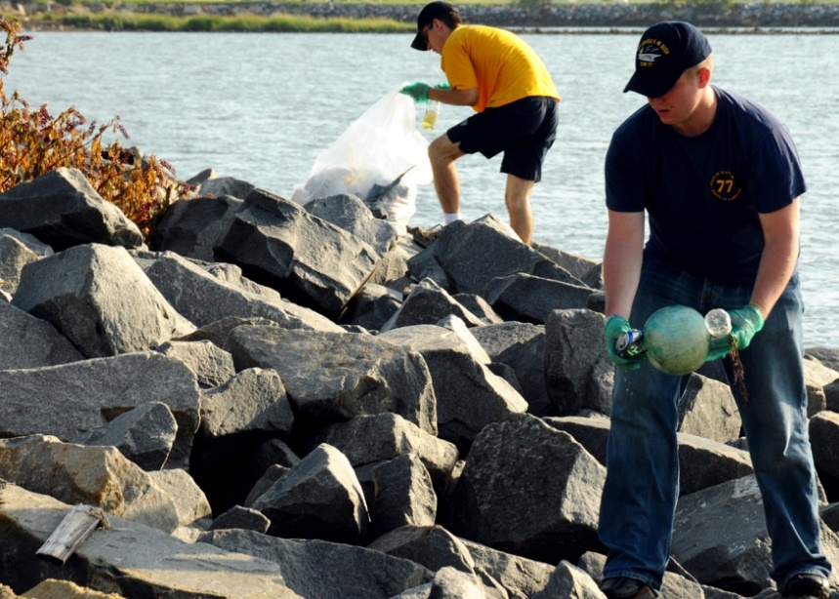
US Navy 100817-N-7908T-083 Machinist's Mate 2nd Class Paul M. Lutz, left, and Electrician's Mate 3rd Class Bryan C. Baker clean up trash at Anderson Park as part of the ship's second.jpg. (n.d.). [Digital image]. Retrieved from https://commons.wikimedia.org/wiki/File:US_
Navy_100817-N-7908T-083_Machinist%27s_Mate_2nd_
Class_Paul_M._Lutz,_left,_and_Electrician%27s_Mate_3rd_Class_Bryan_C._Baker_clean_up_trash_at_Anderson_Park_as_part_of_the_ship%27s_second.jpg
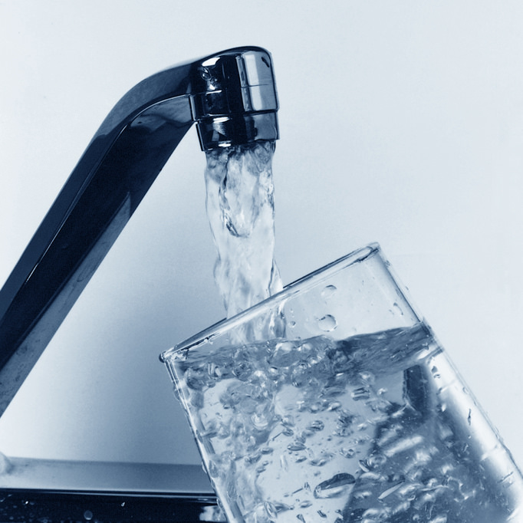
USEPA Environmental-Protection-Agency. Water pouring from a faucet into a clear glass cup. (2006, Sept.). [Digital image]. Retrieved from https://commons.wikimedia.org/wiki/File:Oshima
_children_join_classes_at_E._C._Killin_Elementary_130113-M-AX780-005.jpg

