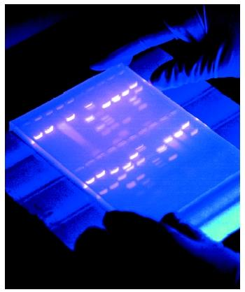 | gel electrophoresis
a laboratory method used to separate mixtures of DNA, RNA, or proteins according to molecular size. The molecules to be separated are pushed by an electrical field through a gel that contains small pores. | 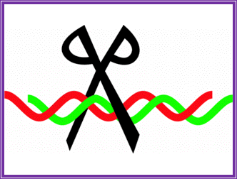
having the property of cleaving DNA molecules at or near a specific sequence of bases. | restriction enzymes
a location in a genome where a short nucleotide sequence is organized as a repeat. These can be found on many chromosomes, and often show variations in length between individuals | variable number of tandem repeats (VNTRs)
a technique used in molecular biology to amplify a single copy or a few copies of a piece of DNA across several orders of magnitude, generating thousands to millions of copies of a particular DNA sequence. | polymerase chain reaction

- Saliva  - Blood  - Hair Follicles  - Skin | DNA sources
A technique using X- ray film to visualize molecules or fragments of molecules that have been radioactively labeled. | autoradiograph
- Urine Alone  - Finger and Toenails  - Cut Hair  - Sweat Alone | Non-DNA Sources

