What Numbers Work? (Pre-Algebra)

Inequality: 3x + 5 > 20
Works | Doesn’t Work

Show the numbers that work on the number line.

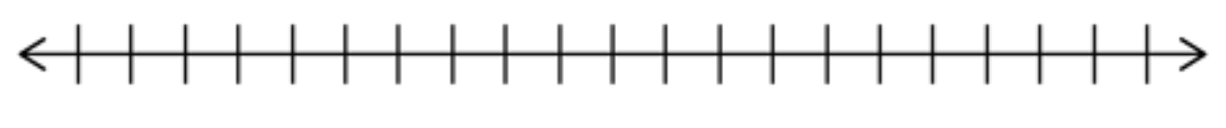

Why do certain numbers not fit?

Inequality: 4x - 5 < 39
Works | Doesn’t Work

Show the numbers that work on the number line.

Why do certain numbers not fit?

Inequality: 2x + 7 ≥ 21
Works | Doesn’t Work

Show the numbers that work on the number line.

Why do certain numbers not fit?

Inequality: 4x - 8 > 12
Works | Doesn’t Work

Show the numbers that work on the number line.

Why do certain numbers not fit?
My Rules for Graphing Inequalities:

Additional Rules for Graphing Inequalities:

