What numbers work? (seventh Grade)

Inequality: x < 5
Works | Doesn’t Work

Show the numbers that work on the number line.

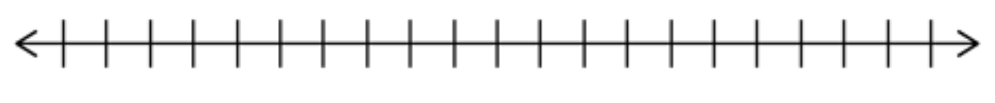

Why do certain numbers not fit?

Inequality: x ≥ 7
Works | Doesn’t Work

Show the numbers that work on the number line.

Why do certain numbers not fit?

Inequality: x + 2 ≥ 6
Works | Doesn’t Work

Show the numbers that work on the number line.

Why do certain numbers not fit?

Inequality: x - 4 ≤ 11
Works | Doesn’t Work

Show the numbers that work on the number line.

Why do certain numbers not fit?
My Rules for Graphing Inequalities:

Additional Rules for Graphing Inequalities:

