What Numbers Work

Inequality: x < 5
Works | Doesn’t Work

Show the numbers that work on the number line.
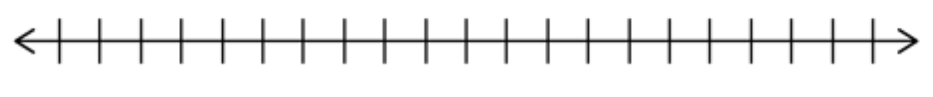
Why do certain numbers not work?

Inequality: 7 ≤ x
Works | Doesn’t Work

Show the numbers that work on the number line.
Why do certain numbers not work?

Inequality: x + 2 ≥ 6
Works | Doesn’t Work

Show the numbers that work on the number line.
Why do certain numbers not work?

Inequality: x – 4 ≤ 11
Works | Doesn’t Work

Show the numbers that work on the number line.
Why do certain numbers not work?

My Rules for Graphing Inequalities:

Additional Rules for Graphing Inequalities:

