Graphing Linear Equations: Guided Notes

Step 1: Plot Points

Step 2: Solid or Dashed Line?
Solid Line | Dashed Line
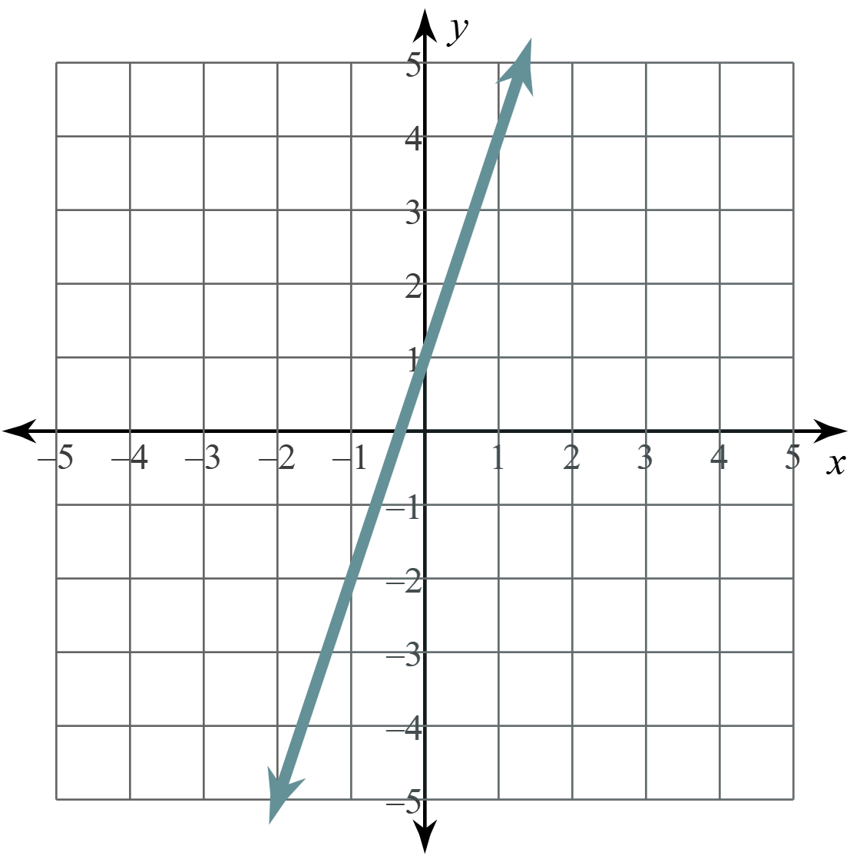 | 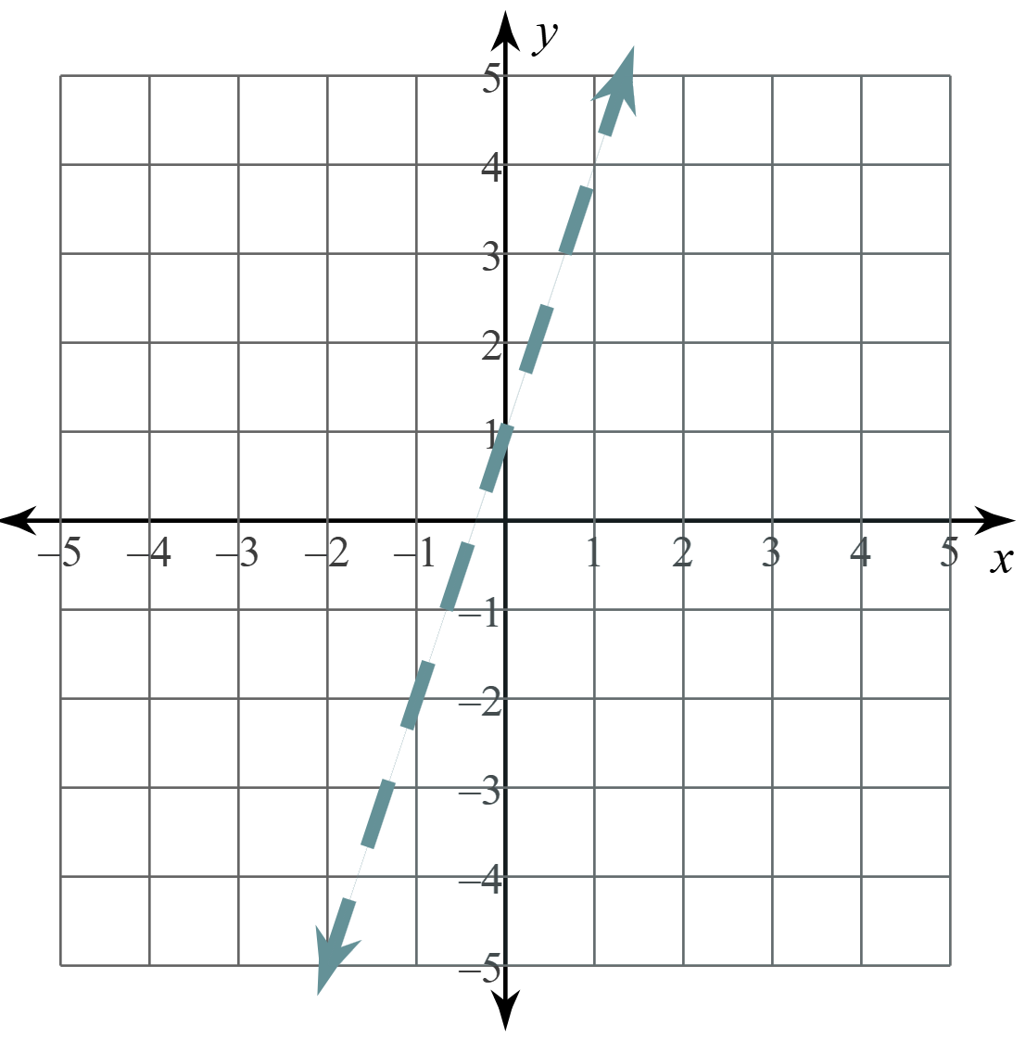

Steps 3 & 4: Pick a “Test Point” & Shade
- If the test point makes the inequality __________, shade __________ the test point.
- If the test point makes the inequality __________, shade __________ the test point.

Examples

1) Graph: 2y < 3x – 2
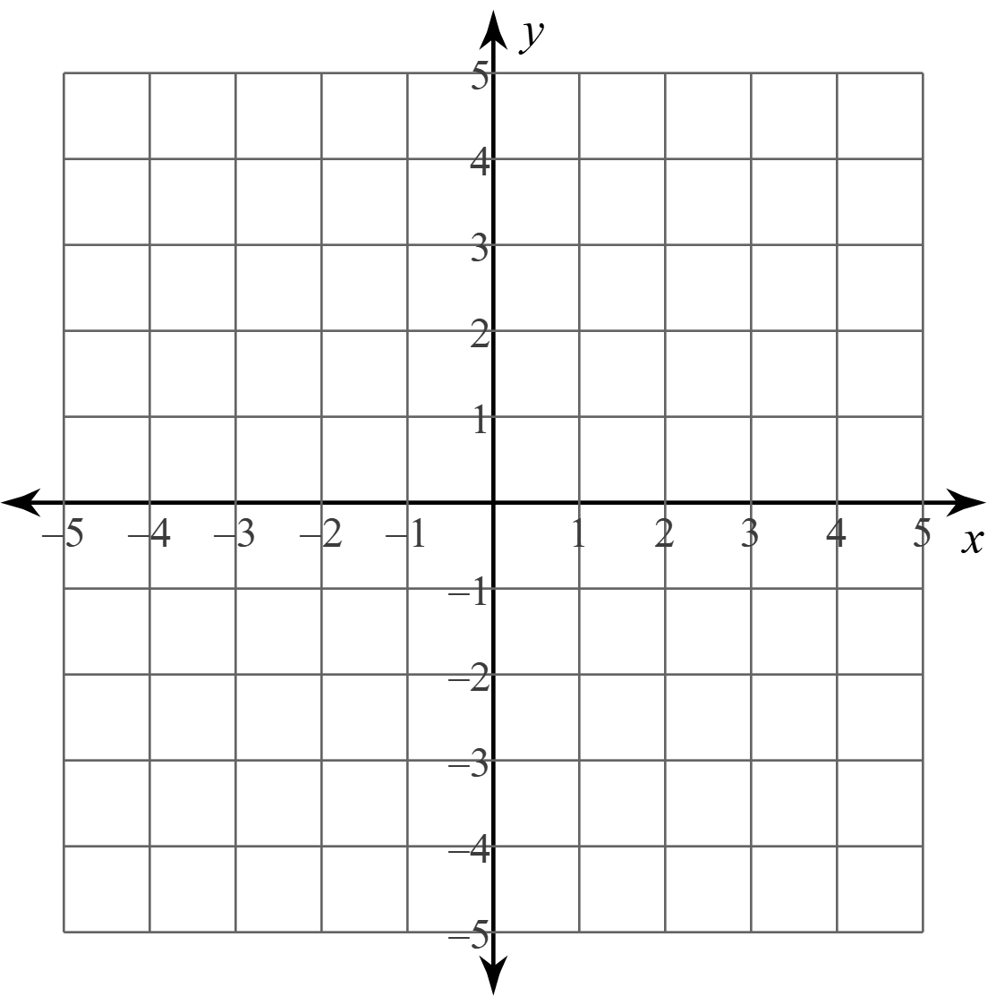
2) Graph: 2y – 4x ≥ 6

