Movie Snacks

Scenario 1:
Your family goes to the movies. The snack bar is all out of large popcorn containers and large cups. The only size they have left is small. Your family has $30 to spend. How many orders of popcorn and drinks can they buy if a popcorn costs $6 and a drink costs $5? Your family does not want any change.

Part A:

Find different combinations of popcorn orders and drinks that have a total of $30:
Total
$30
$30
$30
$30

Part B:
Plot the points of the different combinations on the graph below:
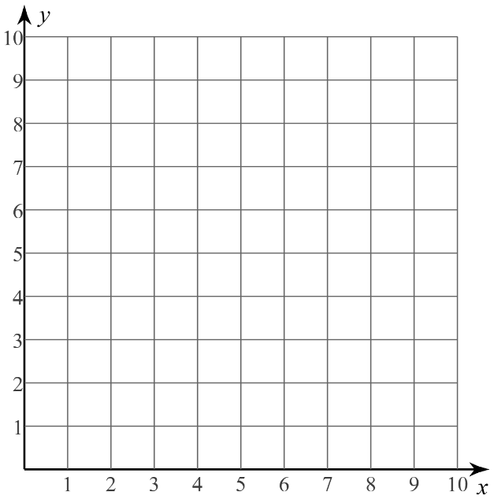 | Part C:  Answer the following questions:  - What type of graph do you see from the points?  - Connect the dots and explain your reasoning.

Scenario 2:
Your family decided it was way too difficult to determine how many orders of popcorn and drinks they needed to buy to get back no change. Now they do not mind if they get change back. How many different combinations of popcorn orders and drinks can your family buy?

Part A:
Find different combinations of popcorn orders and drinks that have a total of less than $30:
Total
$
$
$
$
$

Part B:
Copy the graph you created from Scenario 1 and add the points from Scenario 2 below:
Part C:
Answer the following questions:
- What are the relationships between the two scenarios?

- Is there an equation that can represent both scenarios? If so, what do you think it is?

