You are Martin Luther.  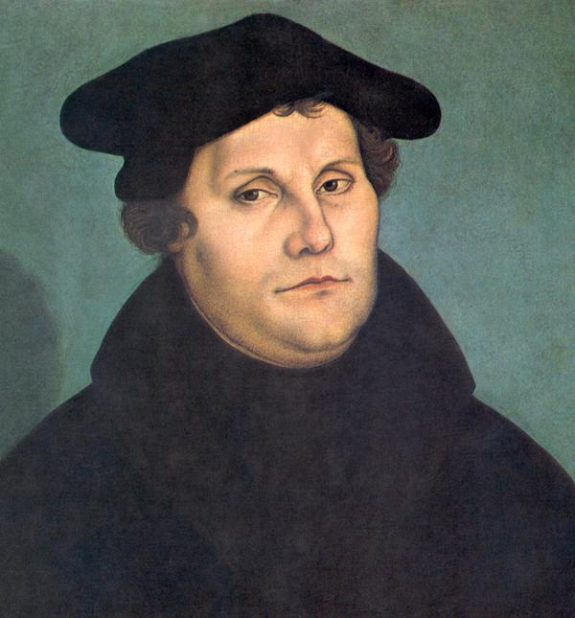  “I am an Augustinian monk, priest, author, and German theologian upset by the use of indulgences by the Roman Catholic Church. I posted my Ninety-five Theses on the door of the All Saints’ Church in Wittenberg, Germany, and started the Protestant Reformation. I refused the request by Pope Leo X and Holy Roman Emperor Charles V to renounce my writings and was excommunicated (officially excluded) from the church.” | You are John Calvin.  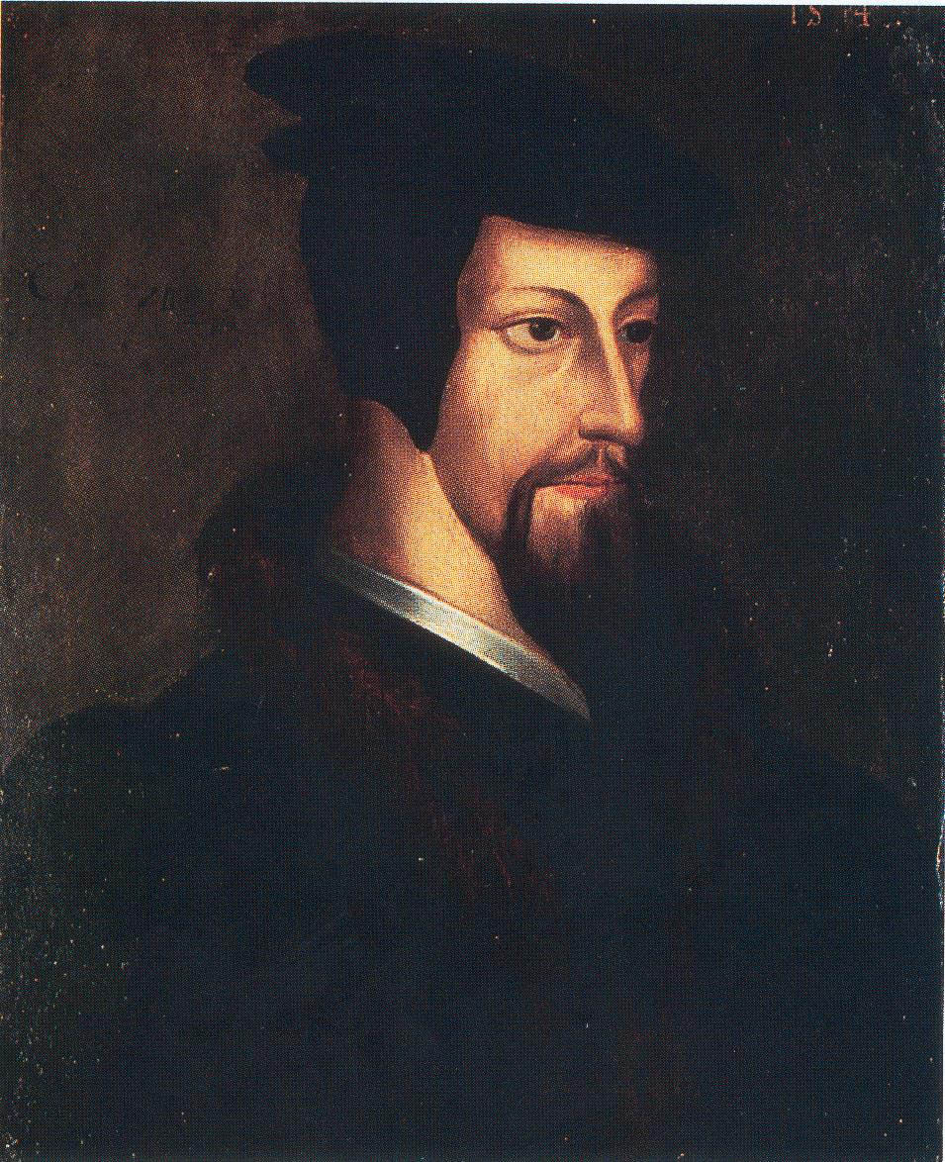  “I am a French theologian, reformer, and pastor based in Geneva. I broke from the Roman Catholic Church in the mid-1500s, and I believe in predestination, or the idea that all events in a person’s life have been determined by God. Many of my interpretations and teachings are part of Reformed churches.” | You are Henry VII of England.  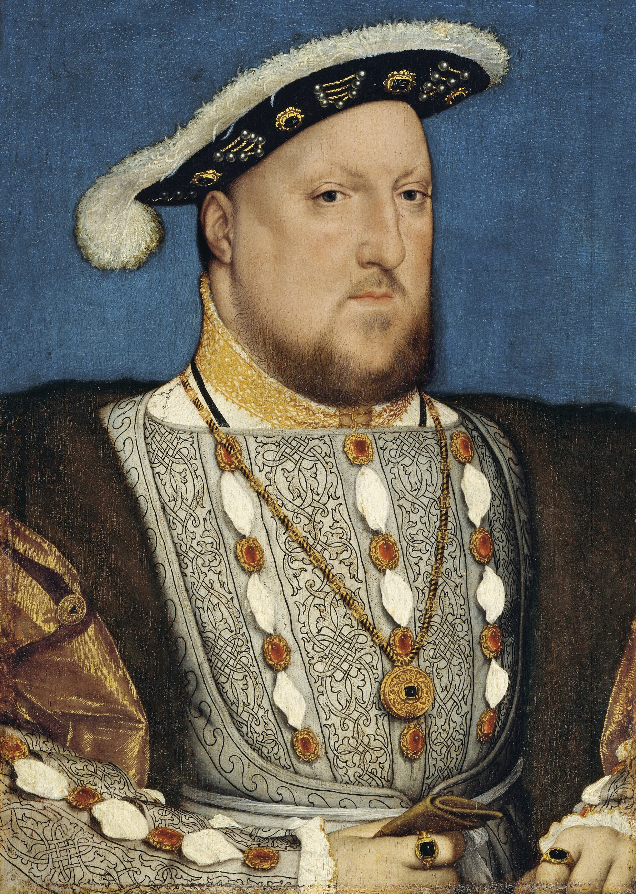  “I am the King of England, and I am currently married to Catherine of Aragon. I want my marriage to be annulled (declared invalid) so I can marry Anne Boleyn. After my disagreement with Pope Clement VII in regards to my annulment, I have initiated the English Reformation by splitting from the Roman Catholic Church, creating the Church of England, and appointing myself the leader. I allow annulments.”
You are Pope Clement VII  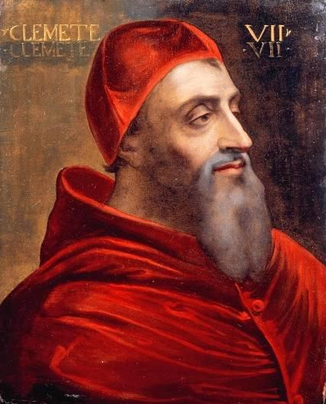  “I am the Pope of the Roman Catholic Church after the death of my predecessor, Pope Leo X, and I inherited the power struggle of the Protestant Reformation. I am a member of the powerful de Medici family. I refused King Henry VIII’s request for an annulment, which led to the English Reformation.” | You are Holy Roman Emperor Charles V  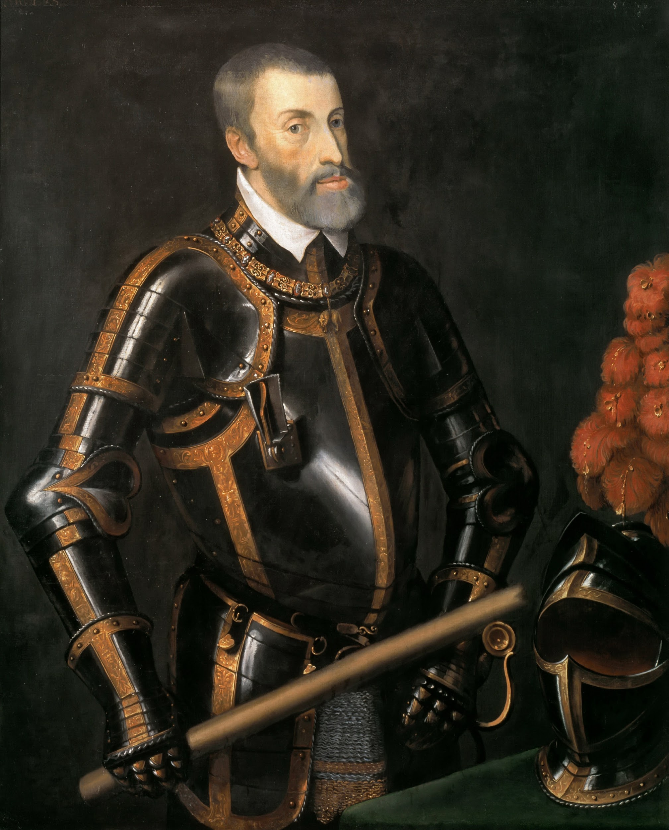  “I am the Holy Roman Emperor, King of Spain, and Duke of Burgundy. I feel that it is my responsibility as the Holy Roman Emperor to defend the Empire from the Protestant Reformation. I worked with Pope Leo X to label Martin Luther as an outlaw at the Diet of Worms.” | You are Catherine of Aragon  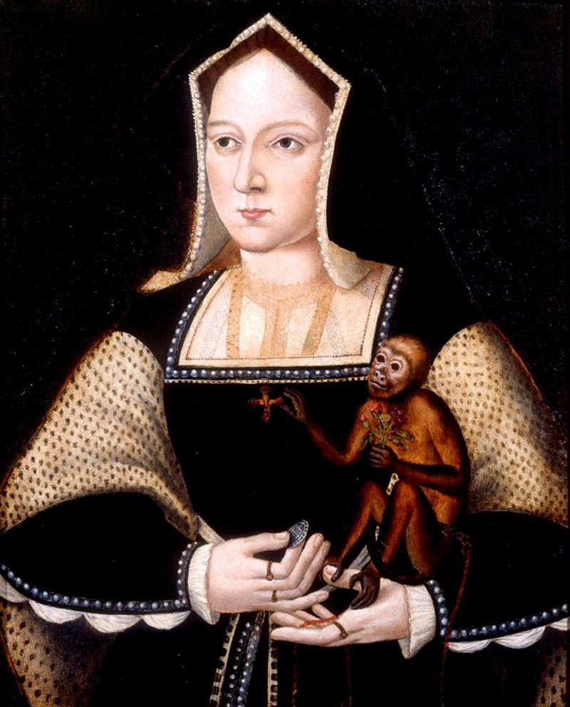  “I am the Queen of England, and I am married to King Henry VIII. I am a devout Roman Catholic, and my husband wants our marriage annulled, which is against the beliefs of my church. This caused King Henry VIII to break away and form the Church of England, which caused the English Reformation.”
You are Pope Leo X  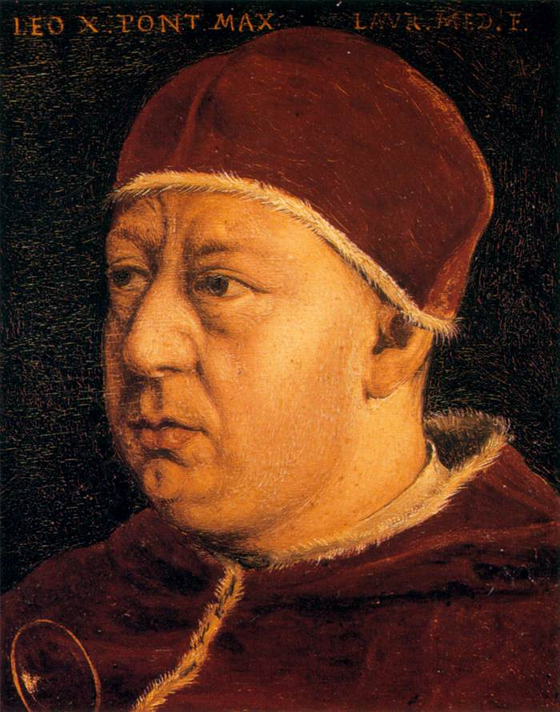  “I was the Pope of the Roman Catholic Church until my death in 1521. I am a member of the powerful de Medici family, and I am an active defender of the granting of indulgences. I refuse to acknowledge the demands listed in Martin Luther’s Ninety-five Theses.” | You are King Henry IV of France  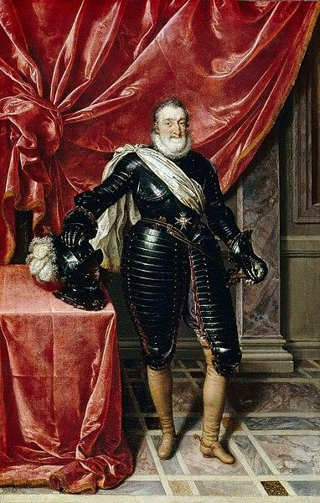  “I am the King of France. I was baptized as a Catholic, but I was raised as a protestant (Huguenot). In order to keep my crown, I converted back to Catholicism, but I still supported protestant causes, such as the Edict of Nantes, where I granted religious freedom to Protestants.”

Historical Mingle Sources
Wikimedia. (n.d.). Martin Luther portrait by Lucas Cranach. [Digital image]. https://commons.wikimedia.org/wiki/File:Martin_Luther_by_Cranach-restoration.jpg
Wikimedia. (n.d.). Portrait of young John Calvin from the collection of the Library of Geneva. [Digital image]. https://commons.wikimedia.org/wiki/File:John_Calvin_-_Young.jpg
Wikimedia. (n.d.) Portrait of Henry VIII by Hands Holbein, the Younger. [Digital image]. https://en.wikipedia.org/wiki/File:Hans_Holbein,_the_Younger,_Around_1497-1543_-_Portrait_of_Henry_VIII_of_England_-_Google_Art_Project.jpg
Wikimedia. (n.d.). Portrait of Pope Clement VII by Del Piombo. [Digital image]. https://commons.wikimedia.org/wiki/File:Portrait_of_Giulio_de_Medici_(1478_-_1534)_Pope_Clement_VII.jpg
Wikimedia. (n.d.). Emperor Charles V in armor by T. Vecelli. [Digital image]. https://en.m.wikipedia.org/wiki/File:Elderly_Karl_V.jpg
Wikimedia. (n.d.). Catherine of Aragon by Horenbout. [Digital image]. https://commons.wikimedia.org/wiki/File:Katharine_of_Aragon_with_a_monkey.jpg
Wikimedia. (n.d.). Pope Leo X by Bronzino. [Digital image]. https://commons.wikimedia.org/wiki/File:Angelo_Bronzino_-_Pope_Leo_X_-_WGA3273.jpg
Wikimedia. (n.d.). Henry IV, King of France in Armor by Pourbus the Younger. [Digital image]. https://commons.wikimedia.org/wiki/File:Henry_IV_of_france_by_pourbous_younger.jpg

