REFORMATION DOCUMENTS PACKAGE

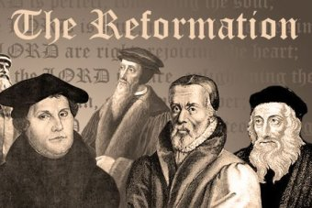

Table of Contents: Document Name | Page
95 Theses: The Disputation of the Power and Efficacy of Indulgences | 2
Diet of Worms | 5
Edict of Nantes | 8
Peace of Augsburg | 11
Pope Clement VII | 14
Glossary | 17
Sources | 18

REFORMATION DOCUMENTS PACKAGE

95 THESES: THE DISPUTATION OF THE POWER AND EFFICACY OF INDULGENCES
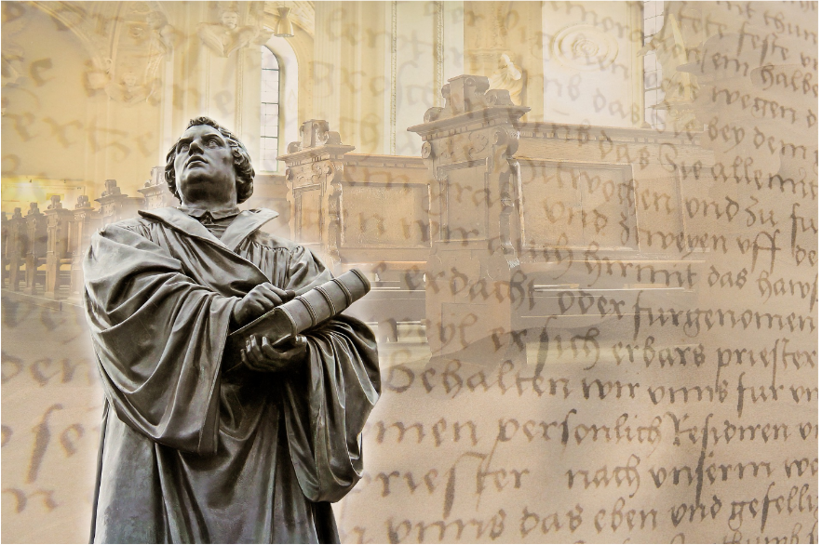
Led by Pope Leo X in the early 1500s, clergy in the Catholic Church sold indulgences. The Catholic Church began the sale of indulgences with Pope Urban II in 1095. Initially, the indulgence was similar to a charitable donation. It was a way that a person could reduce the amount of punishment for sins and wrongdoings that a person’s soul would suffer before going to heaven. The payments were initially intended to support the ongoing business of the church, and it is thought that many of the great cathedrals in Europe were financed by monies collected as indulgences. Church doctrine justified the collection of indulgences. It is believed that the time after death and before entering heaven, a soul resides in a place called purgatory, where the soul remains for a time to account for all the sins or wrongdoings a person committed during their life.
Figure 1: Martin Luther
Source: Breitling, A. (n.d.). Martin Luther. Pixabay. https://pixabay.com/illustrations/luther-martin-luther-wittenberg-1821759/
However, by the late middle ages, abuses to the system drew criticism. Guided by clergy intent on raising large sums of money, indulgences were bought by the purchaser for themselves or bought for someone else to shorten the length of time a soul had to wait in purgatory. Not surprisingly, the wealthy were able to “buy lots of time.” The poor, on the other hand, did not have the means to “buy time.” By 1517, the marketing of indulgences had become so aggressive that a notorious German friar named Johann Tetzel was reported to have said: “As soon as a coin in the coffer rings, a soul from purgatory springs.”
Although sanctioned and practiced by the clergy and the Pope, the buying and selling of these indulgences seriously concerned German theology professor, Martin Luther, who openly preached against the abuse of indulgences. He believed that the practice of indulgences “cheapened grace rather than requiring true repentance” (Brecht 1985, p. 176).
In order to publicize his point of view, Luther wrote his now-famous Ninety-five Theses, which were 95 points of debate about moral and financial issues that he felt came from the selling of indulgences by the Church. On October 31, 1517, Luther sent his work to the Archbishop of Mainz. Then, as was customary when proposing debate on scholarly and religious matters, Martin Luther nailed his Ninety-five Theses to the door of his local church. The Theses were soon printed and distributed across Europe. Luther’s work caused quite a stir, both for him and for the entire continent of Europe. One of his opponents called for him to be burned at the stake for heresy against the church. Scholars and clerics across Europe wrote contradictory papers refuting Luther’s claims. Luther was offered clemency more than once if he would agree to recant his Theses. He refused to recant.
Because of his refusal to confess to the world that his Theses were lies against the church, Luther was tried for heresy and ultimately excommunicated. Excommunication was considered a severe penalty, depriving the guilty Christian of all participation in the “common blessings” of the Church.
Luther was no longer permitted to participate in the holy sacraments and was considered an exile from the Church. When Luther refused to recant his Theses, Pope Leo X ordered that all his books be burned publicly. He issued a document called a “papal bull,” which condemned Luther and all his work as heretical. Luther’s response to the condemnation was to burn the Papal Bull publicly in front of a cathedral in Rome.
Across Europe, however, not all theologians found fault with his Theses. His work inspired other theologians, such as John Calvin, also to question the Church and its practices. Ultimately, Luther’s Ninety-five Theses caused so much controversy that it was recognized as a key event in the start of the Protestant Reformation. After his excommunication, Luther married. He and his wife Katherine von Bora, a nun whom he helped escape the convent, had six children. He spent the remainder of his days translating the Bible into German and preaching his beliefs across Northern Europe, where the belief in “Lutheranism” spread through Scandinavia and other parts of northern Europe. His translated version of the Bible enabled millions of German Catholics and Lutherans to read the scriptures for themselves, a privilege that had traditionally belonged only to the clergy, who could read both Latin and Hebrew.

SOURCES:
- Brecht, Martin. Martin Luther. tr. James L. Schaaf, Philadelphia: Fortress Press, 1985–93, 1:3–5.
- Nelson, E. C. (n.d.). Protestantism. Encyclopedia Britannica. https://www.britannica.com/topic/Protestantism/Ninety-five-Theses.
- Ng, E. K. (n.d.). Indulgences: The business of selling forgiveness. History of Yesterday. https://historyofyesterday.com/indulgences-the-business-of-selling-forgiveness-9906e91f1a5e
- Linder, D. O. (1995). The trial of Martin Luther: An account. Famous Trials. https://famous-trials.com/luther/286-home
- Wikipedia. (n.d.) Katharina von Bora. https://en.wikipedia.org/wiki/Katharina_von_Bora
- Wikipedia. (n.d.). Martin Luther. https://en.wikipedia.org/wiki/Martin_Luther

DIET OF WORMS
When German monk Martin Luther wrote his 95 Theses as criticisms of the Catholic Church and nailed them to the doors of several churches in Wittenburg, Germany, on October 31, 1517, he set an historical tempest in motion. He also mailed his Theses to the Archbishop of Mainz and Magdeburg, knowing that eventually the Pope, who resided in Rome, would be informed of his heretical work.
By 1521, the writings of Luther had, in fact, reached the leader of the Catholic Church, the Pope, in Rome. Disturbed by the criticism of many common clerical practices, Pope Leo X issued a papal bull or decree that Luther was a heretic and had been excommunicated. As a heretic, or person declared to be against Catholic teachings, Luther faced imprisonment or death.
Charles V, Archduke of Austria, King of Spain, was also the Holy Roman Emperor anointed by the Pope. As Emperor, Charles was the civil defender of the Catholic Church and its teachings. According to law, Charles V would normally have had Luther executed as a heretic. However, Luther’s protector, German prince, Frederick III, interceded with the Emperor on Luther’s behalf. Frederick asked that Luther be heard and offered safe passage rather than be seized by authorities and executed. Frederick’s request was granted by Charles V.
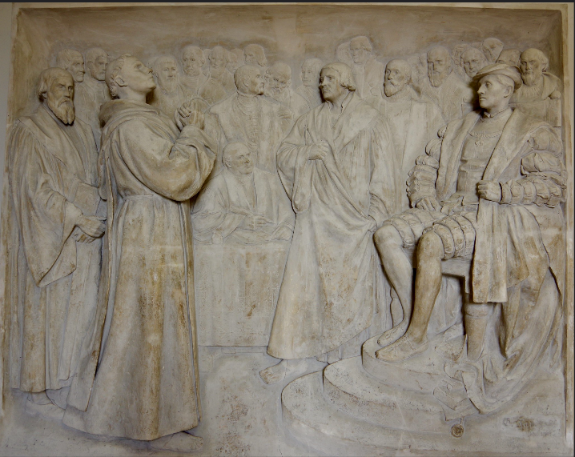
As a gesture of generosity, Charles V summoned Luther to the Diet or Council of Worms by Charles to explain his actions. Charles agreed to pardon Luther for his heresy if he recanted his criticisms of the Church. As Luther traveled to Worms, Germany, he expected to die either by assassination in route to the Diet or by execution on his arrival.
Figure 2: Luther at Worms
Source: Merrett, D. (2017). Martin Luther before Charles V at the Diet of Worms by Gerhard Janensch 1904. [Digital image]. Flikr. https://www.flickr.com/photos/davehamster/37073535632
The Diet was an assembly of religious leaders, nobles, and political authorities of the day. The Diet began in January of 1521, a few weeks after Luther’s excommunication, but Luther did not arrive in Worms until April. On his arrival in Worms, he was asked by the Council to recant or disavow his writings. Luther said this:
I beseech you to grant a gracious hearing to my plea, which, I trust, will be a plea of justice and truth; and if through my inexperience I neglect to give to any their proper titles or in any way offend against the etiquette of the court in my manners or behavior, be kind enough to forgive me, I beg, since I am a man who has spent his life not in courts but in the cells of a monastery; a man who can say of himself only this, that to this day I have thought and written in simplicity of heart, solely with a view to the glory of God and the pure instruction of Christ's faithful people. (Bettenson, H.C. translation of Luther’s account in Opera Latina).
Luther defended his writings, arguing they were based on Biblical scriptures and refused to disavow them. Luther immediately left Worms while the assembly deliberated his refusal to recant. On May 26, 1521, Emperor Charles V issued the Edict of Worms, a document which banned Luther’s teachings and named him an outlaw. Anyone who captured or killed Luther would be rewarded by the government.
Although branded as a heretic and an outlaw, Luther survived the edict because of his protector Frederick III. Soldiers under Frederick’s command “captured” Luther and hid him in Wartburg Castle in the heart of a forest. Luther remained in hiding for more than a year while his religious ideas continued to spread throughout Europe. During his time at Wartburg Castle, Luther began his work translating the Bible into German. When Luther emerged from the Castle, the Emperor did not press for Luther’s arrest. The Edict of Worms was not enforced in Germany, but in Belgium, Luxembourg, and the Netherlands (a region known as the Low Countries), Luther’s active supporters were arrested and prosecuted. Some supporters, who were compelled to publicly recant and repudiate Luther’s teachings under threat of execution, did so and escaped punishment. Two monks, however, who refused to recant were burned at the stake in Brussels.
In 1534, thirteen years after the Diet of Worms, Luther published what historians believe to be his greatest achievement: the Bible. His German translation encouraged more people to learn to read and further challenged the authority of the church leaders. Prior to the publication of the Bible into vernacular languages, worshippers were not able to read the scriptures themselves. They were dependent on Latin-speaking priests to convey the word of God. Luther died in 1546 at age sixty-two. He was buried in Wittenberg’s church—the church where he publicly posted his 95 Theses thirty years earlier.

SOURCES:
- Arcement, K. (2017). Martin Luther shook the world 500 years ago, but did he nail anything to a church door? Washington Post. https://www.washingtonpost.com/news/retropolis/wp/2017/10/31/martin-luther-shook-the-w orld-500-years-ago-but-did-he-nail-anything-to-a-church-door/
- Kilcrease, J. (n.d.). The diet of worms. Lutheran reformation. https://lutheranreformation.org/history/the-diet-of-worms/
- Linder, D. (2020). The trial of Martin Luther: An account. Famous trials. https://famous-trials.com/luther/286-home
- Luther, M. (1545). Martin Luther at the diet of worms, 1521. Translation by H.C. Bettenson from Documents of the Christian Church (1903) based on Luther’s Opera Latina [Wittenberg, 1545, tom 2 fol. 165] (Frankfurt, 1865-73). http://www.ldysinger.com/@texts2/1535_luther/08_1521_worms_here_I_stand.htm
- Merrett, D. (2017). Martin Luther before Charles V at the diet of worms by Gerhard Janensch 1904. [Digital image]. Flikr. https://www.flickr.com/photos/davehamster/37073535632
- Morris, D. B. (2019). Martin Luther as priest, heretic, and outlaw: The reformation at 500. European Reading Room. https://www.loc.gov/rr/european/luther.html
- Wilkes, J. (2020). Your guide to Martin Luther, the theologian who launched the reformation. HistoryExtra. https://www.historyextra.com/period/tudor/martin-luther-who-biography-why-important-edict-worms-95-theses/

EDICT OF NANTES
In 1589, Henry IV succeeded to the French throne after his predecessor, Henry III, was assassinated. At the time of his succession, he was a notable Protestant leader. Four years later, however, he became a Roman Catholic because that was the religion of his subjects. A few short years after his conversion, on April 13, 1598, King Henry IV of France passed into law the Edict of Nantes.
The Edict of Nantes was a law that consisted of four documents with the principal goal being an eventual peaceful reunion of the French people under one agreed-upon faith. The Edict reaffirmed the age-old French heritage of “one king, one faith, one law.” In essence, Henry IV wanted to ensure religious coexistence for the time being by reassuring and supporting the Calvinist Protestant subjects, known as Huguenots, without alienating the Catholics.
The first two documents had to be registered with the Parlement of Paris in order for it to receive the force of law. These two documents consisted of 92 general articles and 52 “secret articles.” The last two documents were known as brevets. A brevet is a royal document that does not need to be registered because it is provisional, ending once the king who issues them dies. Since the Parlement of Paris was made up of Catholics, King Henry IV put the most controversial articles into these “secret” royal brevets.
This edict, which temporarily ended the religious wars between the Roman Catholics and Protestants, granted religious liberties to the Huguenots that they had not had before. Most importantly, the edict recognized the Huguenots’ right to freedom of conscience and liberty to worship in towns they controlled. The Huguenots were empowered to hold public office, and the edict established special new courts, the Chambre de l’Édit, where both Huguenots and Catholic judges shared responsibilities to enforce the provisions of the edict.
Some of the freedoms the Edict granted included the ability to hold public worship in many parts of the kingdom (except Paris), inherit property, engage in trade, exercise full civil rights, such as access to education and the right to be treated in hospitals. Pastors were paid by the state and released from obligations based on religious disputes. The government agreed to subsidize garrisons for Huguenot-fortified towns. Huguenots and Catholics alike were granted full amnesty for crimes committed during the wars by both sides.
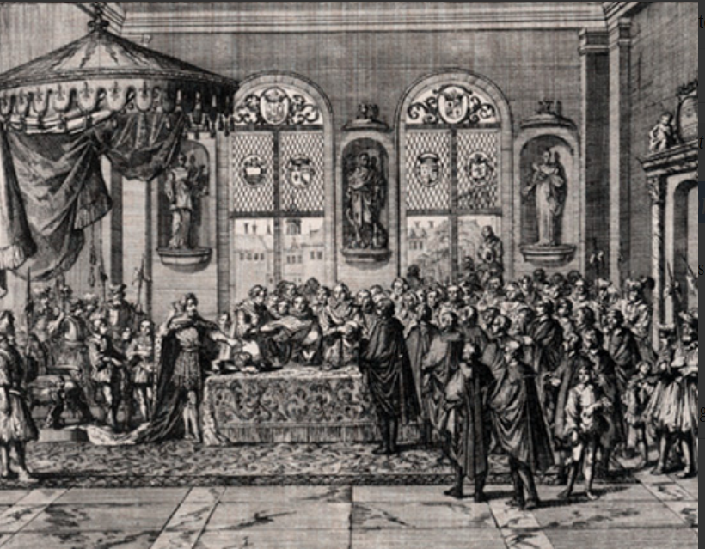
The edict also addressed Catholic concerns. The Catholic character of the crown and the kingdom was reaffirmed. Catholics were permitted to practice their faith anywhere; Huguenots were restricted to locations where they had been given permission to worship. Despite the favoritism to the Catholic Church, Pope Clement VIII, the Roman Catholic clergy in France, and the Parlement resented the edict, and, whenever possible, the Catholic Church disrupted the edict.
Figure 3: Registration of the Edict of Nantes by the Parliament of Parish
Source: Musée virtual du protestantisme. (n.d.). The enforcement of the Edict of Nantes until 1610. [Digital image]. https://museeprotestant.org/en/notice/the-enforcement-of-the-edict-of-nantes-until-1610/
An ardent Catholic, Chief Minister of France, Cardinal de Richelieu considered the edict a danger to the state. He believed the Huguenots were a threat to the internal stability and security of France. In 1629, he annulled the edict by the Grace of Alais. This document removed the political rights of the Huguenots and authorized the destruction of Huguenot fortresses in cities where citizens had practiced Lutheranism. Government funds were no longer available to educate Huguenots or support Protestant clergy. Life for Protestants returned to the persecutions that prevailed before the Edict.
On October 18, 1685, Louis XIV formally revoked the Edict of Nantes and deprived the French Protestants of all religious and civil liberties. French Huguenots were commanded to either convert to Catholicism, face life in prison or life in convents, or flee the country. At this time, it is estimated that over 800,000 Huguenots lived in France. As a result of the Edict revocation, more than 400,000 Huguenots emigrated to England, Prussia, Holland, and America. There is no documentation about the fate of the remaining Protestants.

SOURCES:
- Cengage. (2018). Edict of Nantes. Encyclopedia.com https://www.historytoday.com/archive/months-past/edict-nantes
- Editors of Encyclopedia Britannica. (2020). Edict of Nantes. Encyclopedia Britannica. https://www.britannica.com/event/Edict-of-Nantes
- Musée virtual du protestantisme. (n.d.). The enforcement of the Edict of Nantes until 1610. [Digital image]. https://museeprotestant.org/en/notice/the-enforcement-of-the-edict-of-nantes-until-1610/
- Wolfe, M. (2021). Edict of Nantes. Europe, 1450 to 1789. Encyclopedia of the Early Modern World. https://www.encyclopedia.com/history/encyclopedias-almanacs-transcripts-and-maps/nantes-edict

PEACE OF AUGSBURG
During the Middle Ages, Europe was divided into sovereign realms politically, each governed by a prince or a nobleman. Charles V was the supreme ruler of every realm that pledged its allegiance to the Catholic faith. His dominion in Europe extended from Germany to northern Italy, Austria, Burgundy, Spain, and the southern Italian realms of Naples, Sicily, and Sardinia. He had been named by Pope Clement VII Medici in 1530 as the Holy Roman Emperor and carried out the public and civil responsibilities of the Catholic faith. He spent most of his life defending the integrity of the Holy Roman Empire from the Protestant Reformation. He was the last Holy Roman Emperor to be crowned by a pope.
When Martin Luther nailed his Theses to the Church of Wittenberg and to other area churches in 1517, he started a revolution in Christianity. Catholicism was the official religion of the Christian world at that time. Any other beliefs were considered heresy. Luther indicated in his Theses that beliefs or dogma of Catholicism contradicted the Bible. He especially condemned the pope and Catholic clergy for granting indulgences (forgiveness of sins) based upon the sinner’s ability to pay large fees for their forgiveness. He upheld his beliefs when he was brought before the Diet of Worms in 1521, an assemblage of Charles V and many Catholic noblemen to account for his actions.
Luther’s ideas, which rapidly spread throughout Europe, would not have been widely distributed without the printing press, which had been in use in Europe since the late 1400s. Luther’s pamphlets, books, prayers, and ideas were printed and distributed throughout the realm. Many noblemen and commoners embraced Luther’s Christian beliefs. To support the spread of Lutheranism, a group of princes formed a private army known as the Schmalkaldic League. The League was a defensive military alliance committed to the practice of Lutheranism in their realms, rather than Catholicism. They were prepared to defend their religious choices. At its peak, the League commanded over 10,000 infantry and 2,000 cavalry for mutual protection. Although the League did not directly provoke Charles V, it confiscated church land, expelled bishops and Catholic princes and helped to spread Lutheranism throughout northern Germany. Martin Luther was active in the League, writing an article of faith document known as the Smalcaid articles, which was never formally adopted.
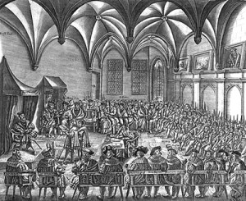
Charles V realized that continuous religious fighting among the realms was not wise. He appointed his brother, Ferdinand I, to create peace between the followers of Lutheranism and Catholicism. In 1555, the Peace of Augsburg, or the Augsburg Settlement, was formed. A treaty between Charles V and the Schmalkaldic League, the Settlement ended religious struggle between the two groups and made the division of the two tenants of Christianity permanent. The settlement supported by the princes of the sovereign realms proclaimed the principle, “Cuius regio; eius religio”—who reigns; his religion.
Figure 4:The Peace of Augsburg.
Source: Holy Roman Empire Association. (n.d.). The Peace of Augsburg. [Digital image]. http://www.holyromanempireassociation.com/peace-of-augsburg.html
The first provision stated that each ruler could choose the religion they preferred for their realm. If commoners in that domain did not want to follow that religion, they were permitted to move to another principality that did practice their religion. A second provision of the settlement stated that if the leader of a state changed his religion, the citizens in his state were not required to follow him. Instead, he was expected to resign from his post. The third and final provision exempted knights and some cities from the requirement of religious uniformity if the religion had been practiced there since the mid-1520’s. This third provision permitted the co-existence of Catholicism and Lutheranism in the same state. The third provision was kept secret for almost twenty years. The Peace of Augsburg recognized only Catholicism and Lutheranism as Christian religions. There was no mention in the document of either Jewish or Muslim followers. Any religion other than Catholicism or Lutheranism was considered heresy. Although not perfect, the Peace of Augsburg reduced internal religious conflicts for more than fifty years.

SOURCES:
- Editors of the Encyclopedia. (2020). Peace of Augsburg. Encyclopedia Britannica. https://www.britannica.com/event/Peace-of-Augsburg
- Editors of the Encyclopedia. (2020). Schmalkaldic league. Encyclopedia Britannica. https://www.britannica.com/event/Schmalkaldic-League
- Holy Roman Empire Association. (n.d.). The Peace of Augsburg. [Digital image]. http://www.holyromanempireassociation.com/peace-of-augsburg.html

POPE CLEMENT VII
Pope Clement VII came to the Roman papacy at a time of great religious and political change in Europe. He served as head of the Catholic Church and ruler of the Papal States from 1523-1534. Born in Florence, most historians write of Pope Clement VII as a morally decent man, yet an indecisive pope. Inadvertently a major influence in the Protestant Reformation, Clement was caught in the political warring of two kings, each of whom asked him to take their side in control of Europe—Holy Roman Emperor Charles V (Archduke of Austria and King of Spain), and Francis I, (King of France). Clement struggled with political, military, and religious conflicts throughout his time as Pope. He dedicated himself to making peace among the different Christian leaders. Although a religiously devout man, Clement occupied much of his time supporting and engaged in art and science. He commissioned some of the most famous artwork of the age, including Michelangelo’s “The Last Judgment” in the Sistine Chapel. He approved Nicolaus Copernicus’ theory that the Earth revolved around the sun. He protected the Jews from the Inquisition. Although Clement was considered a diplomat, his detractors believed his interest in cultural and worldly things made him indifferent to the dangers of the Protestant Reformation.
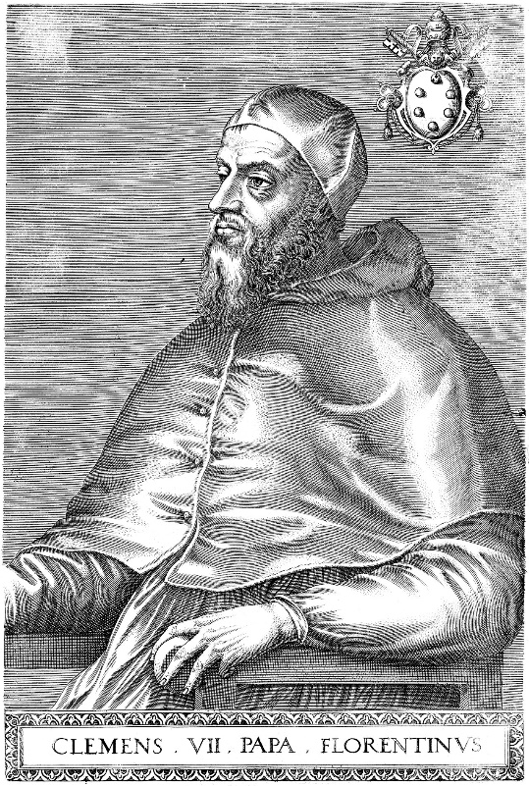
By the time Clement VII was elected pope in 1523, Martin Luther’s reforms about religious teachings had spread widely throughout northern Europe. The previous pope, Leo X, had already excommunicated Luther from the Catholic Church because of his ideas. Excommunication from the church did little to stop Luther’s reforms from gaining in popularity and influence. Interest in Luther’s premises gradually made their way from northern Europe to England, also a Catholic country.
In open opposition to church law, Henry VIII of England demanded a divorce from Catherine of Aragon because of her inability to produce a male heir. Catherine, who was violently opposed to divorce, informed Pope Clement that Henry intended to marry again. Clement, thought to be influenced by Catherine’s nephew, the Holy Roman Emperor Charles V, refused to grant Henry a divorce which was against the teachings of the Church. According to Church law, a valid marriage could not be dissolved until the death of one of the partners. Prohibited by Church law to annul the marriage, Clement issued a very public decree, a papal “bull,” threatening the King with excommunication if he persisted with his plans to divorce Catherine. The papal bull was posted on doors of churches throughout Europe:
Figure 5: Portrait of Pope Clement VII (1568) Source: Wikipedia (n.d.). Pope Clement VII. [Digital image]. https://en.wikipedia.org/wiki/Pope_Clement_VII
Papal Bull, [N]otifying that on the appeal of queen Katharine (Catherine of Aragon) from the judgment of the Legates, who had declared her contumacious (stubborn) for refusing their jurisdiction as being not impartial, the Pope had committed the cause, at her request, to Master Paul Capisucio, the Pope’s chaplain, and auditor of the Apostolic palace, with power to cite the King and others; that the said Auditor, ascertaining that access was not safe, caused the said citation, with an inhibition under censures, and a penalty of 10,000 ducats, to be posted on the doors of the churches in Rome, at Bruges, Tournay, and Dunkirk, and the towns of the diocese of Terouenne (Morinensis). The Queen, however, having complained that the King had boasted, notwithstanding the inhibition and mandate against him, that he would proceed to a second marriage, the Pope issues this inhibition, to be fixed on the doors of the churches as before, under the penalty of the greater excommunication, and interdict to be laid upon the kingdom. –issued Bologna, 7 March 1530, 7 Clement VII.
Determined to set aside Queen Catherine and marry Anne Boleyn, Henry decided to break away from the Catholicism of Rome, starting his own church—the Church of England. He declared laws stating that church bishops in England could be consecrated without papal approval. After the convenient death of the Archbishop of Canterbury, William Warham, an ardent friend of the pope, Henry appointed his friend Thomas Cranmer as Archbishop. The new Archbishop Cranmer granted to the annulment Henry sought. Henry set Catherine aside and married Anne Boleyn. Pope Clement excommunicated both Henry and Cranmer, a move that drove Henry to embrace more of the reforms already circulating throughout Europe. In 1534, Henry VII was declared the head of the Church of England by Parliament. The break with the Catholic Church was permanent, and the movement of an English reformation had begun.
Clement’s role in the development of the English Reformation is regarded as a turning point in the history of Catholicism. Despite being regarded by historians as both intelligent and cultured, Clement is also remembered as a man who lacked resolution and the ability to act.

SOURCES:
- Editors of Encyclopedia Britannica. (2020). Clement VII. Encyclopedia Britannica. https://www.britannica.com/biography/Clement-VII-pope
- Reformation 500. (n.d.) Charles V. Concordia Seminary. https://reformation500.csl.edu/bio/charles-v/
- The Anne Boleyn Files. (2013). Pope Clement VII forbids Henry VII to marry again. Papal bull. https://www.theanneboleynfiles.com/7-march-1530-pope-clement-vii-forbids-henry-viii-to-marry-again/
- Wikipedia (n.d.). Pope Clement VII. [Digital image]. https://en.wikipedia.org/wiki/Pope_Clement_VII

GLOSSARY
- Absolution: The act of forgiving someone for having done something wrong or sinful. Absolution required confessing and receiving forgiveness from a priest in order for the sin or act to be forgiven.
- Annul: To declare or make legally invalid or void.
- Catholicism: A Christian church having a hierarchy of priests and bishops under the pope. Worship includes a liturgy centered in the Mass, veneration of the Virgin Mary and saints, clerical celibacy, and a body of dogma including transubstantiation and papal infallibility.
- Clemency: Act of being merciful and moderate the severity of punishment for an act or belief.
- Coffer: A place or account where a sum of money or other resources whose principal or interest is set aside for a specific objective. Payments for indulgences were set aside for use in the Roman Catholic Church during the Middle Ages.
- Diet: A meeting of the most significant political authorities in the Holy Roman Empire for the purpose of discussing and resolving key issues facing the realm.
- Ecclesiastical: of or relating to a church, especially as an established institution.
- Edict: A proclamation having the force of law.
- Excommunicate. Exclude from the rights of church membership.
- Heresy: Having a religious opinion contrary to church dogma.
- Indulgences: In the Roman Catholic Church, an indulgence was a grant by the Pope for the remission of the temporal punishment in purgatory still due for sins after absolution. The unrestricted sale of indulgences by Pardoners was a widespread abuse in the Middle Ages. The sale of indulgences was a key point in Martin Luther’s 95 Theses.
- Lutheranism: A Protestant church that follows the teachings of Martin Luther; relating to doctrines such as justification by faith alone, developed by Martin Luther or his followers.
- Papal Bull: A decree from the Pope. Papal bull comes from the Latin word of “bulla” which means seal. Each letter or decree was given a wax seal with the papal crest as proof it was from the pope.
- Polemics: An aggressive attack on or refutation of the opinions or principles of another.
- Protestants: A member of any of several church denominations denying the universal authority of the Pope and affirming the Reformation principles of justification by faith alone, the priesthood of all believers, and the primacy of the Bible as the only source of revealed truth.
- Purgatory: A place or state of punishment. According to Roman Catholic doctrine, the souls of those who die in God’s grace may make satisfaction for past sins in purgatory and become fit for heaven.
- Recant: Publicly withdraw or repudiate a statement or belief.
- Repudiate: To reject as unauthorized or as having no binding force.
- Sanction: A formal decree levied against an individual or a state for violation of a law.
- Vernacular: A language or dialect native to a region or country rather than a literary, cultured, or foreign language.

COMPLETE LIST OF SOURCES
- Australian Broadcasting Corporation. (2017). The Reformation. [Digital image]. ABC. The Reformers - The Spirit of Things - ABC Radio National (Australian Broadcasting Corporation) https://www.abc.net.au/radionational/programs/archived/spiritofthings/the-reformation-image/9084468
- Arcement, K. (2017). Martin Luther shook the world 500 years ago, but did he nail anything to a church door? Washington Post.
- Brecht, Martin. Martin Luther. tr. James L. Schaaf, Philadelphia: Fortress Press, 1985–93, 1:3–5.
- Cengage. (2018). Edict of Nantes. Encyclopedia.com https://www.historytoday.com/archive/months-past/edict-nantes
- Editors of Encyclopedia Britannica. (2020). Clement VII. Encyclopedia Britannica. https://www.britannica.com/biography/Clement-VII-pope
- Editors of Encyclopedia Britannica. (2020). Edict of Nantes. Encyclopedia Britannica. https://www.britannica.com/event/Edict-of-Nantes
- Editors of the Encyclopedia. (2020). Peace of Augsburg. Encyclopedia Britannica. https://www.britannica.com/event/Peace-of-Augsburg
- Editors of the Encyclopedia. (2020). Schmalkaldic League. Encyclopedia Britannica. https://www.britannica.com/event/Schmalkaldic-League
- Holy Roman Empire Association. (n.d.). The Peace of Augsburg. [Digital image]. http://www.holyromanempireassociation.com/peace-of-augsburg.html
- Kilcrease, J. (n.d.). The Diet of Worms. Lutheran reformation. https://lutheranreformation.org/history/the-diet-of-worms/
- Linder, D. (2020). The trial of Martin Luther: An account. Famous trials. https://famous-trials.com/luther/286-home
- Luther, M. (1545). Martin Luther at the Diet of Worms, 1521. Translation by H.C. Bettenson from Documents of the Christian Church (1903) based on Luther’s Opera Latina [Wittenberg, 1545, tom 2 fol. 165] (Frankfurt, 1865-73). http://www.ldysinger.com/@texts2/1535_luther/08_1521_worms_here_I_stand.htm
- Merrett, D. (2017). Martin Luther before Charles V at the Diet of Worms by Gerhard Janensch 1904. [Digital image]. Flikr. https://www.flickr.com/photos/davehamster/37073535632
- Morris, D. B. (2019). Martin Luther as priest, heretic, and outlaw: The Reformation at 500. European Reading Room. https://www.loc.gov/rr/european/luther.html
- Musée virtual du protestantisme. (n.d.). The enforcement of the Edict of Nantes until 1610. [Digital image]. https://museeprotestant.org/en/notice/the-enforcement-of-the-edict-of-nantes-until-1610/
- Nelson, E. C. (n.d.). Protestantism. Encyclopedia Britannica. https://www.britannica.com/topic/Protestantism/Ninety-five-Theses
- Ng, E. K. (n.d.). Indulgences: The business of selling forgiveness. History of Yesterday. https://historyofyesterday.com/indulgences-the-business-of-selling-forgiveness-9906e91f1a5e
- Reformation 500. (n.d.) Charles V. Concordia Seminary. https://reformation500.csl.edu/bio/charles-v/
- The Anne Boleyn Files. (2013). Pope Clement VII forbids Henry VII to marry again. Papal bull. https://www.theanneboleynfiles.com/7-march-1530-pope-clement-vii-forbids-henry-viii-to-marry-again/
- Wikipedia. (n.d.) Katharina von Bora. https://en.wikipedia.org/wiki/Katharina_von_Bora
- Wikipedia. (n.d.). Martin Luther. https://en.wikipedia.org/wiki/Martin_Luther
- Wikipedia (n.d.). Pope Clement VII. [Digital image]. https://en.wikipedia.org/wiki/Pope_Clement_VII
- Wilkes, J. (2020). Your guide to Martin Luther, the theologian who launched the reformation. HistoryExtra. https://www.historyextra.com/period/tudor/martin-luther-who-biography-why-important-edict-worms-95-theses/
- Wolfe, M. (2021). Edict of Nantes. Europe, 1450 to 1789: Encyclopedia of the Early Modern World. https://www.encyclopedia.com/history/encyclopedias-almanacs-transcripts-and-maps/nantes-edict

