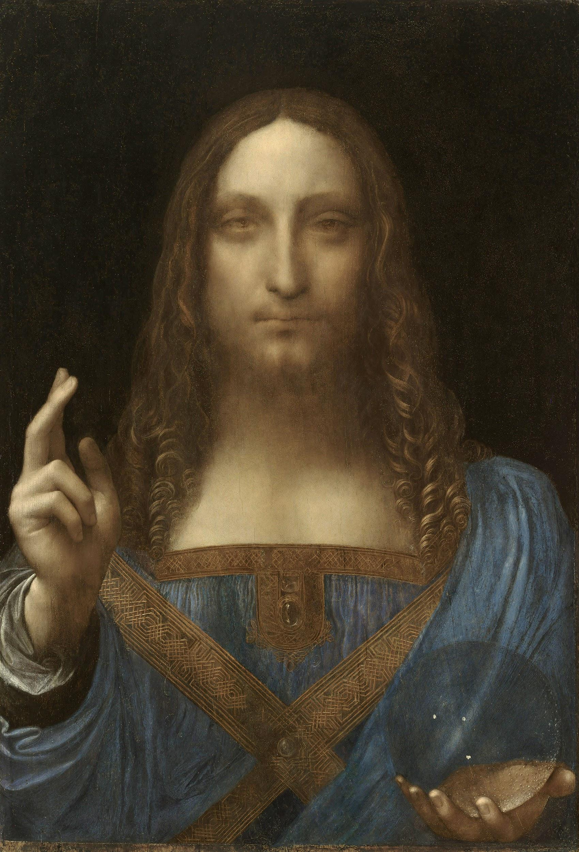
da Vinci, L. (ca. 1500). Salvator Mundi [Painting: Oil on walnut wood]. Wikimedia Commons. https://commons.wikimedia.org/wiki/File:Leonardo_da_Vinci,_Salvator_Mundi,_c.1500,_oil_on_walnut,_45.4_%C3%97_65.6_cm.jpg
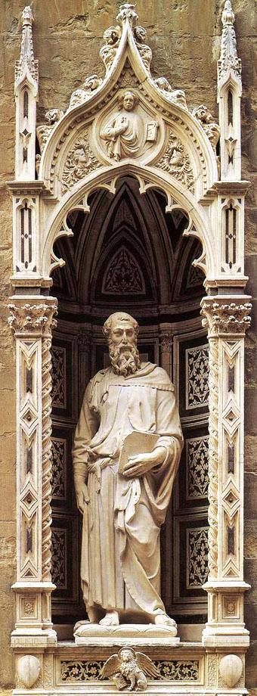
Donatello. (1411-1413). Saint Mark [Marble statue]. Wikimedia Commons. https://commons.wikimedia.org/wiki/File:Stmark.jpg
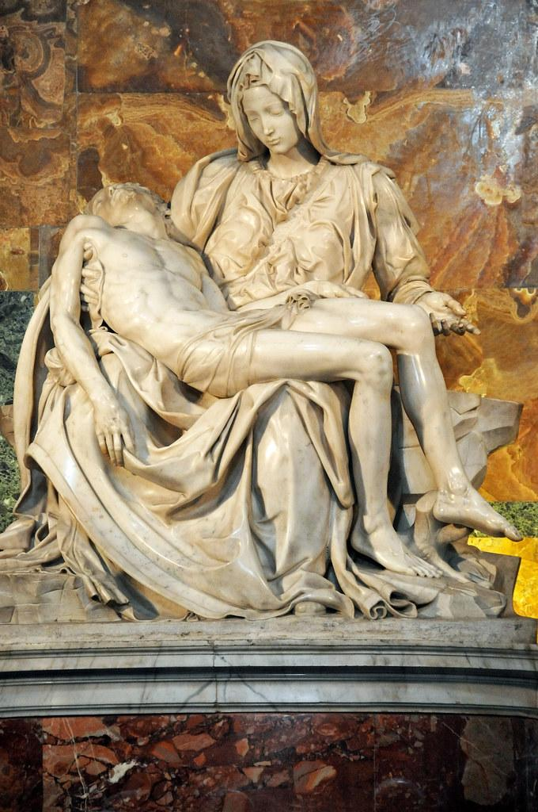
Michelangelo. (1498-1499). Pietà [Statue]. Wikimedia Commons. https://commons.wikimedia.org/wiki/File:Michelangelo%27s_Piet%C3%A0,_St_Peter%27s_Basilica_(1498%E2%80%9399).jpg
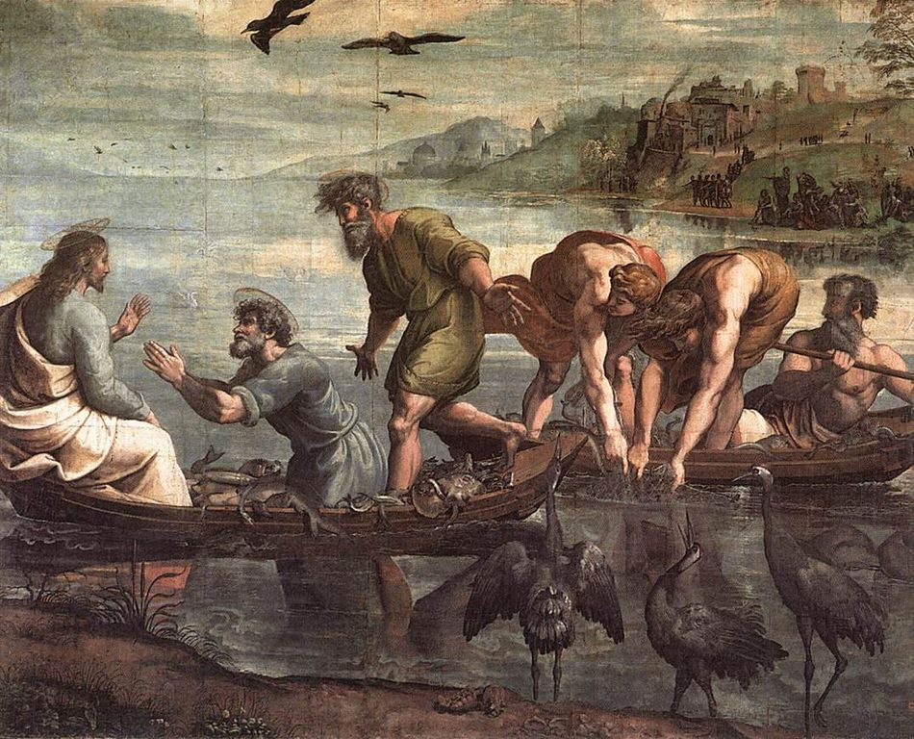
Raphael. (1515). The miraculous draught of fishes [Painting]. Wikimedia Commons. https://commons.wikimedia.org/wiki/File:V%26A_-_Raphael,_The_Miraculous_Draught_of_Fishes_(1515).jpg

