Emoji Reflection
Circle the three emojis that you think best represent each group’s perspective on allotment, and then briefly explain your choices.
U.S. Government Perspective
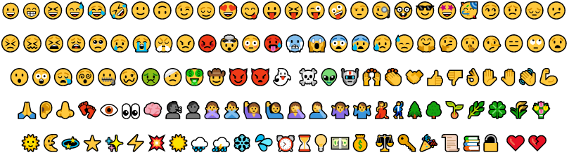
Reasoning:

Native American Perspective
Reasoning:

