MAPS SHOW PATTERNS ON EARTH’S SURFACE
There are many different types of maps. These maps tell us important information. One type of map is called a topographical map. Topographical maps show the shape of an area. You can see the low and high points of land, or elevation, based on the colors of the map. Usually, shades of brown show where mountain ranges are located. Shades of blue are used to show how deep the water masses are. The color green is used to show where the land is mostly flat.
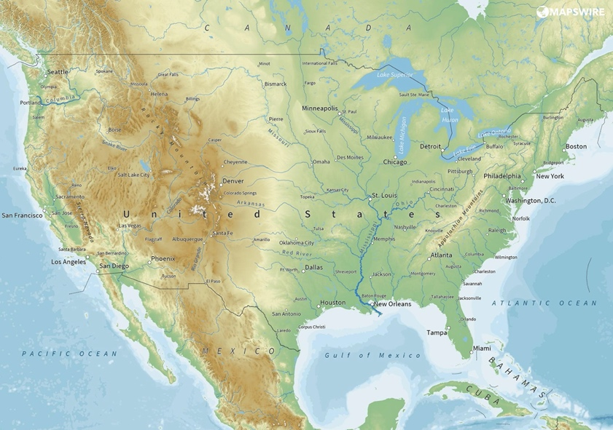
You can see the low and high points of land, or elevation, based on the colors of the map.
Mapswire. Physical Map of the United States [Map]. https://mapswire.com/countries/united-states/
Use colored pens/pencils
Circle highest elevation in red.
Circle lowest elevation in blue.
Circle the Appalachian Mountains in green.
Circle where you live on the map in black. Based on the details of the map, does this location have a high or low elevation? How do you know?
_____________________________________________________________________________
_____________________________________________________________________________
_____________________________________________________________________________

Earthquakes Occur in Patterns
The U.S. Geological Survey tracks earthquakes that happen all over the world. The map below shows where earthquakes have happened in a 30-day period. An earthquake is the shaking of the surface of Earth from a sudden release of energy in the earth’s crust. In this map each circle is a different earthquake. The brighter the color the more recent it has happened. The bigger the circle the larger the earthquake was. A red circle means the earthquake has happened within the last hour. An orange circle has happened int the last day, a yellow circle shows earthquakes that happened within the last week, and if the circle is white it has happened in the last month. About 90 percent of earthquakes that happen on earth take place around the Pacific Ocean. This is known as the Ring of Fire.
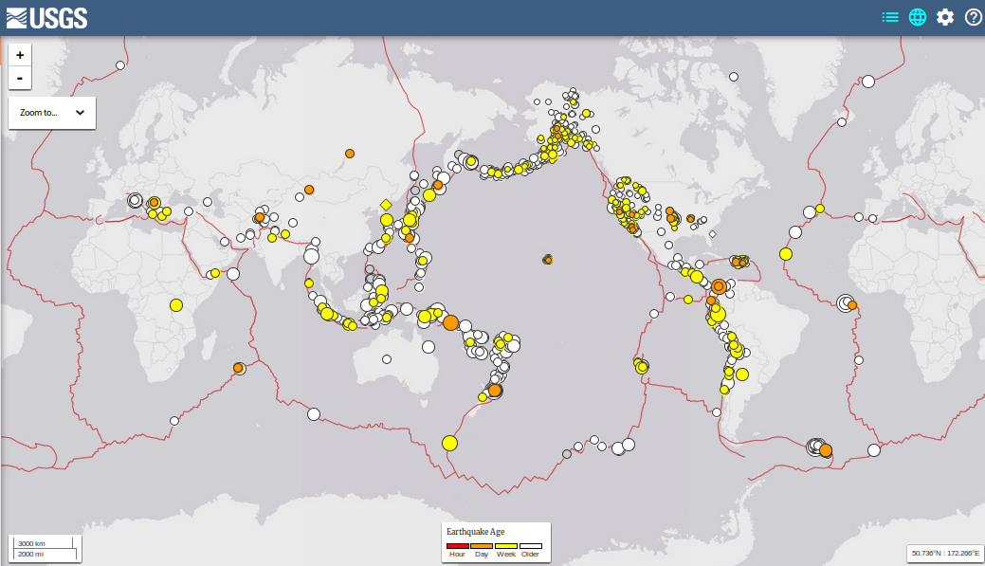
This map is unique. It shows you where earthquakes have occurred most in a 30-day period.
Your Own World, USA. 09-14-2016 USGS Earthquakes, Last 30 Days [Map]. https://yowusa.com/2016/09/planet-x-signs-12/09-14-2016_usgs_earthquakes-2//
Use colored pens/pencils
Trace the pattern of earthquakes around the Pacific Ocean in blue.
Trace the pattern of earthquakes in Europe in green.
Why do you think scientists have named the area in the Pacific Ocean the Ring of Fire? _____________________________________________________________________________
_____________________________________________________________________________
_____________________________________________________________________________

Volcanoes Occur in Patterns

Like earthquakes, most volcanoes are along the edges of the Pacific Ocean. A volcano is a rupture or break in the crust that allows hot lava, ash, and gases to escape from below the earth’s surface. Usually, a volcano looks like a mountain or hill with a crater or vent at the top. The map below shows all of the active volcanoes around the world using a red dot. The red lines shoe the oceanic spreading ridge. This is the fracture zone along the ocean bottom.

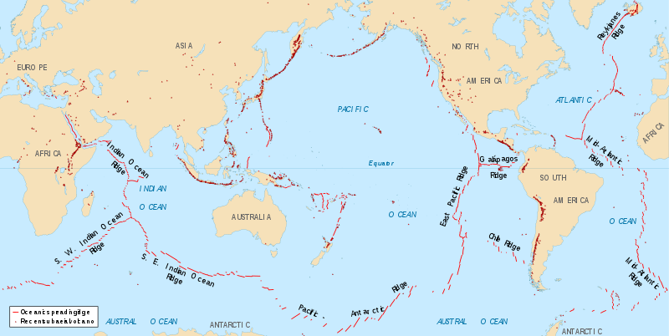
This map is unique. It shows you where active subduction zones are located.
Spreading ridges volcanoes map. (n.d.) In Wikimedia Commons. https://commons.wikimedia.org/wiki/File:Spreading_ridges_volcanoes_map-en.svg
Use colored pens/pencils
Trace the pattern of volcanoes that create the Ring of Fire in green.
Identify other patterns about volcanoes that you see on this map in blue.
What pattern do you see in the location of earthquakes and volcanoes? Why do you think this is?
_____________________________________________________________________________
_____________________________________________________________________________
_____________________________________________________________________________ _____________________________________________________________________________
_____________________________________________________________________________

Mountain Ranges Occur in Patterns

Below is another example of a topographical map. This map shows the entire earth in one picture. Like the first topographical map you saw, this one shows high and low elevation points based on the colors. High points of elevation are shown in dark brown and grey. These areas are large landforms that rise above the surrounding area in the form of a peak, known as mountains.
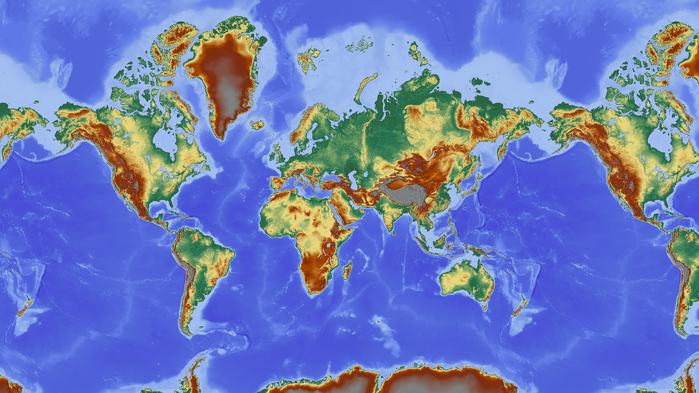
Topographical World Map
Pixabay. (n.d.) Map of the World. Hans. [Map]. https://pixabay.com/illustrations/map-of-the-world-map-relief-map-1804890/
Use colored pens/pencils
Trace mountain ranges around the Ring of Fire in black.
Identify other patterns of mountain locations in green.
What pattern do you see in the location of earthquakes, volcanoes, and mountains? Why do you think this is?
_____________________________________________________________________________
_____________________________________________________________________________
_____________________________________________________________________________ _____________________________________________________________________________
_____________________________________________________________________________

