PATTERNS ON EARTH’S SURFACE
Maps show patterns on Earth’s surface. Use the map to compare and contrast the patterns you identified in earthquake activity, volcanic activity, and mountain growth.
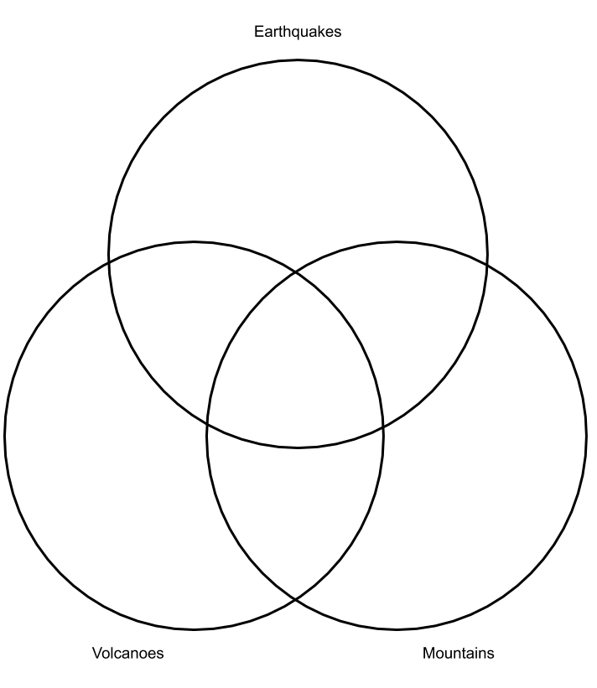

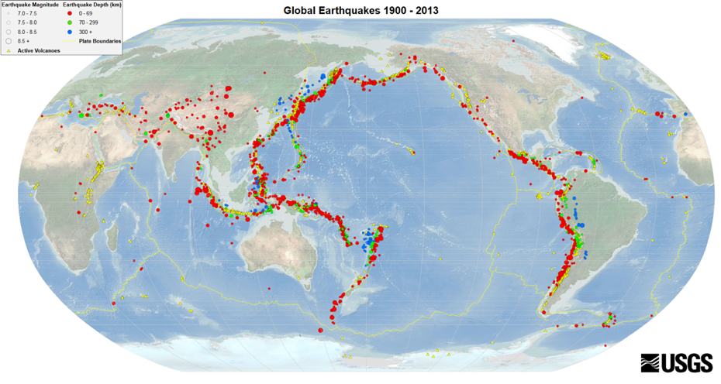
USGS. [@USGS]. (2017, February 17). Earthquake Information by Region Seismicity of the Earth Maps 1900-2013 [Tweet]. Twitter. https://twitter.com/USGS/status/834095848963395584?s=20

