It’s Party Time!
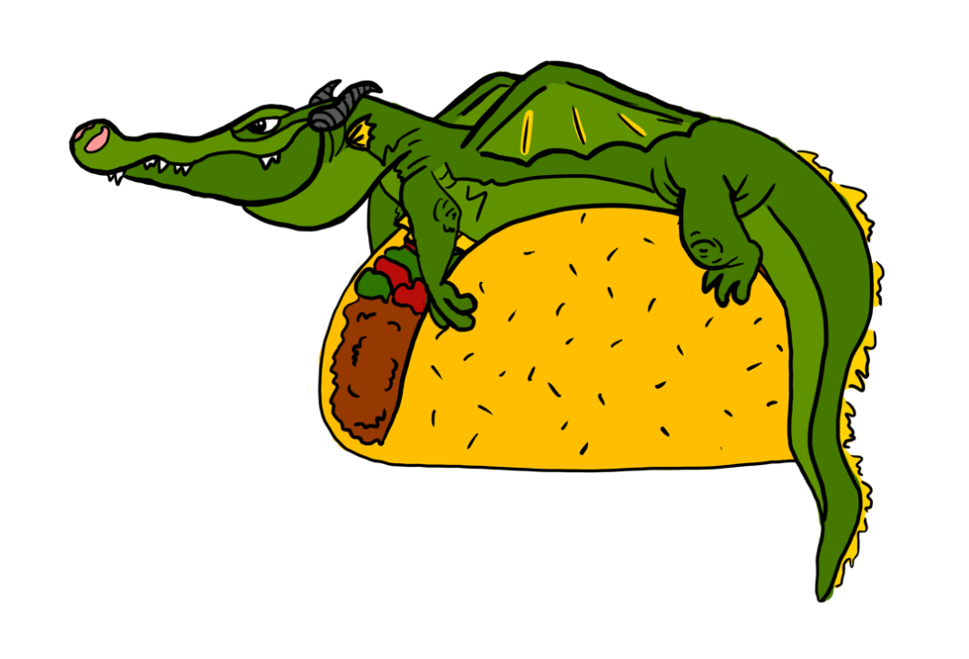

You’re Invited to a Dragon Taco Party!

Who: ____________________________________________________________________________________________________________________________________________________________

What:
__________________________________________________________________________________________________________________________________________________________________________________________________________________________________________

Where:
____________________________________________________________________________________________________________________________________________________________

When:
____________________________________________________________________________________________________________________________________________________________

Why:
________________________________________________________________________________________________________________________________________________________________________________________________________________________________________________________________________________________________________________________

