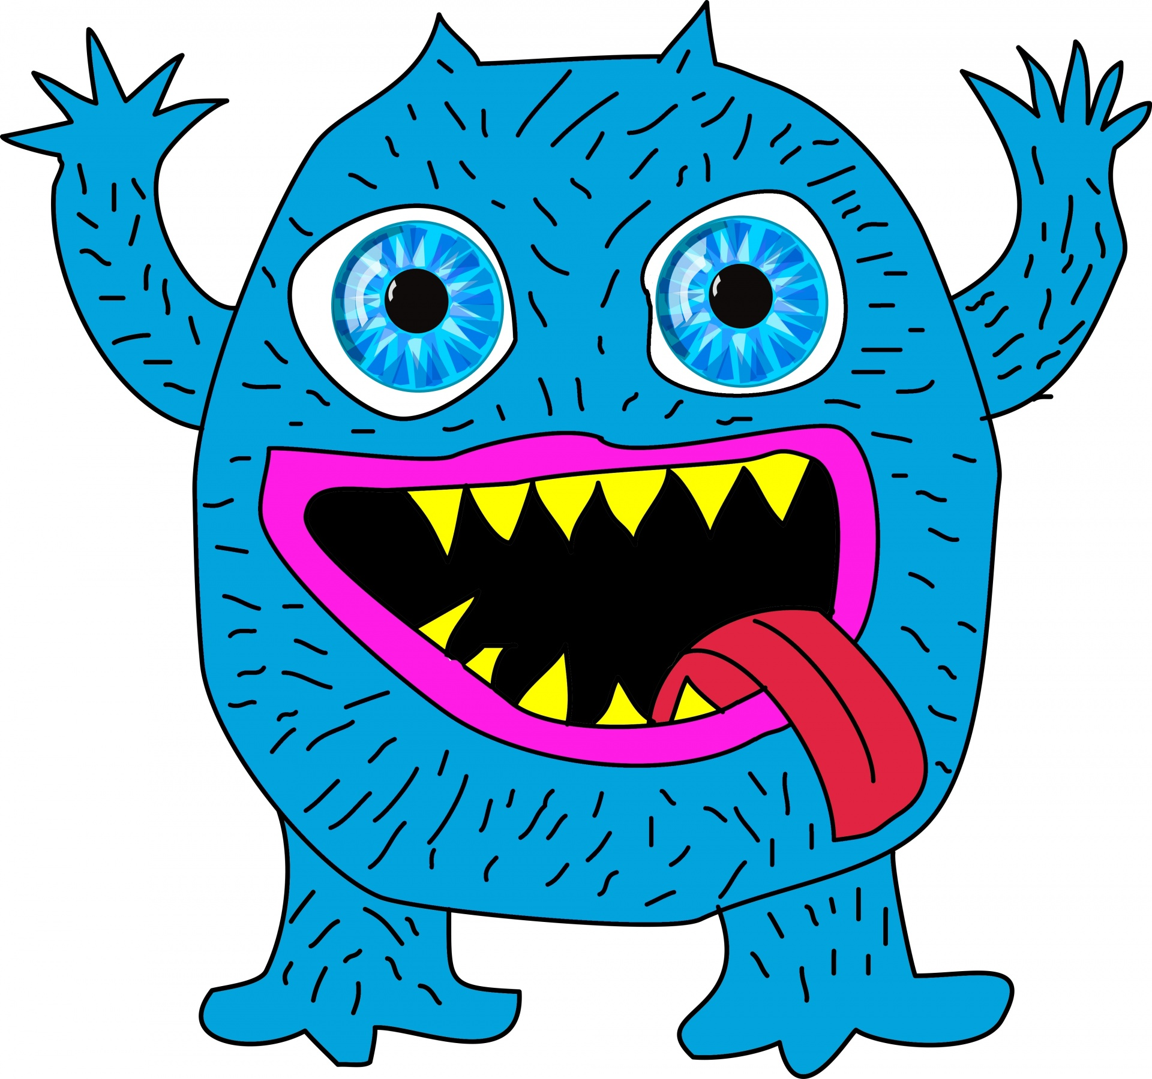

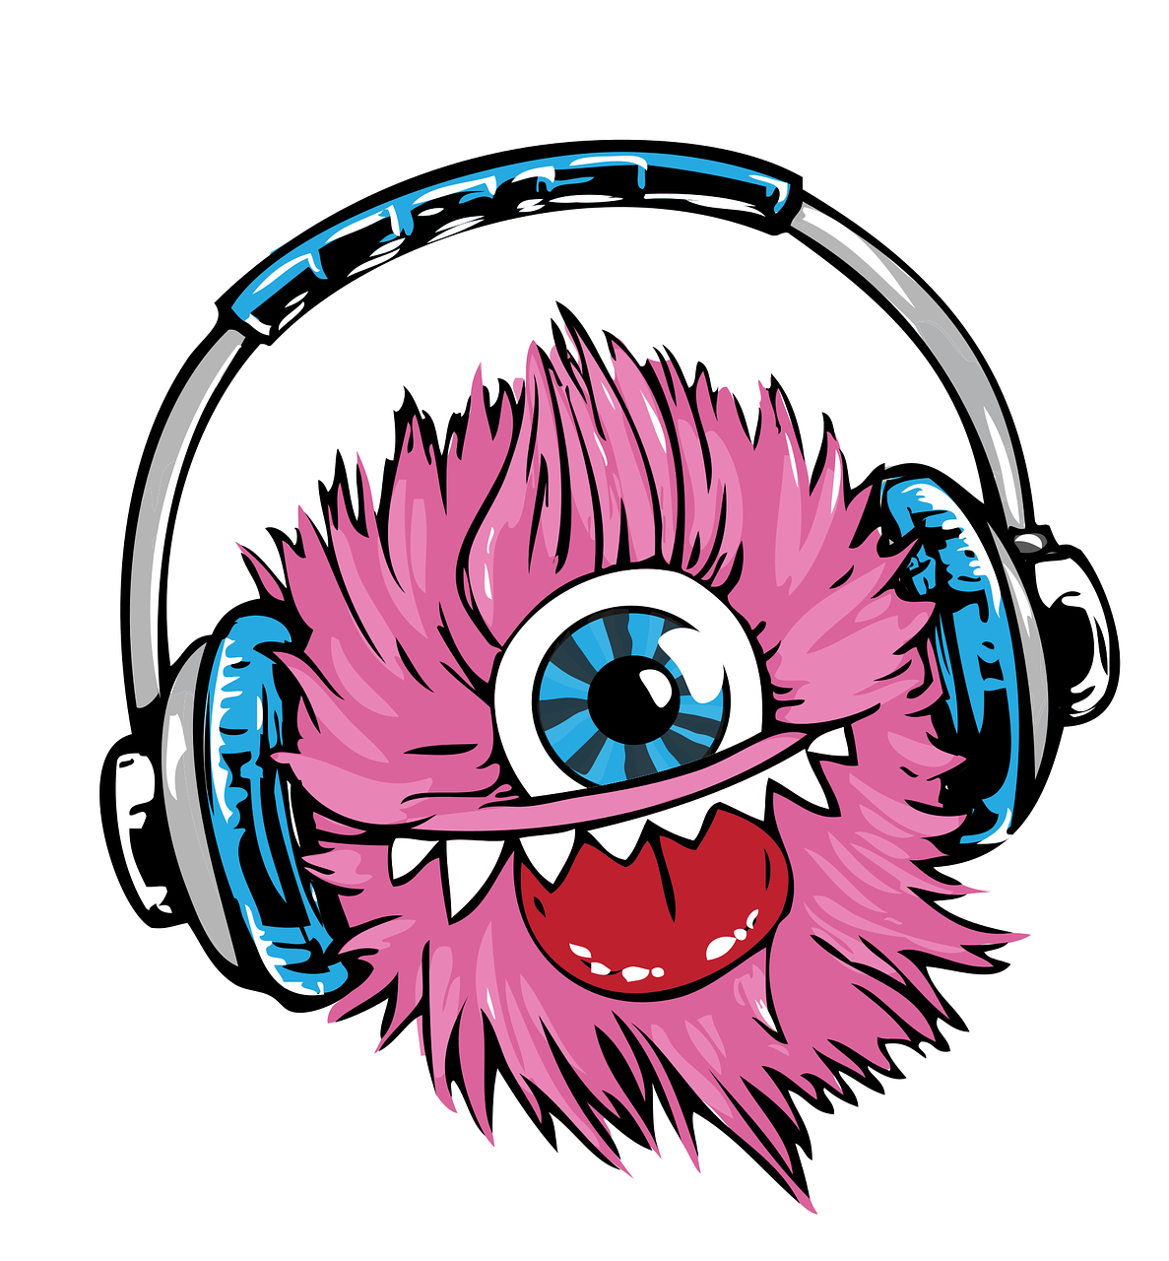

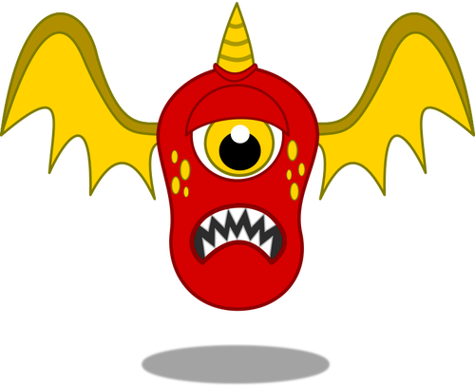

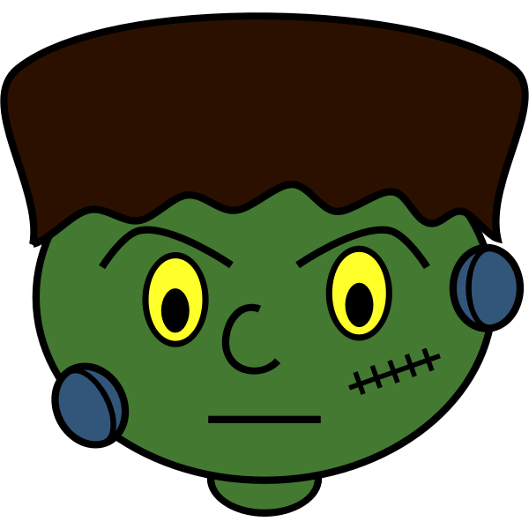

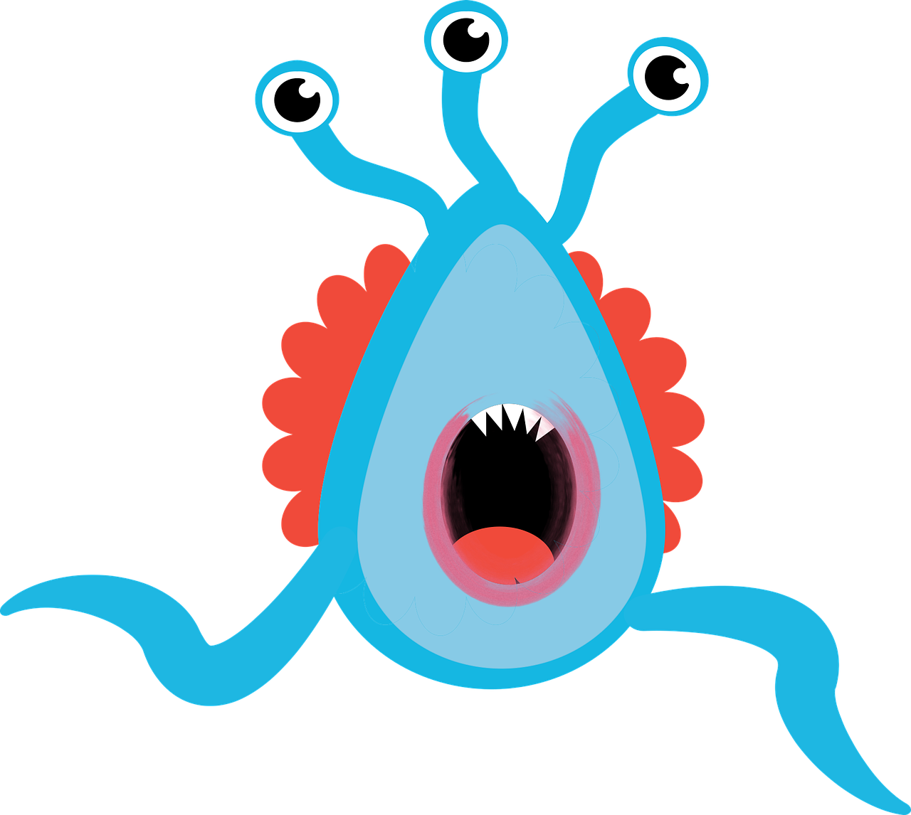

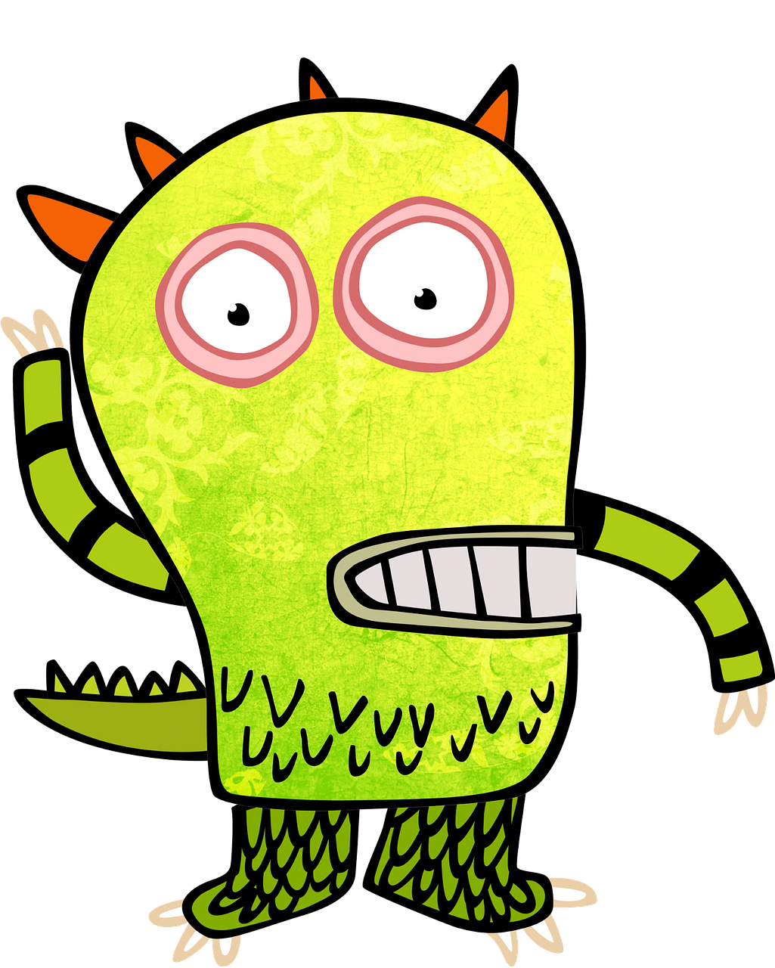

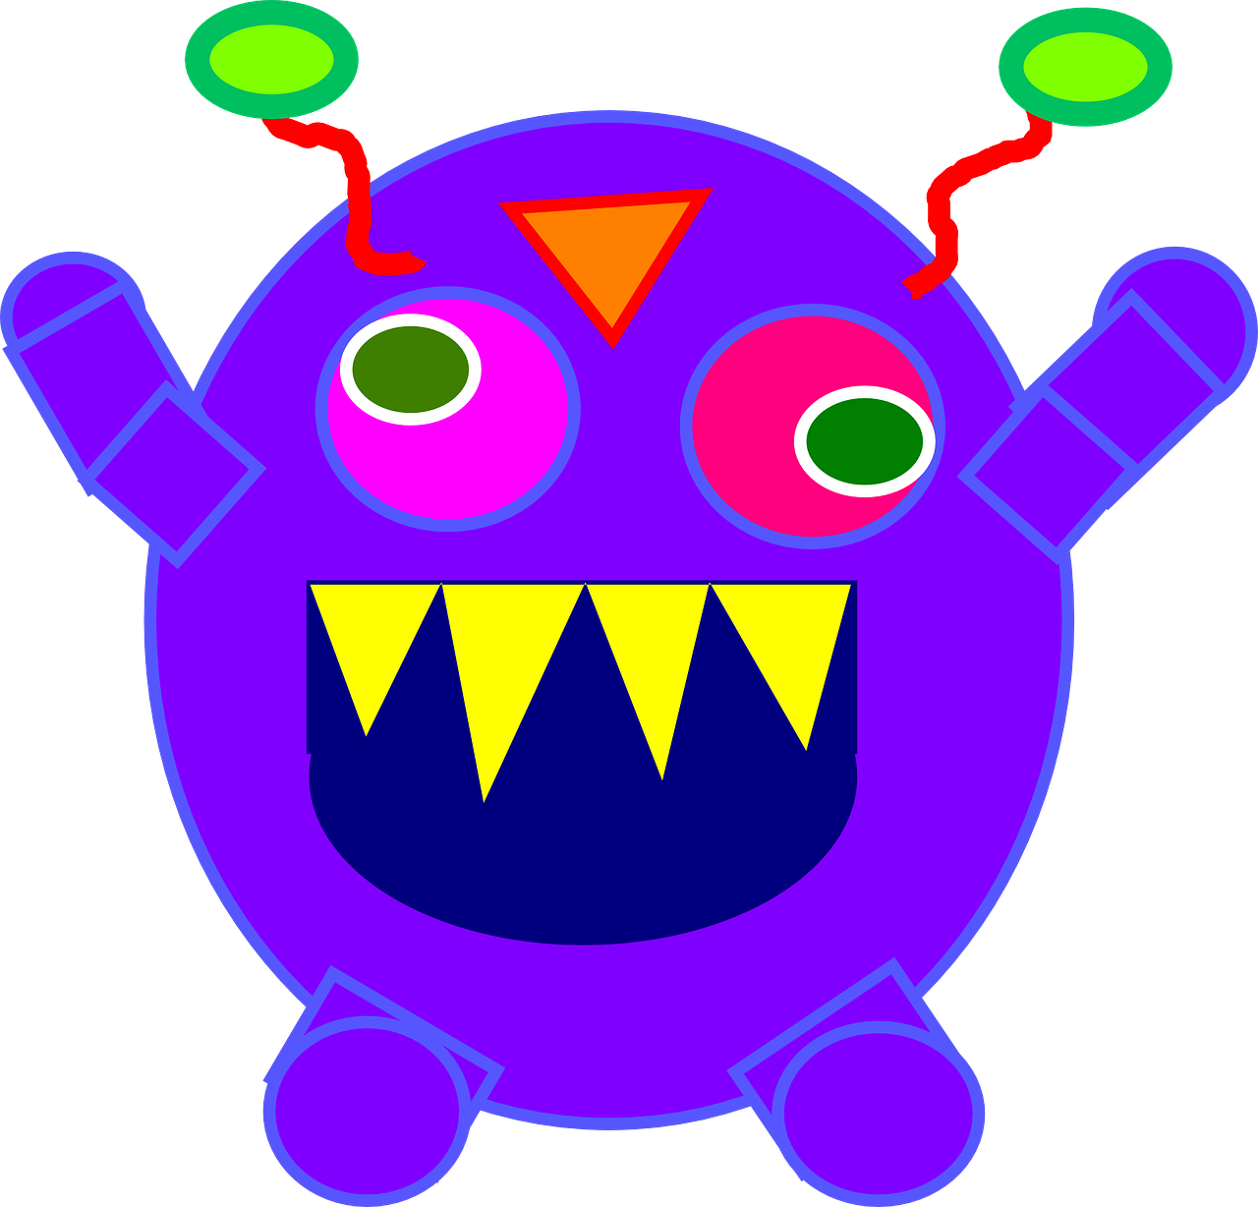

Image Sources
Acaladolopes. (2019, March 7). Monster, scared, running, scary. https://pixabay.com/vectors/monster-scared-running-scary-4037255/
ArtsyBee. (2016, January 11). Monster clipart kids. https://pixabay.com/illustrations/monster-clip-art-kids-1131847/
Clker-Free-Vector-Images. (2014, August 4). Monster, roar, sharp, teeth, purple. https://pixabay.com/vectors/monster-roar-sharp-teeth-purple-312273/
GraphicMama-team. (n.d.). Monster headphones headset free photo. https://www.needpix.com/photo/656132/monster-headphones-headset-listen-smile-music-notes-tongue-teeth
Openclipart. (2019, February 19). Cartoon image of blood-thirsty animal. https://publicdomainvectors.org/en/free-clipart/Red-flying-monster/81412.html
Openclipart. (2014, October 10). Vector image of Halloween vampire. Green illustration of scary Halloween face. https://freesvg.org/halloween-monster-vector-graphics
Siedlecki, P. (n.d.). Blue monster with blue eyes on white. https://www.publicdomainpictures.net/en/view-image.php?image=155188&picture=blue-monster

