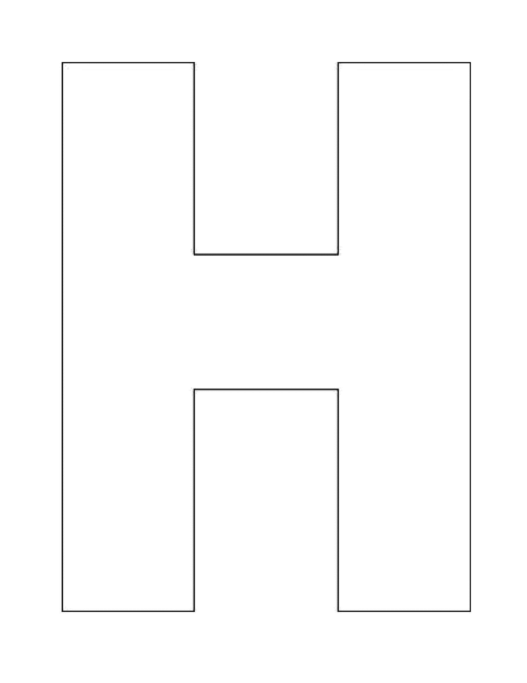


H-Chart
What is the injustice in the Tulsa Race Massacre article?
What is the injustice in the Dreamland Burning excerpt?
What do the two texts together tell us about injustice?

