H-Chart

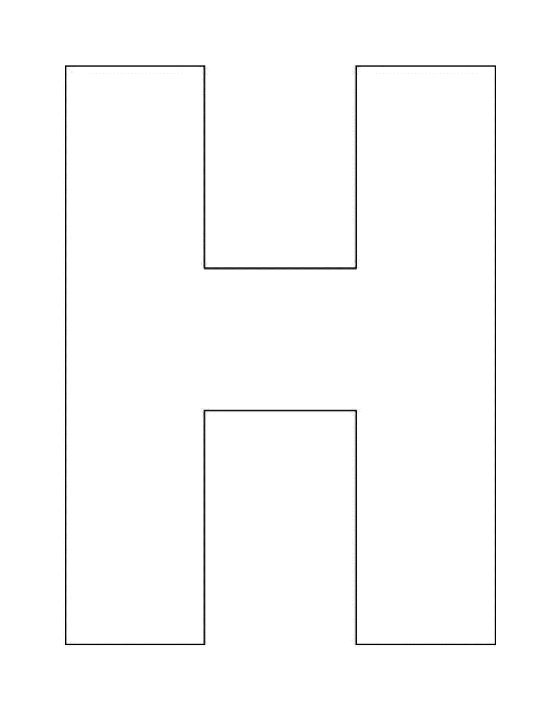

What is the injustice in the *Tulsa Race Massacre* article?

What is the injustice in the *Dreamland Burning* excerpt?

What do the two texts together tell us about injustice?