Tulsa Race Massacre: 1921 Tulsa newspapers fueled racism, and one story is cited for sparking Greenwood's burning
By Randy Krehbiel, Tulsa World
May 31, 2019

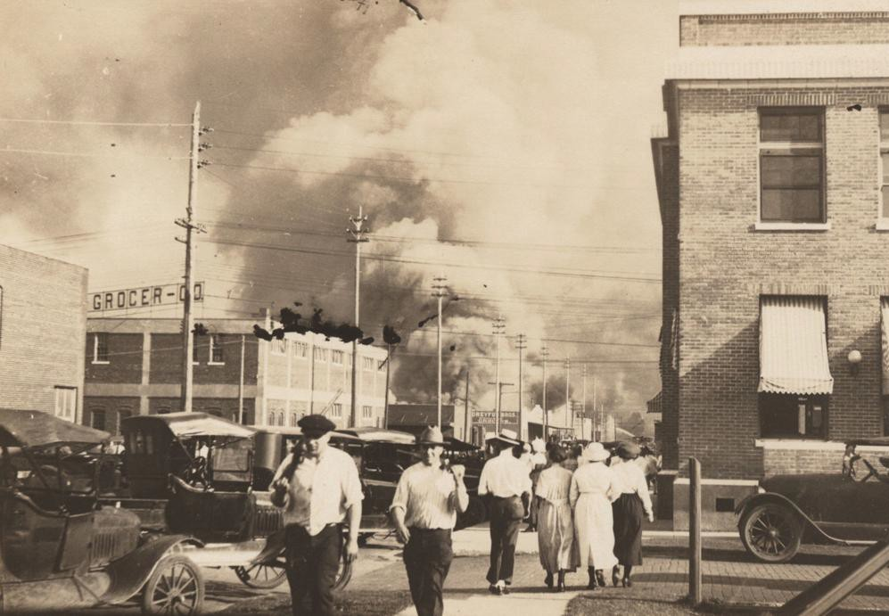
Greenwood burns on June 1, 1921, after a white mob invaded the district and destroyed 35 blocks of property.

There are many lessons from Tulsa’s 1921 race massacre. One of them, often overlooked, is that words matter.
Walter White, the intrepid NAACP investigator of that era, wrote that the injudicious use of one word, “assault,” in the May 31, 1921, Tulsa Tribune was in large part responsible for the conﬂagration that consumed the hopes and dreams and the very lives of black Tulsans that same evening and night and the morning of June 1, 1921.
Roscoe Dunjee, then-editor of the inﬂuential Oklahoma City newspaper The Black Dispatch, agreed and published the entire article containing the offending word under the headline, “The Story That Set Tulsa Ablaze.”
Adj. Gen. Charles Barrett, who arrived in Tulsa on the morning of June 1, expressed similar sentiments, both at the time and in his memoir, published 18 years later.

The story in question carried the headline “Nab Negro for Attacking Girl in an Elevator.” Just ﬁve paragraphs long, it appeared at the bottom of the right hand column on Page 1 of the May 31 editions of the Tulsa Tribune, the city’s afternoon newspaper.
The same paper but dated June 1, 1921, was sent to mail subscribers.
Brieﬂy stated, the story said a young African-American identiﬁed as “Diamond Dick” Rowland had been arrested that morning for “attempting to assault the 17- year-old white elevator girl” in a downtown building the previous day.
In the terminology of the day, the story essentially accused Dick Rowland of attempted rape.
Within hours of the arrest, and probably after the Tribune story hit the streets, Tulsa police received a threat on Rowland’s life. He was moved six blocks from the ramshackle city lockup to the county jail on the top ﬂoor of the courthouse at Sixth Street and Boulder Avenue, where the Bank of America Building now stands.
There the riot that became a massacre began.
Opinions vary on how much that one word in a newspaper contributed to the death and destruction, but it and the story in its entirety are illustrative of the language the white-owned press, in an era when newspapers were the only mass media, used to describe whites and blacks.
Rowland was “a negro delivery boy who gave his name to the public as ‘Diamond Dick.’” He had been skulking about the building for no apparent reason, the story implied.
The girl, Sarah Page, was “an orphan who works as an elevator operator to pay her way through business college.”
It emerged that neither of these descriptions was entirely warranted. Page was not exactly an innocent damsel in distress; Rowland most likely was just trying to do his job—although what, exactly, that job was is unclear.
“Without pausing to ﬁnd whether or not the story was true, without bothering with the slight detail of investigating the character of the woman who made the outcry (as a matter of fact, she was of exceedingly doubtful reputation), a mob of 100-per-cent Americans set forth on a wild rampage,” White wrote, referring to a motto popular at the time and adopted by, among others, the new Ku Klux Klan.
The morning Tulsa World was perhaps the ﬁrst to blame its archrival for inciting the riot. It quoted Chief of Detectives J.W. Patton as saying police had concluded that Rowland was innocent of wrongdoing and that the Tribune’s “colored and untrue account … incited such a racial spirit upon the part of the whites and under the impression there would be a lynching the armed blacks invaded the business district. If the facts as told the police had only been printed I do not think there would have been (any) riot whatever.”
This version of events was self-serving for both the police and the World. News stories and archival documents reveal that, by action and inaction, many members of the police force, including Patton, were complicit in what happened to Greenwood. The World, though largely supportive of black Tulsans and their resistance to a pig-in-a-poke scheme to exchange their property for lots farther away from downtown, reﬂected the prevailing racism of the times.
On June 4, 1921, in an editorial headlined “‘Bad N----rs’”, the World lectured the “innocent, hard-working colored element” of Tulsa on the need to control those among them who “boast of being ‘bad n-rs.’”
Even sympathetic reporting reveals the mindset of the times.
Two days earlier, on June 2, the World published the only bylined story about the massacre and its aftermath to appear in either Tulsa daily newspaper. The reporter, Faith Hieronymus, had interviewed African Americans interned at the city’s minor league baseball park on the afternoon of June 1.
Hieronymus seems to have been the only person to have done this, and she wrote movingly of the victims’ plight. But she quoted her subjects in the vernacular and carefully noted that they attributed the destruction of Greenwood to Dick Rowland’s recklessness.
A subhead, probably inserted into the story by an editor to break up the block of type, reads “Black, but human.”
A widespread story, dating from shortly after the riot, is that the Tribune also published an editorial with a headline in the vein of “To Lynch Negro Tonight.” No copy of it has ever turned up and, all things considered, probably never existed.
For one thing, the Tribune’s chief critics—the World, Walter White and The Black Dispatch—never mentioned it. Words very similar to those attributed to the missing editorial appeared in both the World and the Tribune but after the fact in descriptions of what had already occurred.
Further, the Tribune editorialized against lynching immediately before and after the massacre. So to call for it in Rowland’s case would have meant ﬂip-ﬂopping twice in a matter of days.
At the time, many said the arrest story was enough to ignite the simmering racial unrest afﬂicting the entire nation. White, in fact, thought Tulsa an unlikely place for such an “eruption,” as he called it. The Tribune story, he said, was the spark that set the ﬁre, not the fuel that caused it to roar out of control.
“Her reign of terror stands as a grim reminder of the grip mob violence has on the throat of America, and the ever-present possibility of devastating race conﬂicts where least expected,” he wrote.
Ninety-eight years later, in a time when harsh and careless words ﬂy around the world in seconds and are instantly etched on eternity, it is perhaps worth remembering when a single word was blamed for countless deaths and a brief newspaper account became known as the story that set Tulsa ablaze.

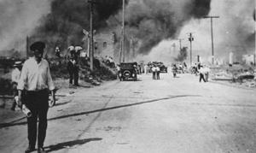
1921 Tulsa Race Massacre used as argument for slavery reparations during House congressional hearing

Tulsa Race Massacre: Facts and Figures
Number of dead: The true death toll has always been in question. Thirty-seven death certificates were issued for deaths directly related to the massacre. It is commonly believed the actual number was much higher. A Red Cross report in 1921 said estimates ranged from 55 to 300. Among the verified dead were nine black victims burned beyond recognition.
Injured: According to the Red Cross, 184 blacks and 48 whites were in surgical care within 24 hours. Another 531 received first aid in first three days. Maurice Willows, the Red Cross director, said it was impossible to know how many people were actually injured because so many left the city or refused treatment. He said wounded were reported in Muskogee, Sapulpa and other adjoining towns, and as far away as Kansas City.
Homes destroyed: 1,256 burned
Homes looted but not destroyed: 215
Square blocks burned: 35
Economic impact: Between June 14, 1921, and June 6, 1922, $1.8 million of claims were filed against the city of Tulsa and disallowed, according to the Race Riot Commission report issued in 2001. In inflation adjusted dollars, that would be more than $26 million today.

Source: Krehbiel, R. (2019, May 31). Tulsa Race Massacre: 1921 Tulsa newspapers fueled racism, and one story is cited for sparking Greenwood's burning. Tulsa World. https://tulsaworld.com/news/tulsa-race-massacre-1921-tulsa-newspapers-fueled-racism-and-one-story-is-cited-for-sparking/article_420593ee-8090-5cfc-873e-d2dd26d2054e.html

