“Labels Impact History”

Caption This:​ Examine each image closely, and create a 1–3 sentence caption that explains what is happening in the image or what each image represents.
Image #1: |  | Image #2:
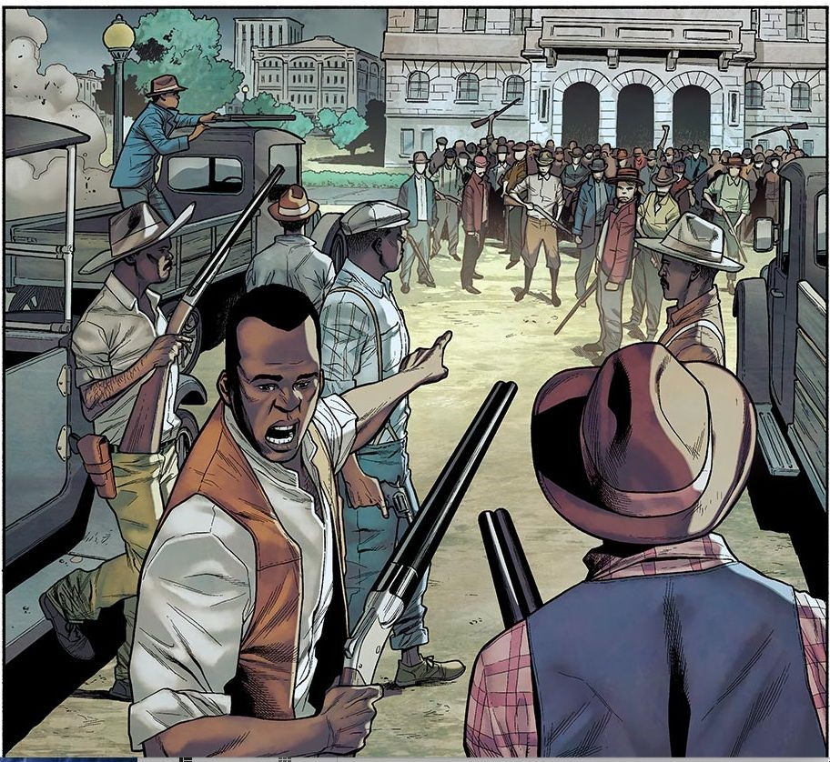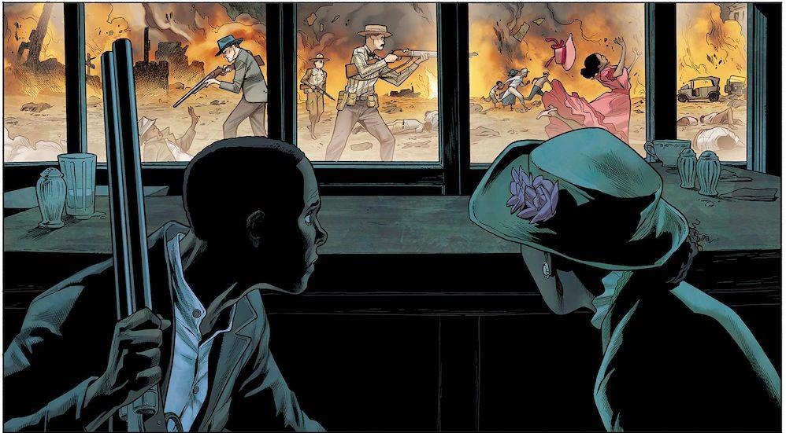

Brainstorm the differences and similarities​ between the labels “riot” and “massacre.”

Riot:​ Massacre:​

“Image/Video Response”
Label each image as “riot” or “massacre.” Would you categorize each image as a “riot” or a “massacre?” Why? Justify your answer using definitions of “riot” and “massacre” and details from the images.

Image #1:  Video Response - How I Know It https://www.youtube.com/watch?v=Gho  AGJUDEvc  Draw a large circle on the back of your paper with a larger rectangle around it. In the circle, write an answer to the questions below. In the rectangle, write where you learned this information.  How do the speakers refer to the riot or massacre? Based on what you know at this time, would you call the event a riot or a massacre? |  | Image #2:

