CARD MATCH SET 1
Relating to a long poem, typically one derived from ancient oral tradition, narrating the deeds and adventures of heroic or legendary figures or the history of a nation. | 
Extremely impressive or daunting; inspiring great admiration, apprehension, or fear. | 
Imaginative or fanciful; remote from reality. | 
So great or extreme as to be difficult to believe; extraordinary. | 
Made, done, happening, or chosen without method or conscious decision. | 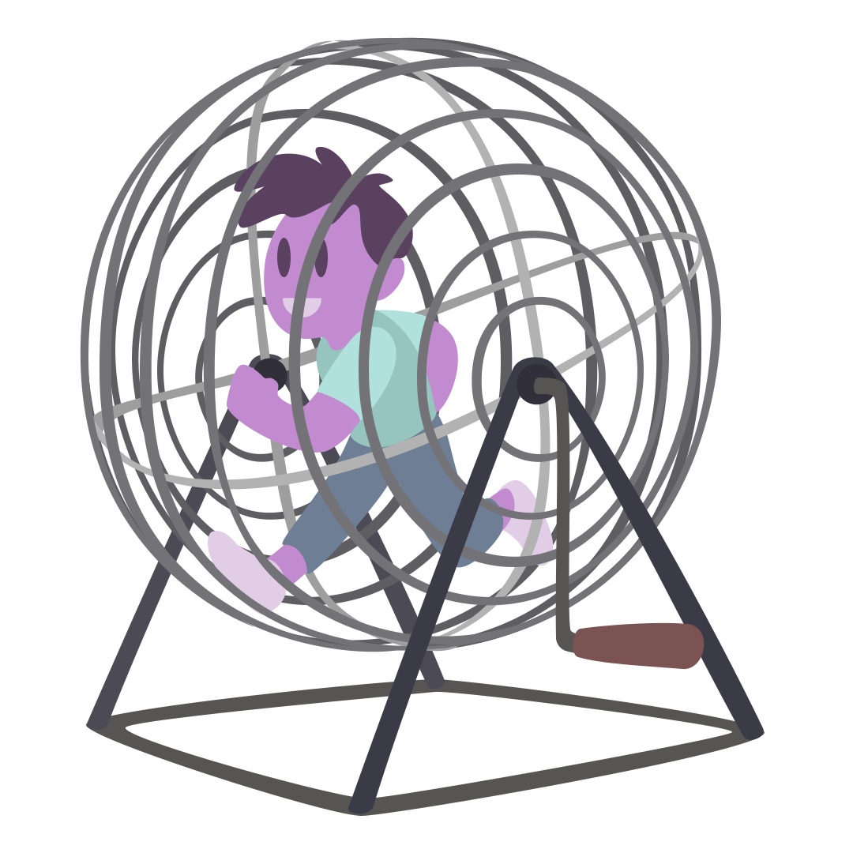
Being the only one of its kind; unlike anything else. | 

